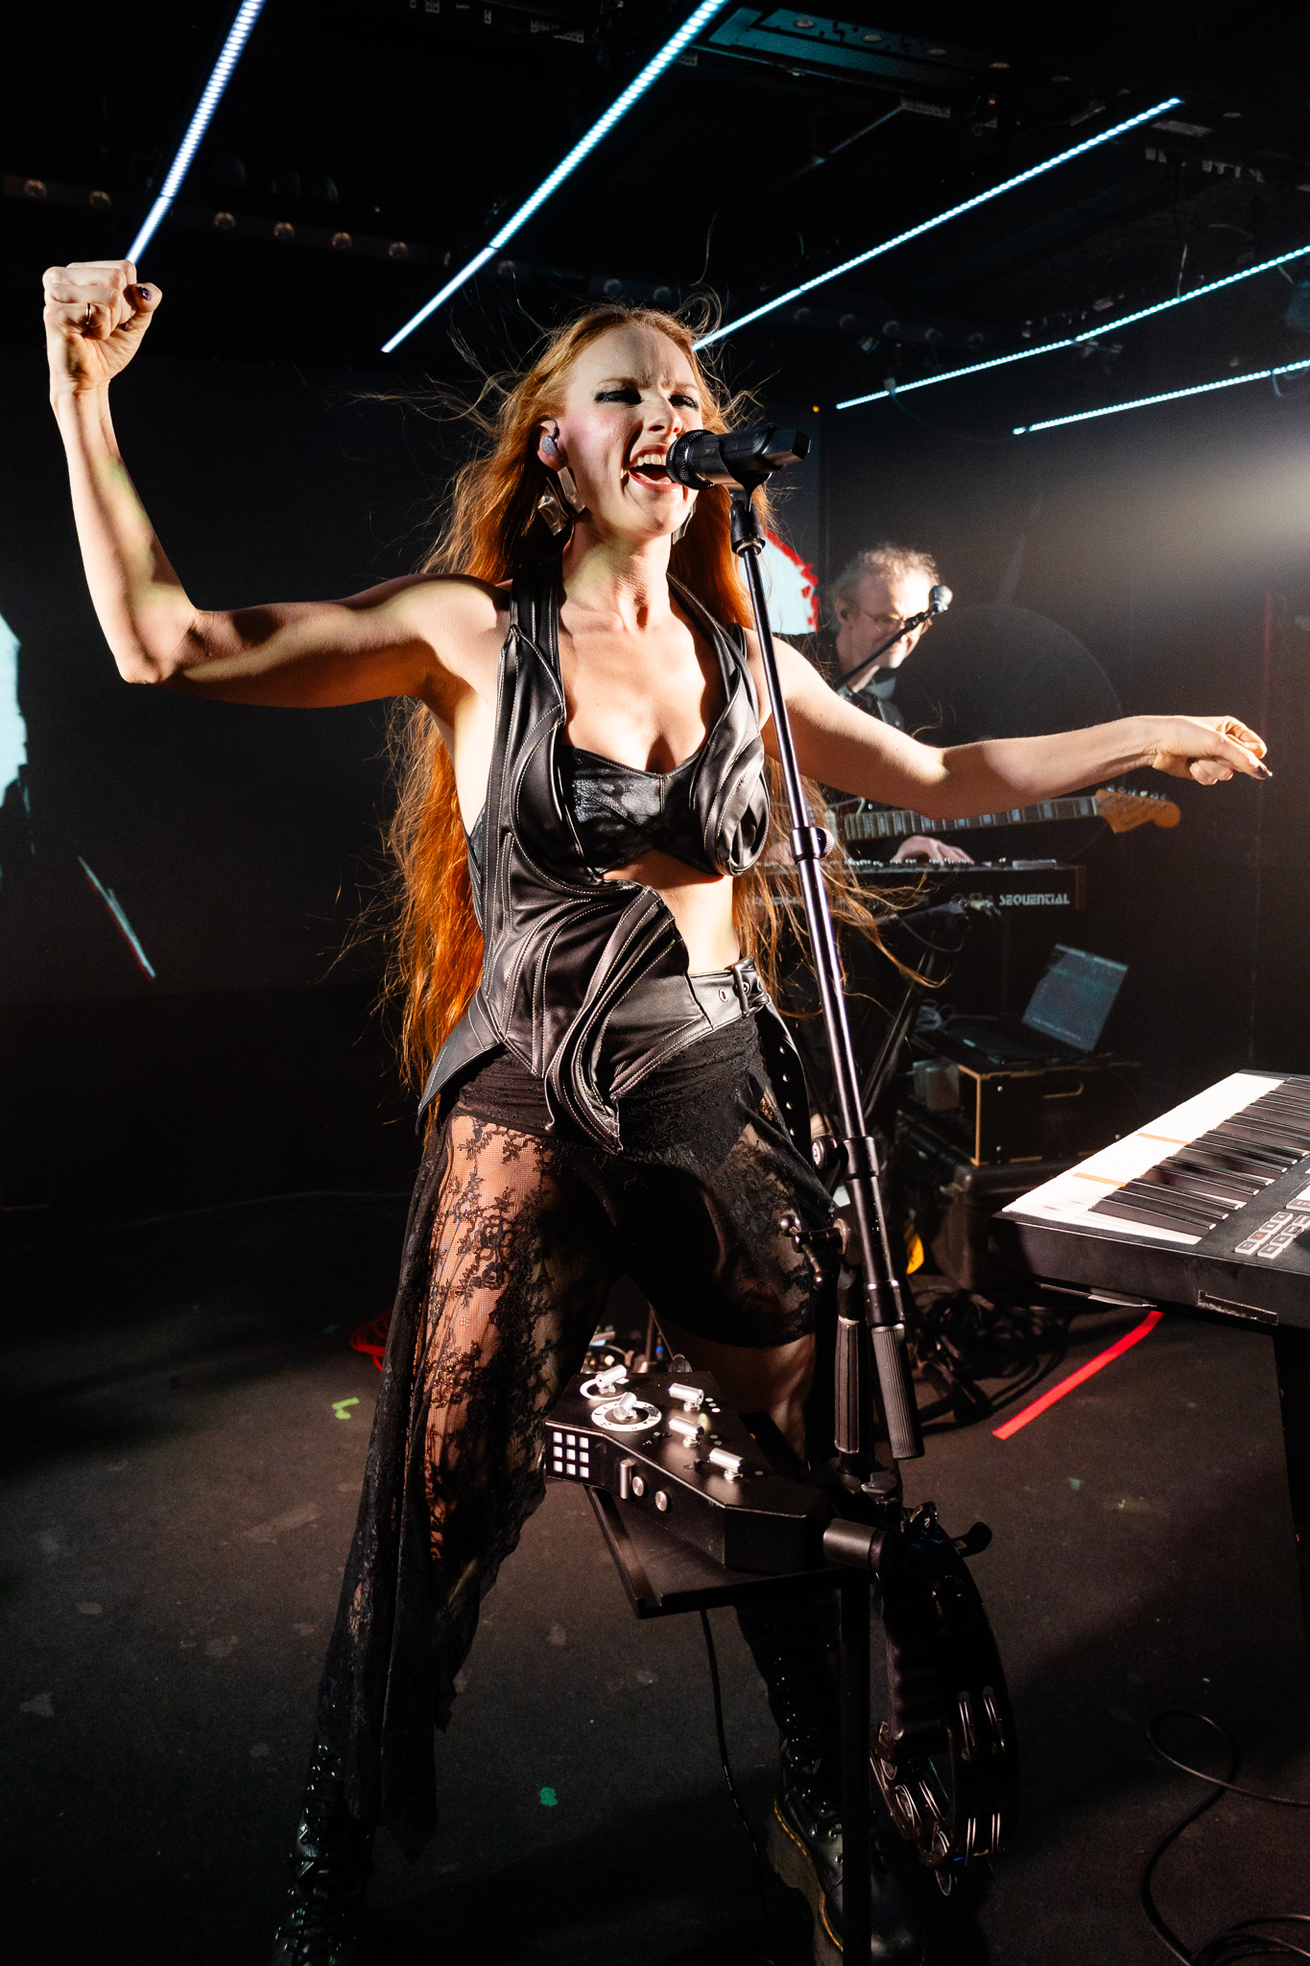

**The Sennheiser mic Vera Blue keeps rushing back to**

***With a voice built on sensitivity, strength and storytelling, Vera Blue finds consistency and creative freedom through Sennheiser’s Digital 6000 system and MM 445 microphone capsule.***

***Sydney, Australia, 15 October 2025 –*** For years, Vera Blue (real name Celia Pavey)’s voice has captivated audiences across Australia and beyond as an instrument that blends vulnerability, power and deep emotional resonance. As her career evolved, so did her expectations for live performance. With the MM 445 capsule and Digital 6000 wireless microphone system from Sennheiser, the manufacturer building the future of audio for 80 years, Vera Blue has found a setup that not only matches her sound but elevates it, night after night.

Longtime Front of House Engineer James “Jimmy” Livingston and Monitor Engineer Michael Wickens say the switch to the Digital 6000 system was a natural evolution for an artist already dedicated to precision and consistency. “We’ve been using the MM 445 for years, it’s always been Celia’s mic,” says Livingston. “We tried other capsules out of necessity, but we always came back to the 445. It’s the only one that truly captures her voice.”

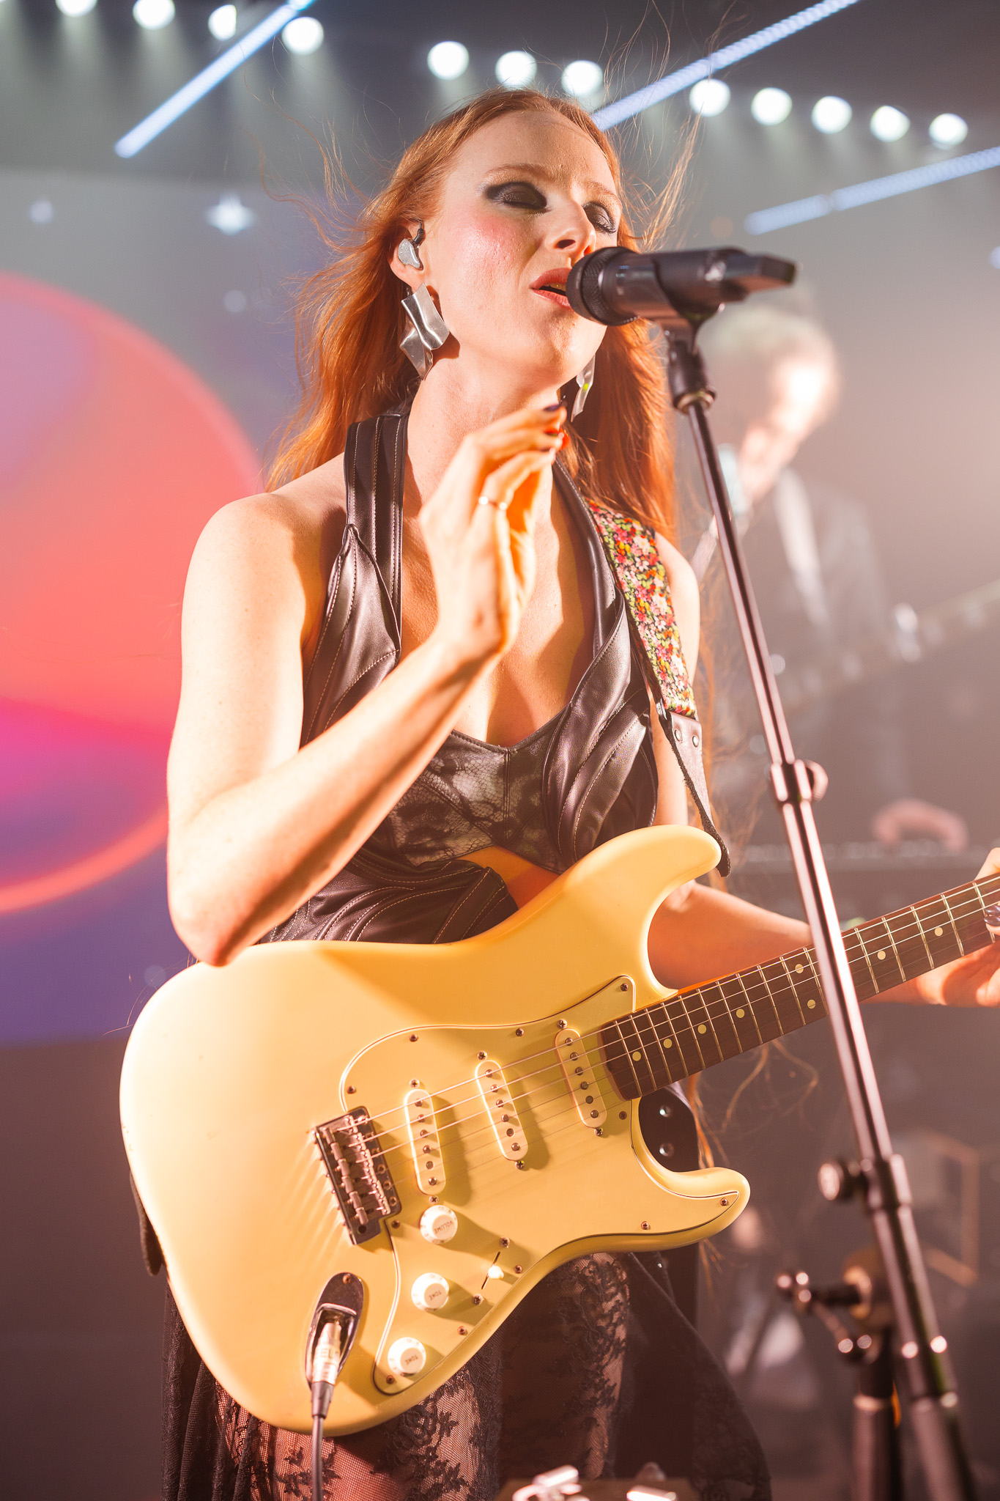

Vera Blue performing at Mary’s Underground

Photo by @sonicsydney

For Vera Blue, the choice is personal. “The 445 just gets my voice,” she explains. “It’s clear, warm and it handles all the delicate bits without losing power. Plus, it cuts out stage spill, which helps me stay focused. I can trust it and that trust gives me freedom.”

**Freedom to perform**

That trust is critical. When Vera Blue walks on stage, she’s not thinking about signal chains or RF scans – she’s focused on telling stories, connecting. “Songwriting started when I was about 14 as a way to process emotions and tell stories,” she says. “Somewhere along the way it turned into my whole world. I love it so much.”

For her, reliable gear is what makes that storytelling possible. If she knows her sound is locked, she can take risks, draw the audience in, and focus on the emotion of the moment rather than the technical details.

The MM 445’s supercardioid pickup pattern and spring-mounted capsule isolate her voice from the ambient stage noise, delivering an intimate and focused vocal that cuts through even the densest mix. Its aluminium-copper voice coil responds quickly to dynamics, capturing the nuance and power of Vera Blue’s live performance with high rejection and feedback resistance, even in high-volume moments.



Vera Blue performing at Mary’s Underground

Photo by @sonicsydney

“The D6000’s made everything better,” she shares. “Cleaner sound, no dropouts and the confidence to move anywhere on stage. If I know the sound is locked, I can stop thinking and just be in the moment.”

Livingston agrees. “You can’t overstate how important reliability is. Celia’s one of the most consistent vocalists I’ve ever worked with. The gear needs to be just as consistent. The Digital 6000 gives us the quality of studio sound with the resilience of a live system.”

Built for touring artists and live production environments, the Digital 6000 features equidistant frequency spacing for intermodulation-free operation, allowing more wireless channels to fit into tighter RF environments. The system’s Link Density mode doubles available channels without compromising quality, making it ideal for festival setups and quick turnaround shows.

Even in acoustically difficult spaces like Mary’s Underground, a small, low-ceiling club with speakers placed close to the vocal mic, the setup performed without issues. “It was really good,” says Wickens. “It’s a tricky room, but the system worked really well. I’ve had lots of people commenting on how good it sounded. We were able to push it over the mix without feedback, which was great.”

**Sound you can trust**

“Celia knows how her voice is supposed to sound. She’s incredibly tuned in to detail, but also trusts us to deliver,” says Wickens.

That sensitivity to sound carries over into the studio, too. Vera Blue has worked closely with producer and fellow Sennheiser and Neumann user Eric J Dubowsky, shaping tracks like ["Rushing Back" with Flume](https://www.youtube.com/watch?v=_RkuyHSfSn4) and experimenting with new sonic directions. As Dubowsky explained in [his interview with The Pulse](https://www.youtube.com/watch?v=ie1ZIMoRWag&ab_channel=ThePulse), tools that capture nuance in the studio and hold up on stage allow artists to move seamlessly between both worlds, supporting creativity at every stage of the process.

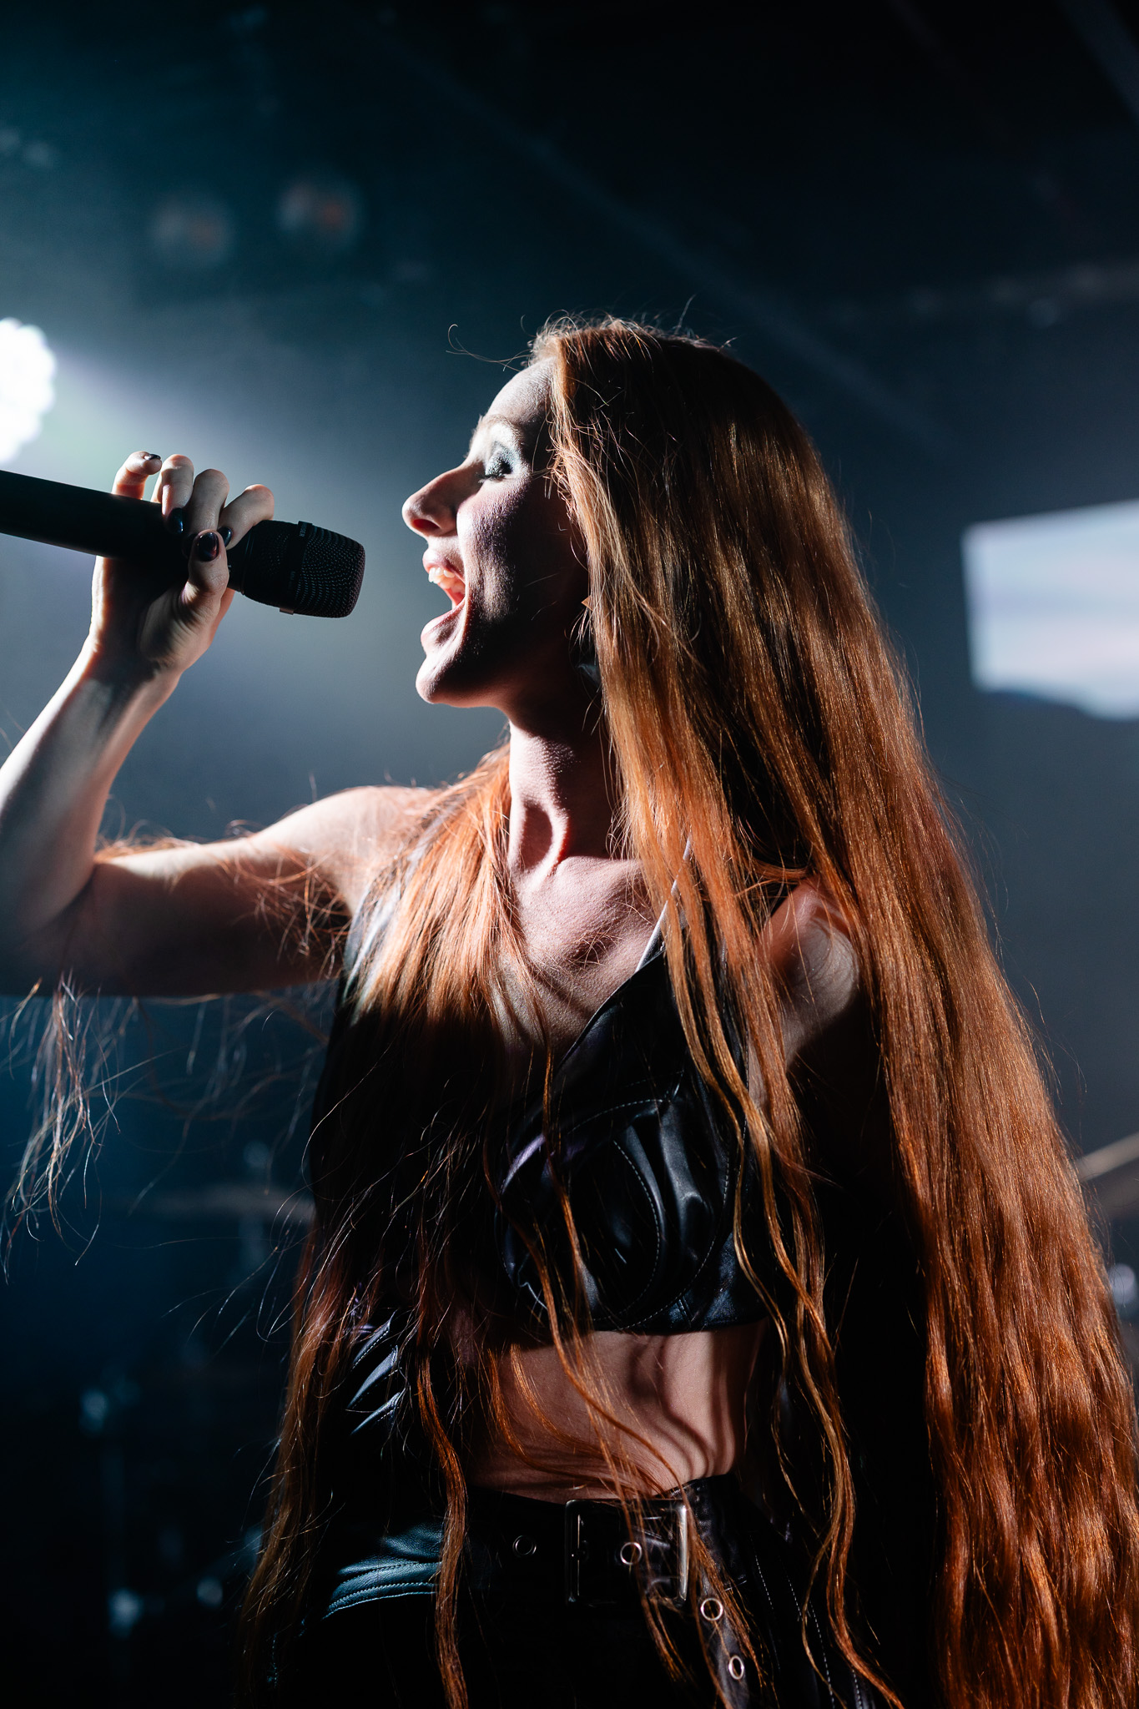

Vera Blue performing at Mary’s Underground

Photo by @sonicsydney

Her band has also felt the benefits of Sennheiser. From the G3 IEM system used in earlier years to the G4 in-ear monitors now powering their stage mix, the upgrade was instantly clear. “The band noticed it immediately,” Wickens says. “It’s tighter, clearer and more musical.”

**What comes next**

As Vera Blue looks ahead to her upcoming album *Rituals*, her technical team is continuing to explore ways to support an even more immersive and flexible live experience. With evolving show designs and performance goals, they’re always on the lookout for tools that can streamline setup and enhance sound quality. Sennheiser’s Spectera system is one such innovation they’re eager to explore as part of what comes next.

But for now, the combination of the MM 445 and Digital 6000 remains the beating heart of her vocal chain.

“Performing can be quite spiritual and magical,” Celia says. “So when everything is in its right place it can feel otherworldly, perfect.”

For more information on upcoming shows, music and recent projects, visit: https://www.verablue.com/

###

**About the Sennheiser brand – 80 Years of Building the Future of Audio**

We live and breathe audio. We are driven by the passion to create audio solutions that make a difference. This passion has taken us from the world’s greatest stages to the quietest listening rooms – and made Sennheiser the name behind audio that doesn’t just sound good: It feels true. In 2025, the Sennheiser brand celebrates its 80th anniversary. Since 1945, we stand for building the future of audio and bringing remarkable sound experiences to our customers.

While professional audio solutions such as microphones, meeting solutions, streaming technologies and monitoring systems are part of the business of Sennheiser electronic SE & Co. KG, the business with consumer devices such as headphones, soundbars and speech-enhanced hearables is operated by Sonova Holding AG under the license of Sennheiser.

[www.sennheiser.com](http://www.sennheiser.com)

[www.sennheiser-hearing.com](http://www.sennheiser-hearing.com)

|  |  |
| --- | --- |
| **Local Press Contacts**  Daniella Kohan  [Daniella.kohan@sennheiser.com](mailto:Daniella.kohan@sennheiser.com)  [+1 860 598 7420](tel:+1%20860%20598%207420)  Kirsten Spruch  kirsten.spruch@sennheiser.com  +1 (860) 598-7484 | Hotwire Australia  [sennheiseranz@hotwireglobal.com](mailto:sennheiseranz@hotwireglobal.com) |