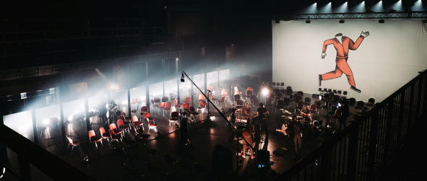

Live concerts during lockdown
Milliarden rely on Sennheiser

Wedemark, 2 March 2021 - On 5 February 2021, the Berlin band Milliarden presented their latest album “Schuldig” at an exclusive live concert at CLUB100 in Bremen. Due to coronavirus restrictions, the performance went ahead without a live audience – but that didn’t prevent it from being a resounding success. More than a thousand music fans were happy to buy an online ticket to enjoy the live stream of the concert. Wireless systems and wired microphones from Sennheiser played a key role in creating the outstanding sound.

Milliarden presented their new album “Schuldig” at CLUB100 | 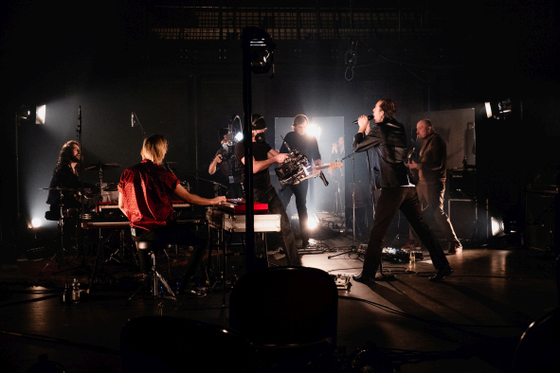

In addition to wired Sennheiser microphones, Milliarden also chose ew 500 G4 wireless systems together with the matching handheld and bodypack transmitters, which they operated in the BW (626 to 698 MHz) frequency range. The handheld transmitter used by lead vocalist Ben Hartmann was equipped with the new MM 445 microphone capsule, which Sennheiser launched at the end of 2020. Urs Maurer (management and FOH mix) is full of praise regarding its sound characteristics: “The proximity effect really comes into its own with this capsule, which means that it primarily picks up the singer’s voice – which is what we want to hear – and transmits hardly any of the sound from the surroundings,” Maurer points out. “I’m highly impressed – the MM 445 capsule sounds incredibly good. During the concert in Bremen, one of the really good things I noticed was how little background noise gets picked up by the microphone head – that’s absolutely sensational and is priceless for a band like Milliarden, who are not exactly known for being quiet when they’re on stage!”

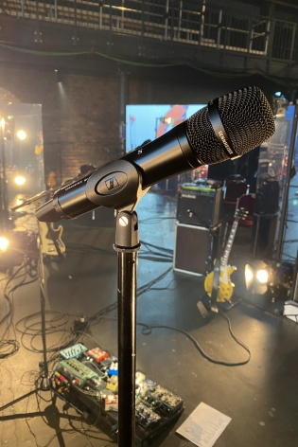 | Milliarden’s Ben Hartmann used an evolution wireless 500 G4 handheld transmitter with the new high-rejection MM 445 microphone head

The MM 445 dynamic microphone head fitted with Sennheiser’s standard capsule interface has been designed specifically for vocals and offers an impressive combination of presence and openness. It gives every voice a greater level of fullness, intensity and assertiveness. Sophisticated acoustic design combined with a lightweight aluminium voice coil ensures a fast transient response and creates an exceptional acoustic proximity. The high-rejection super-cardioid pick-up pattern provides consistent protection against feedback – even at extreme stage volumes or when used in front of the PA system on runways and second stages.

Perfect reception in all areas
The four EM 300-500 G4 receivers available in Bremen were operated with an ASA 214 active four-way antenna splitter, which was also used to supply them with power. Two Sennheiser A 2003-UHF were used as passive directional antennas. “No dropouts occurred at all, not even when Ben moved quite a way away from the central stage with his handheld transmitter,” said Urs Maurer with great satisfaction.

For in-ear monitoring, Milliarden always choose wireless systems from Sennheiser. For many years now, the band has been using four reliable ew 300 IEM G2, which, at the CLUB100 concert, were operated in combination with an A 5000-CP passive antenna with circular polarisation. The perfect wireless coverage ensured that the musicians could be provided with their individual monitor mix in all areas of the spacious concert venue – even in rooms far away from the show itself.

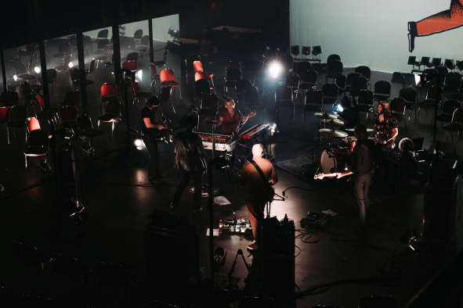 | The virtual live concert at CLUB100 gave fans a welcome opportunity to enjoy the songs from Milliarden’s new album “Schuldig”

Solidarity in difficult times
“We got an incredible amount of positive feedback from our fans through social media about our performance at CLUB100,” said Urs Maurer. “You can tell that the lockdown has really starved people of enjoying cultural events, and, of course, a lot of fans were curious to hear the songs on the new album. Some of our musician friends and others in the business called to congratulate us on the concert. It’s really nice to have the feeling that there is a lot of solidarity in the performing arts community in spite of these difficult times.”

Pilot project with a perspective
The evening was not only musically outstanding, the concept developed by the city of Bremen also serves as a model for how to support the music and cultural scene. CLUB100 (www.club100-bremen.de) is a solidarity event and streaming project at the Pier2 venue in Bremen, with its central concert hall that offered space for up to 2,800 people before the pandemic took hold. At the location, which is well-known far beyond the local region, cultural events have regularly been held since 14 January 2021 under the motto “Live on stage and streaming live on screens worldwide”.

Around 40 events are scheduled to take place at CLUB100 until May 2021 – initially only as streams but, at a later date, possibly also with a limited live audience present, provided that Covid restrictions and the seven-day incidence rate make this possible. Until then, the CLUB100 events will be broadcast in a digital form on the internet. Anyone who wants to watch a live stream will first have to buy a ticket. There is no provision for downloading recordings later, as the Bremen project is explicitly designed to be a virtual equivalent to a live experience.

“We hope that we will soon be able to stage live concerts at CLUB100 in front of an audience – we are prepared for everything and can respond to events as they unfold,” said Gero Stubbe (Koopmann Concerts & Promotion GmbH & Co. KG). Together with Olli Brock (Hafensänger Konzerte UG, operator of Pier2 and Tower), Stubbe is responsible for the project, and together with Clubverstärker e.V. and the company Sendefähig GmbH, he is co-initiator at CLUB100. Thomas Holz, Sennheiser Relations Manager, is convinced by the underlying idea: “CLUB100 is a groundbreaking project that opens up a new perspective for those involved in the arts and for their environment in these difficult times, and this is welcome in every respect.”

The programme of events at CLUB100 is supported by Bremen’s Senator for Economic Affairs, Labour and Europe, and by WFB Wirtschaftsförderung Bremen GmbH with total funding of up to 1.1 million euros. “It is not our aim only to subsidise the closure of a venue, but to fund its operation under Covid-secure conditions,” said Kristina Vogt, Senator for Economic Affairs, on the subject of CLUB100. “What we are doing in Bremen will hopefully have an effect throughout Germany.”

Download the high-res images of this release here.

About Sennheiser
Shaping the future of audio and creating unique sound experiences for customers – this aim unites Sennheiser employees and partners worldwide. Founded in 1945, Sennheiser is one of the world’s leading manufacturers of headphones, loudspeakers, microphones and wireless transmission systems. Since 2013, Sennheiser has been managed by Daniel Sennheiser and Dr. Andreas Sennheiser, the third generation of the family to run the company. In 2019, the Sennheiser Group generated turnover totaling €756.7 million. www.sennheiser.com

Local press contact

Maik Robbe
maik.robbe@sennheiser.com
+49 5130 600 1028

