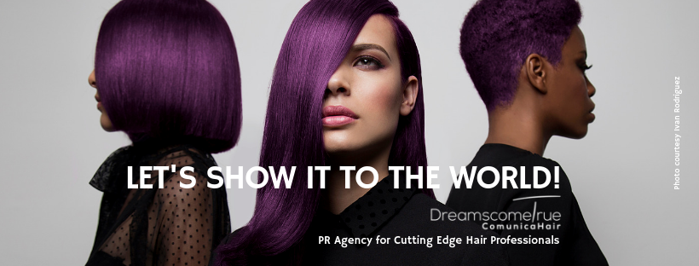
Specialised PR Agency for Cutting Edge Hair Professionals.
Creative Hairdressers are our clients.

For more information, please contact Marta de Paco
On +34670780664 or email press@dreamscometrue.es

Important:
These images are only available for editorial content.
Credits must be included.
Notification of their publication is expected.

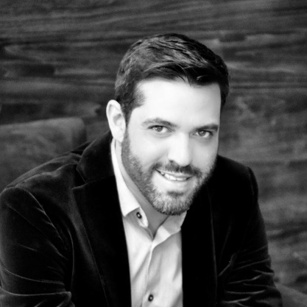
IVAN RODRIGUEZ
MEXICO
MESSY EFFORTLESS Collection

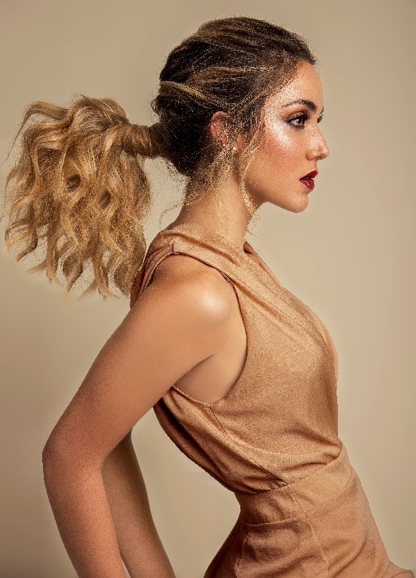
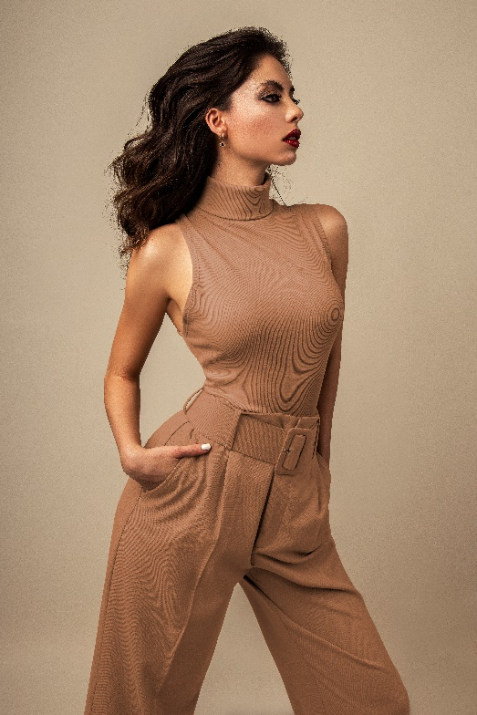
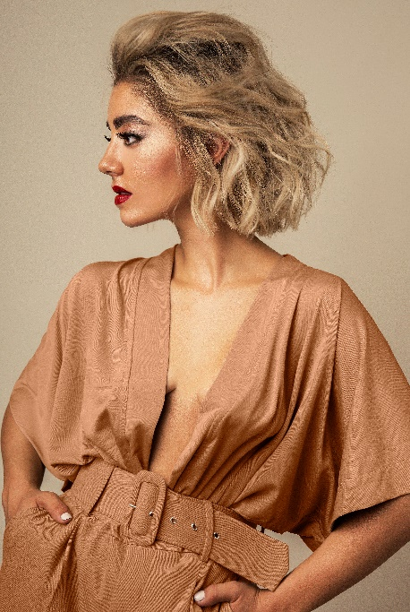

Hair: Ivan Rodriguez @El Salon Hairdressing Club
Hair Instagram @ivanrohair
Photographer: Jell Loya
MUA: Thessa Peralta
MUA Instagram @thessaperalta_mua
Stylist: Melissa Webb
Stylist Instagram @melwebbg
Models: Look 1: Messy Ponytail – Regina. Look 2: Messy Wob Bun – Aby. Look 3: Messy Half-Midi - Karla. Look 4: Messy Dark Waves – Alexa. Look 5: Messy Blonde Bob – Saso. Look 6: Messy High Bun – Michelle.
#ivanrohair #ivanrodriguezhairdresser

IVAN RODRIGUEZ
MEXICO
MESSY EFFORTLESS Collection

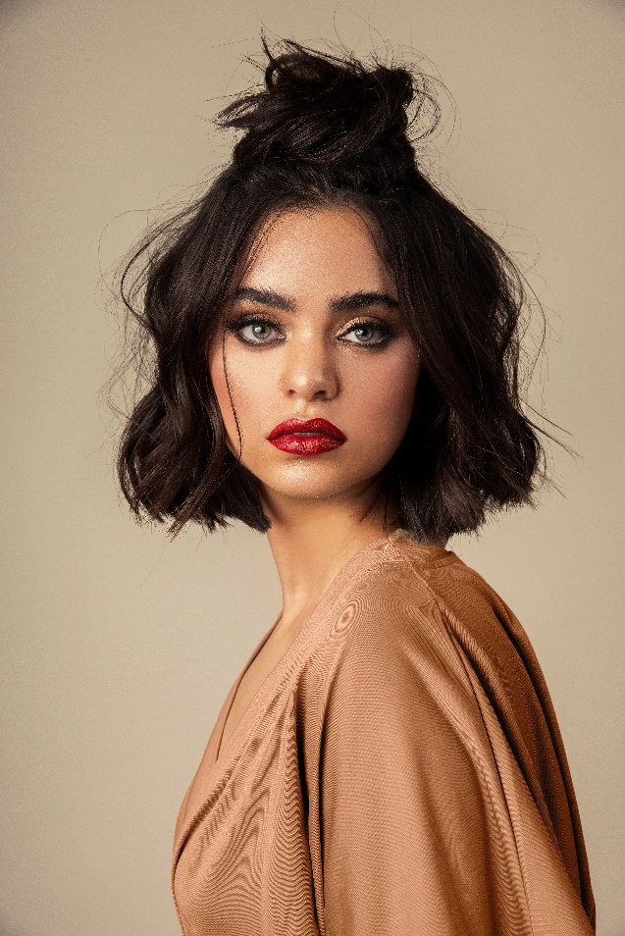

Messy Effortless is the new collection by Ivan Rodriguez for the beginning of 2020. A new decade begins and with it the new iconic looks that will reign in the new twenties….
Messy Effortless is a collection full of texture, simplicity and movement. Consisting of a perfect set of natural colour techniques, current haircuts and different approaches for stylised hair that become the main features of each look. Messy Effortless gives freedom to the hair; it is casual and chic, current and elegant, but above all it is a collection that represents the woman of 2020.

#ivanrohair #ivanrodriguezhairdresser

