Press Information//

EVOC cooperation – FALL/WINTER 2023-24
EVOC x Bicycle Nightmares – to explore together in search of an answer to the unknown

EVOC Sports, global market leader for protector backpacks, is collaborating with Spanish lifestyle/photography/streetwear label BICYCLE NIGHTMARES with the creation of a range of functional products in limited colourways. The result of this collaboration is the presentation of two special editions of tried-and-tested products WEEKENDER 25 BN and DUFFLE BACKPACK 26 BN. Their launch will be accompanied by a pop-up-store concept in the centre of Munich during the ISPO, so as to make the idea of a cooperation physically graspable and also in order to set up a place for creative exchange.

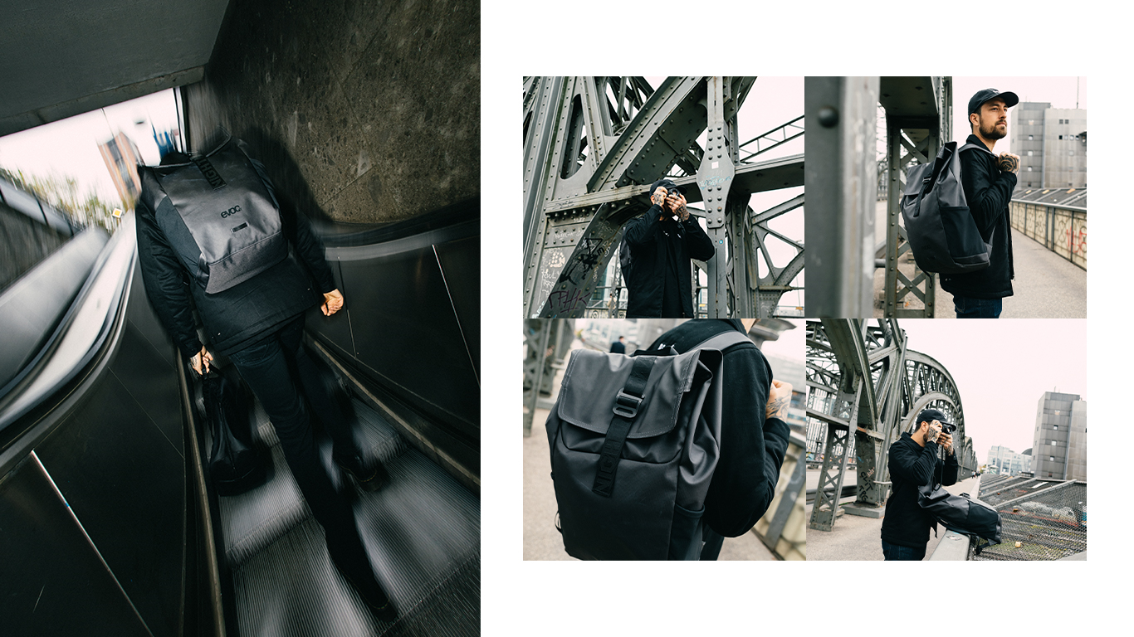

To explore together in search of an answer to the unknown
This is the mantra according to which the two brands have found their connection, the unifying elements being the love of the sport, travel, as well as contemporary aesthetics.
Inspired by the urban lifestyle of Barcelona and the complexity of modern freestyle mountainbike photography, Hector Saura has captured a unique perspective of the mountainbike and dirt jump scene with his label Bicycle Nightmares. Covering the realms of sport, art, architecture and design, Bicycle Nightmares represents the notion of reinterpreting the world of cycling under a new light and discovering what unifies the global communities.
The collaboration of EVOC and Bicycle Nightmares combines the technological expertise and premium quality standards of a German outdoor brand with the minimalist and urban design language of Hector Saura’s brainchild.

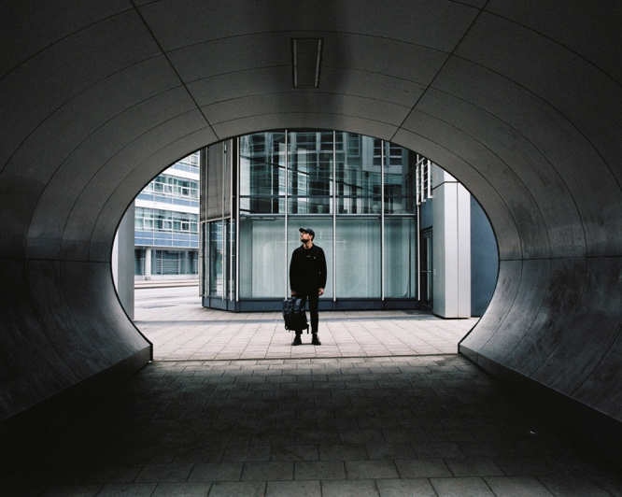

„Monochrome“
Hector Saura, founder of Bicycle Nightmares is renowned for his black and white photography and his unique aesthetics inspired by urban Barcelona and its dirt jump culture. Sharp contrasts, clear forms, pure beauty.
This concept is reflected in the “Monochrome“ colour scheme of the limited EVOC X Bicycle Nightmare products.

DUFFLE BACKPACK 26 BN
The DUFFLE BACKPACK 26 BN can withstand even the worst showers and offers a volume-adjustable main compartment. No matter how long your day in the city is going to be, you’ll be set for everything.

- Waterproof and 100% PVC-free main material
- Lid with aluminium buckle with which to a adapt the volume of the main compartment
- Separate and easy-to-reach lateral compartments for laptop, phone and keys
- Detachable chest strap

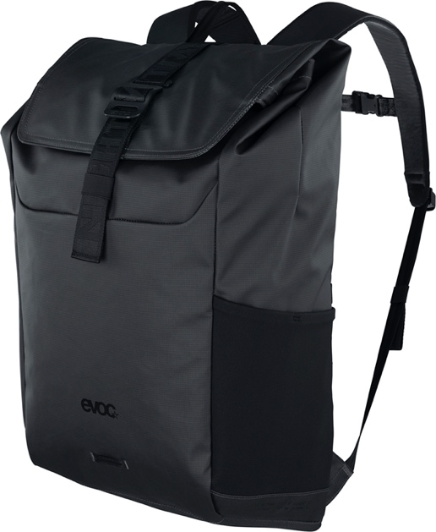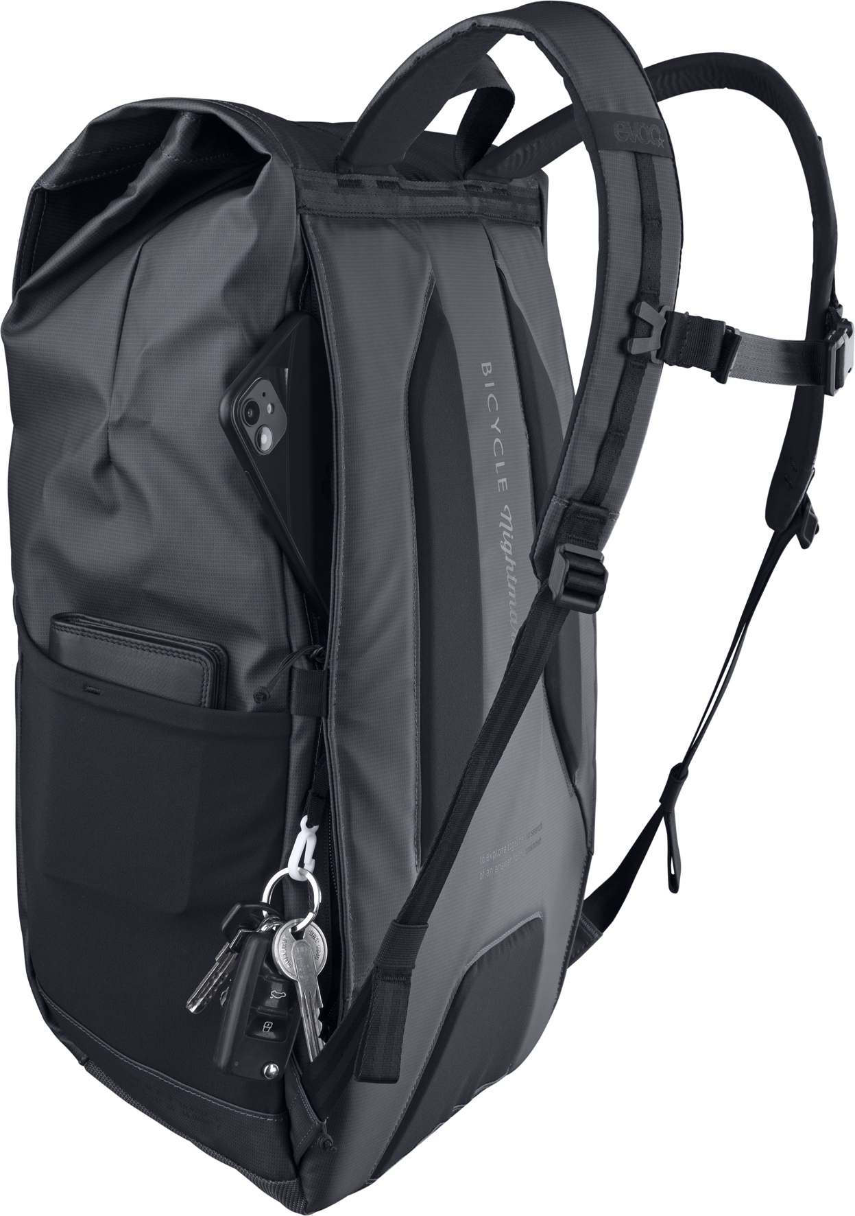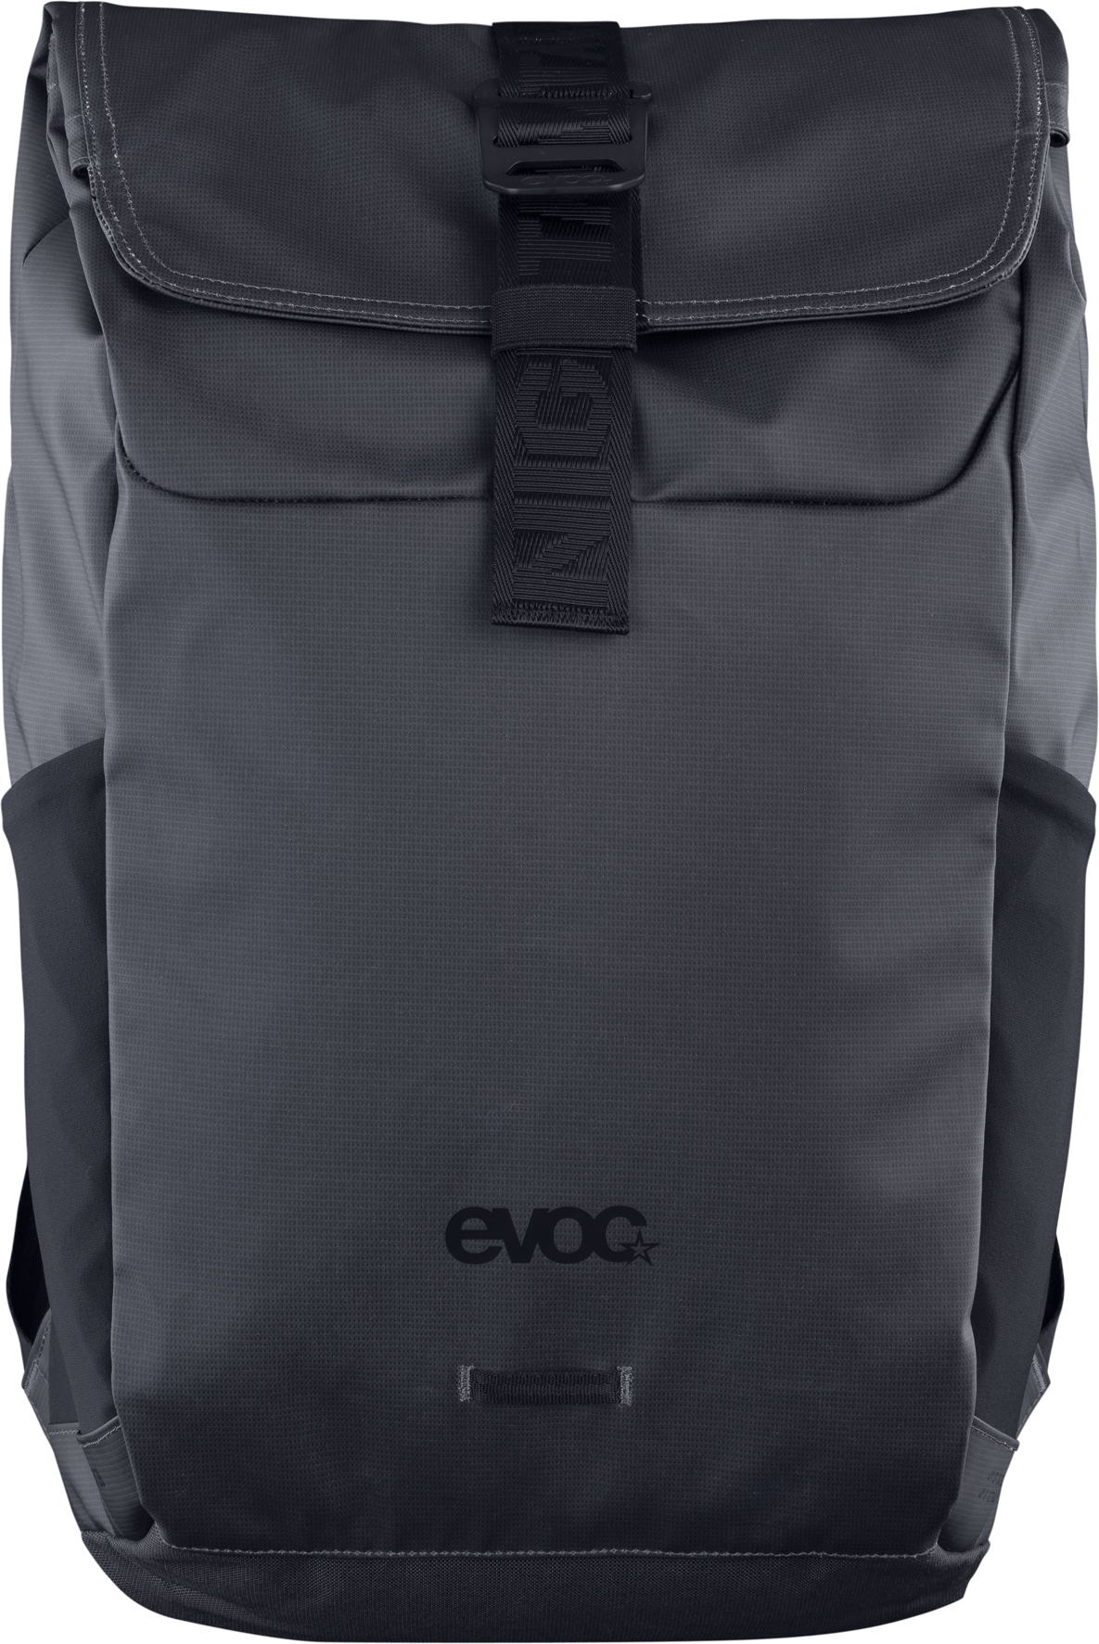

WEEKENDER 25 BN
The WEEKENDER 25 BN is more than just a travel bag. It’s your daily training partner at the gym, your suspicious bag of cash, or your partner in crime when you need a break from the bustle of the city and just want to get away.

- Perfect size for weekend trips, as carry-on luggage or daily trips through the urban jungle

- Stylishly reduced, modern design
- Water and dirt repellant, TPU-coated and 100% PVC-free material
- Two exterior zippered compartments for valuables
- Two interior compartments for smaller items
- Sturdy handles made from durable fabric
- Removable, padded shoulder straps for perfect carrying comfort

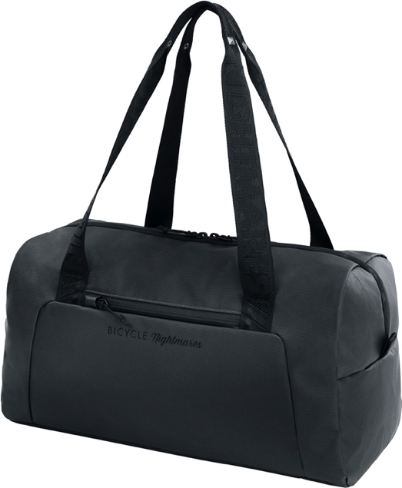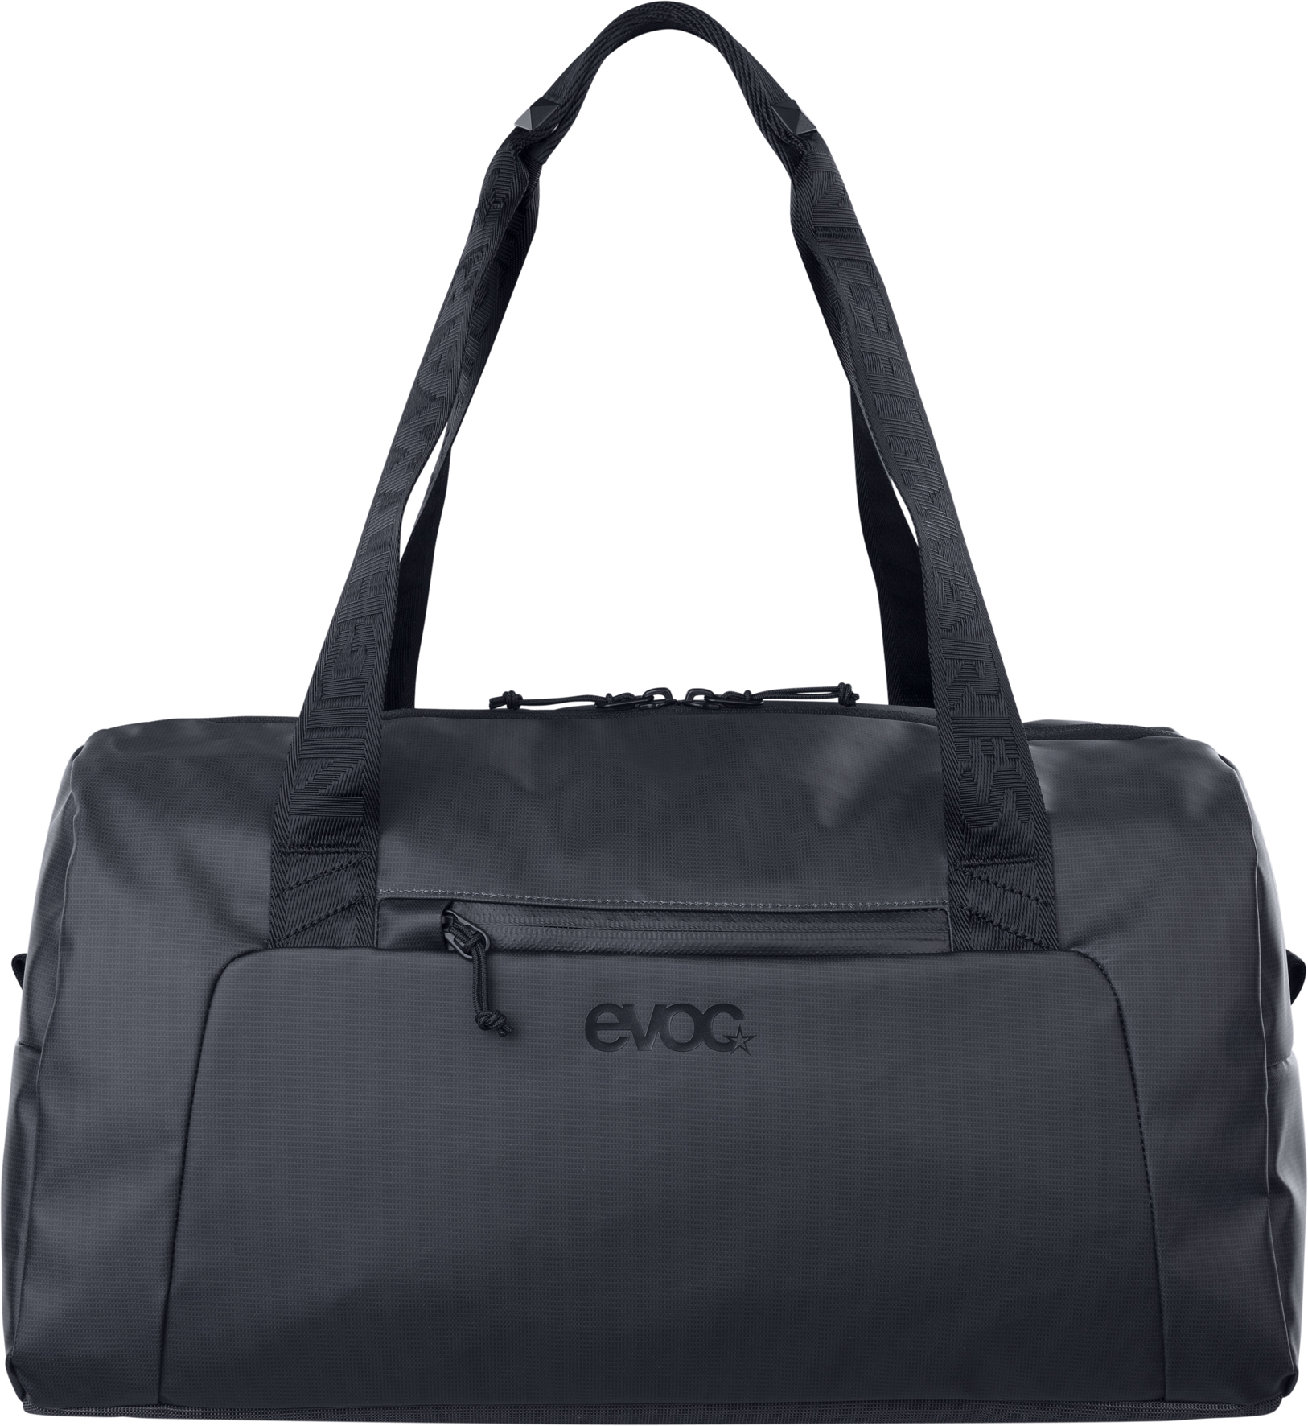

EVOC x Bicycle Nightmares Pop-Up-Store
Accompanying the launch of the limited edition collection, a pop-up store will be opening its doors in the centre of Munich from 27.11. - 02.12. 2023 (10 am - 8 pm). The concept is breaking new ground, because aside from the classical retail experience, it lets you discover the two brands physically and makes the special approach of the cooperation graspable.
In the urban jungle of central Munich, we are creating a space for exchange between creative and interested people inside and outside the scene. It is also intended as a kind of “sanctuary“ for creative recovery and inspiration - naturally for ISPO visitors, but also for anyone who might become curious passing by.
The mix between design/streetwear shop and photo exhibition creates a special shopping experience where the Bicycle Nightmare founder Hector Saura himself will be standing behind the counter. In case there are any questions regarding the products, there will also be EVOC

team members present, open for a chat about anything. The opening event on 27.11.2023 (from 5 pm) is for invited guests from the world of sports, fashion and media. EVOC and Bicycle Nightmares will be personally presenting products and photography in the form of a vernissage.

Downloadable image material at the EVOC Pressroom.

As at: 11/2023

Subject to change.

Media contact: EVOC Press l EVOC Sports GmbH | press@evocsports.com

