PRESS RELEASE 15/12/2021

Usquare.brussels: first conversion work starts
on iconic buildings
of former Fritz Toussaint barracks

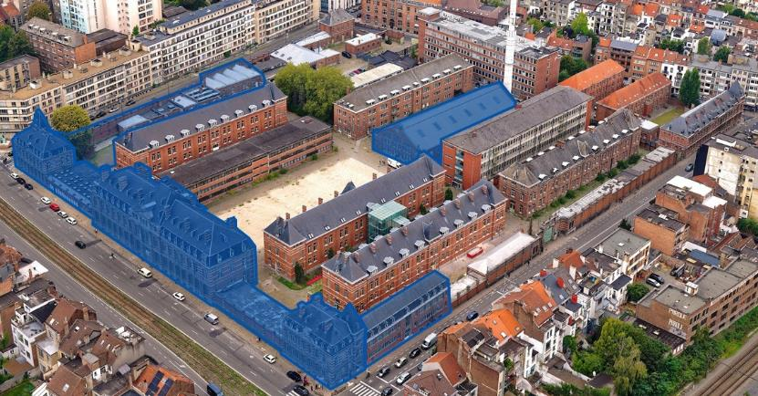
v
In blue, the buildings affected by this first work. © sau-msi.brussels (GlobalView)

The Brussels Minister-President Rudi Vervoort, the rectors of ULB and VUB, Annemie Schaus and Caroline Pauwels, and the director of the Urban Development Corporation (SAU), Gilles Delforge, have announced the start of the first work on Usquare.brussels, the transformation of the former Fritz Toussaint barracks in Ixelles into an open, mixed and multifunctional district. The work that has started consists of the conversion of seven iconic buildings of the former gendarmerie barracks. There will be a strong emphasis on the circular economy, with materials being reused on site, and on reducing carbon emissions, with the buildings ultimately being connected to a heating network using geothermal energy.

This first Usquare.brussels project, which will run in phases until the end of 2023, relates to seven iconic buildings on the site.
- The renovation of the complex of six buildings fronting onto Boulevard Général Jacques will create space for university facilities and accommodation for researchers. The resulting 9,000 m² university hub will be shared between ULB and VUB. It will include:
- the Brussels Institute for Advanced Studies, the first institute of its kind in Belgium, where international researchers will be able to stay;
- the Centre for Research in Urban Studies, Sustainability Sciences and Environmental Transformation;
- an International Reception Centre providing services to students, researchers and professors coming from or travelling to other countries.
- a unique Citizen and Participative Science space for participation and dialogue between the universities and the city.
The site’s owner, the Brussels Region, has granted the two universities a long lease on these six buildings.

- The seventh building on which work has started is the gendarmerie’s old riding school at the centre of the site. This structure is of significant historic value, and its façades will be restored. Ultimately, it will become a 1,600 m² sustainable food court.

A first iconic project to be followed by several others

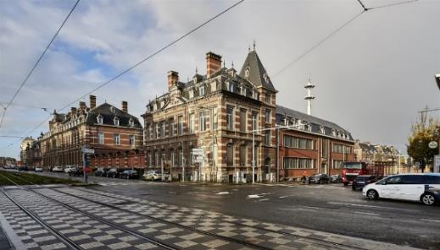
The present buildings at the corner of Boulevard Général Jacques and Avenue de la Couronne. © sau-msi.brussels (Reporters)

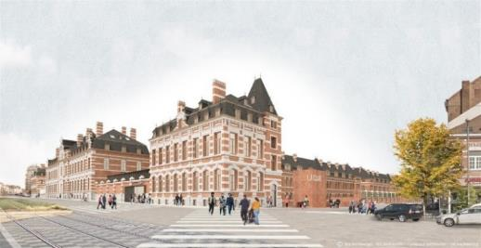
Simulation of the buildings at the corner of Boulevard Général Jacques and Avenue de la Couronne at the end of 2023, with the future new entrance to the Usquare.brussels site on Avenue de la Couronne. © evr architecten, BC Architects, Callebaut Architecten
The Minister-President of the Brussels-Capital Region, Rudi Vervoort, states: ‘I’m delighted at the launch of this first Usquare.brussels project, relating to the two sides facing outwards onto the city that are most visible to the general public and to the former riding school, which has welcomed thousands of visitors during the many events of the temporary occupation programme See U since 2019. The work on the future university side of Usquare.brussels and the future food hall, carried out with the support of the European Regional Development Fund (ERDF), will start the process of overhauling the old barracks and opening them up to the city. It will be followed, in particular, by the construction of family housing, which the regional government has decided will be all public. Within a few years, Usquare.brussels will have become an open, diverse and dynamic district that is urban and welcoming, university-centred and international, sustainable and innovative, and for which the Region and the universities have set ambitious objectives in terms of both showcasing the site’s architectural heritage and circular construction based on the reuse of materials. I would like to express my gratitude to ULB and VUB for their crucial involvement in this ambitious project for the Region.’

Annemie Schaus, the rector of ULB, sees the start of work as a milestone for this partnership: ‘The launch of this project underlines the importance of our collaboration with the Brussels Region and VUB, which was already of clear symbolic value. It embodies our common desire to contribute to the development of a site fully embedded in the urban fabric. The university activities that will take place in these buildings will focus on the city and its citizens, in addition to the links with the community created by our two Fablabs which are already active on the site.’

Caroline Pauwels, the rector of VUB, is delighted to see the Usquare.brussels project beginning to take shape with this first phase of renovation: ‘With the start of work on the buildings facing onto Boulevard Général Jacques, the people of Brussels will see the site gradually undergoing a physical transformation. This marks a new step in the opening up of the site, which we hope will help create links between local residents and our universities as the work progresses. We are also very happy to have new research premises specialising in urban themes and designed to welcome and bring together different publics.’

Gilles Delforge, director of the SAU, points out that ‘The launch of this first Usquare.brussels project, which will be completed at the end of 2023, will be followed by 2028 by a number of other stages in the site’s conversion: the redevelopment of the public spaces by the SAU; the construction of family housing by the SLRB-BGHM and citydev.brussels; and the creation of student accommodation for which the SAU has launched a public procurement process in consultation with ULB and VUB. The SAU, which is coordinating the site’s conversion operations, is also the project manager for several of them. After the renovation of the old riding school, it will oversee the process of getting the food court up and running. This will definitely be one of the flagship elements of Usquare.brussels and a very useful shared facility for residents of the neighbouring districts. Incidentally, the activities of the temporary occupation programme See U, which we initiated in consultation with the Region, the municipality and the universities, will continue until the summer of 2022. We are thinking about the best way of preserving the collaborative approach that See U has established with local residents in the area around the old barracks.’

Environmental ambitions: reuse of materials and geothermal energy

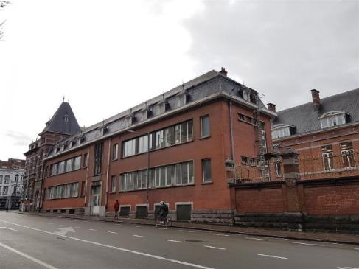
The present buildings at the start of Avenue de la Couronne. © sau-msi.brussels

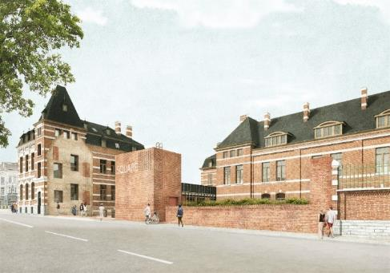
Simulation of the future new entrance to the Usquare.brussels site at the start of Avenue de la Couronne. © evr architecten, BC Architects, Callebaut Architecten
The architectural consortium consisting of evr architecten, BC Architects, Callebaut Architecten and VK Engineering, appointed in 2018 through the public procurement process to select the project designer for the first seven buildings, has developed plans tailored to the universities’ requirements, combining a contemporary approach and the showcasing of the architectural heritage. Rectors Annemie Schaus and Caroline Pauwels explain: ‘In terms of both the premises’ layout and access arrangements and the idiom employed to impart a new identity to these iconic buildings, the architectural plans proposed for this renovation project meet the universities’ wish to create ever closer links with the city.’

The rectors of ULB and VUB emphasise: ‘The universities are particularly happy to have had the opportunity to help develop new knowledge in the field of the circular economy and contribute to the study of renewable energy by setting up a partnership between their researchers and the engineering firms. This fruitful cooperation will ensure the achievement for this first operation of the ambitious objectives set by the Brussels Region and the universities for the entire Usquare.brussels site, thanks in particular to the recovery of bricks from the buildings which will be dismantled in order to create the structures of the new entrances and the grand monumental staircase which will replace the Avenue de la Couronne building, and the geothermal test drilling, which will ultimately make it possible to connect the converted buildings to a heating network supplied by renewable geothermal energy. This will reduce the carbon footprint of ULB’s and VUB’s activities on the Usquare.brussels site.’

ULB, VUB and the SAU have awarded the public procurement contract for the conversion of the first seven Usquare.brussels buildings to the contractor BPC – Bâtiment et Ponts Construction.

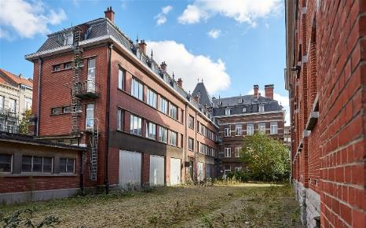 | 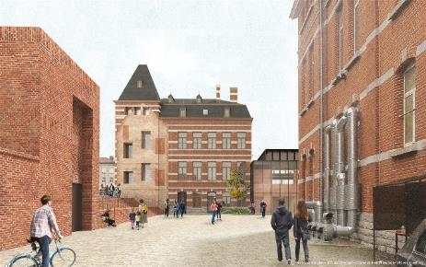
The present buildings at the corner of Boulevard Général Jacques and Avenue de la Couronne, seen from inside the Usquare.brussels site.  © sau-msi.brussels (Reporters) | Simulation of the buildings at the corner of Boulevard Général Jacques and Avenue de la Couronne, seen from inside the site, at the end of 2023, with the new entrance to the Usquare.brussels site on Avenue de la Couronne. © evr architecten, BC Architects, Callebaut Architecten

University, regional, federal and European funding

The conversion of the first seven buildings on the site by the universities and the SAU is being made possible by a large European subsidy, supplemented by additional budgets provided by the two universities and by the Brussels-Capital Region. The European Regional Development Fund (ERDF) is contributing 1,391,398.10 euros for the conversion of the Riding School and 9,033,200 euros for the conversion of the buildings on Boulevard Général Jacques. The ERDF is supporting this project on the basis of its environmental ambitions, as it will lead to the creation of a research centre specialising in sustainable development issues, a sustainable development visitor centre linked to the research centre, an Institute of Advanced Studies specialising in sustainable development, the Brussels Institute for Advanced Studies (BIAS) and a sustainable food court.

BELIRIS has contributed 137,000 euros to the removal of asbestos from the buildings.

In addition, the focus on the reuse of construction materials and on new circular economy practices in this project gained it a be.exemplary subsidy in 2019 (325,000 euros for special studies and work).

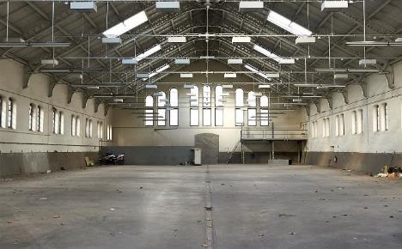 | 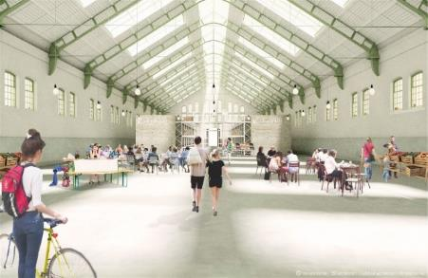
The interior of the riding school (Building M).  © sau-msi.brussels (Reporters) | Simulation of the interior of the riding school (Building M) at the end of 2023. © evr architecten, BC Architects, Callebaut Architecten

Usquare.brussels: transforming the former Fritz Toussaint barracks
into an open, multifunctional district

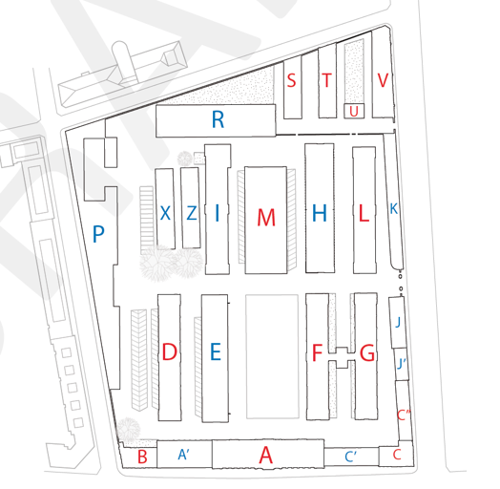

The 3.85-hectare site of the former Fritz Toussaint barracks in Ixelles, which has 22 buildings with a total floor space of 56,500 m², belongs to the Brussels-Capital Region, which purchased it from the federal state in early 2018. It was originally a residential school where gendarmes were trained. The site is part of a series of barracks built at the start of the 20th century on what are known as the ‘military boulevards’. Following police reforms and the disappearance of the gendarmerie, the buildings were occupied by the federal police, which has gradually vacated them.
The Brussels Regional Government has tasked the Urban Development Corporation (SAU) with overseeing the conversion of the former barracks, in close collaboration with the universities ULB and VUB. The project has been given the name Usquare.brussels.
The university communities of ULB and VUB will be the beneficiaries of several key phases of the work: the facilities constructed in the first phase of the work (Buildings A, A’, B, C, C’ and C’’) as well as those in Buildings F, G and L. In consultation with ULB and VUB, the SAU has also launched a public procurement process for the creation of accommodation for a mixed public of resident students and students on exchange programmes. Together, these projects represent a total floor space of ​​40,000 m².
The SAU is the regional public body responsible for carrying out major urban development projects in Brussels. For Usquare.brussels, it is coordinating all conversion operations; it initiated and financed the temporary occupation programme See U; it is supporting the universities in the development of student accommodation; it is in charge of the energy networks; it is the project manager for the redevelopment of the public spaces; and it is responsible for the development of shared facilities, including the food court (Building M), and local shops.
As the Region has decided that all family housing in Usquare.brussels will be public, the plans for the site also include operations relating to social and government-regulated housing that the SLRB-BGHM and citydev.brussels will build on Rue Juliette Wytsman and Rue Fritz Toussaint.

For more information: www.usquare.brussels

Media contacts:

Nancy NGOMA | Rudi Vervoort’s French-language spokesperson
+32 477 75 65 82 | nngoma@gov.brussels

Zeynep BALCI | Rudi Vervoort’s Dutch-language spokesperson
+32 498 81 65 14 | zbalci@gov.brussels

Valérie BOMBAERTS | Communication ULB
+32 2 650 25 34 | presse@ulb.be

Sicco WITTERMANS | spokesperson for Vrije Universiteit Brussel
+32 473 96 41 37 | sicco.wittermans@vub.be

Pascal SAC | Head of Communication and Regional Marketing sau-msi.brussels
+32 477 252 285 | p.sac@sau-msi.brussels

Geneviève PLANCHARD | Communication ERDF Directorate (Brussels International)
+32 491/86.58.02 | gplanchard@sprb.brussels

