Next-generation in-car audio
Sennheiser and Continental present immersive soundscapes during exclusive event

Wedemark, 1 September 2020 – Audio specialist Sennheiser and technology company Continental will present their next-generation solutions for premium in-car audio at an exclusive event at the Sennheiser Store in Berlin on 3 September. Participants will be able to enjoy an incredibly immersive in-car entertainment experience, created by the combination of Sennheiser’s AMBEO Mobility technology with Continental’s Ac2ated Sound system. The in-car sound system on show includes several new elements that are considered the next break-through since the Sennheiser and Continental system was first presented at this year’s CES.

The Sennheiser and Continental in-car sound system now allows for full audio individualization for each seat. The driver needs to make a call, while their passenger wants to keep listening to an audio book? No problem at all: From crystal-clear call quality to personalized content playback, AMBEO Mobility enables a wealth of new sonic possibilities, while reducing listening fatigue. A key element in creating these personalized listening zones are the specially designed headrests with integrated high-fidelity transducers. By adding this personal near-field playback source close to the driver’s and passengers’ ears, the listening experience is augmented considerably.

To create fully enveloping sonic experiences, the AMBEO Mobility software analyzes and distils the fundamental components of any native stereo music track and plays them back immersively through the appropriate loudspeaker or actuator. Thanks to the integration of Continental’s further developed Ac2ated Sound system, this concert-hall experience can be delivered with minimum hardware, allowing the vehicle to be lighter and offering more flexible design possibilities.

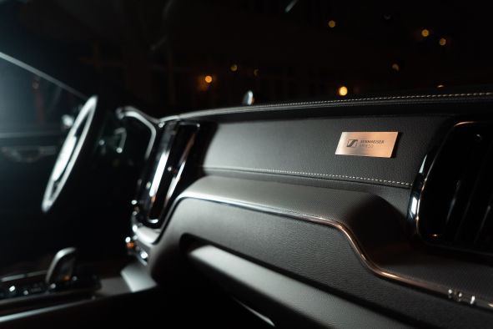 | AMBEO Mobility analyzes music and plays it back immersively, creating an incredible as-if-there feeling

The software also includes a new feature to enhance and enrich the bass response: AMBEO Mobility reproduces low frequencies with optimum power and punch while effectively limiting noise bleed to the outside of the vehicle.

All AMBEO Mobility features can be selected and combined as desired, ensuring tailor-made audio systems for any car audio concept.

About Continental Ac2ated Sound
Continental’s Ac2ated Sound system abandons conventional loudspeaker technology, exciting selected surfaces in the vehicle interior to produce sound. In comparison to conventional audio systems, Ac2ated Sound enables a reduction of weight and space of up to 90 percent. In this way, the system not only produces highest audio quality but is also perfectly suited for electric vehicles, where saving space and weight is a priority.

About Sennheiser AMBEO Mobility
With AMBEO Mobility, Sennheiser brings 75 years of audio excellence and its unique audio software portfolio to everyday driving. The AMBEO Mobility software delivers the ultimate in audio capture and reproduction to transform the way that people experience content in the car. As a scalable and adaptive system, AMBEO Mobility supports the evolution of transportation needs and shapes the future of in-car listening by providing an enveloping concert hall experience, personalized to the listener’s taste and needs.

The images accompanying this press release can be downloaded here: https://sennheiser-brandzone.com/c/181/MacevTfy.

About Sennheiser
Founded in 1945, Sennheiser is celebrating its 75th anniversary this year. Shaping the future of audio and creating unique sound experiences for customers – this aim unites Sennheiser employees and partners worldwide. The independent family company, which is managed in the third generation by Dr. Andreas Sennheiser and Daniel Sennheiser, is today one of the world’s leading manufacturers of headphones, loudspeakers, microphones and wireless transmission systems. In 2019, the Sennheiser Group generated turnover totaling €756.7 million. www.sennheiser.com

Global Press Contacts

Jacqueline Gusmag Stephanie Schmidt
jacqueline.gusmag@sennheiser.com stephanie.schmidt@sennheiser.com
T +49 (05130) 600 – 1540 +49 (5130) 600 – 1275

Participation in the exclusive showcase
We still have a limited number of slots available for media. If you are interested in next-generation car audio, please register here to reserve your exclusive listening slot on 3 September. We value your safety and will hold the event in full compliance with Covid-19 regulations.

