For immediate distribution

Sweetwater Studios to Host Recording Master Class
Featuring Billy Cobham, Fareed Haque, Tim Landers and Scott Tibbs
Immersive classroom experience between September 6 and September 8 to be led
by Sweetwater Studios producer/engineer Mark Hornsby
August xx, 2018, Fort Wayne, IN - Sweetwater Studios, the multi room, world-class recording facility owned by music retailer Sweetwater Sound, will host a three-day, hands-on recording master class next month, featuring accomplished musicians Billy Cobham, Fareed Haque, Tim Landers, and Scott Tibbs. The class will be held between September 6 and September 8 and led by Sweetwater Studios' Senior Producer / Engineer Mark Hornsby.
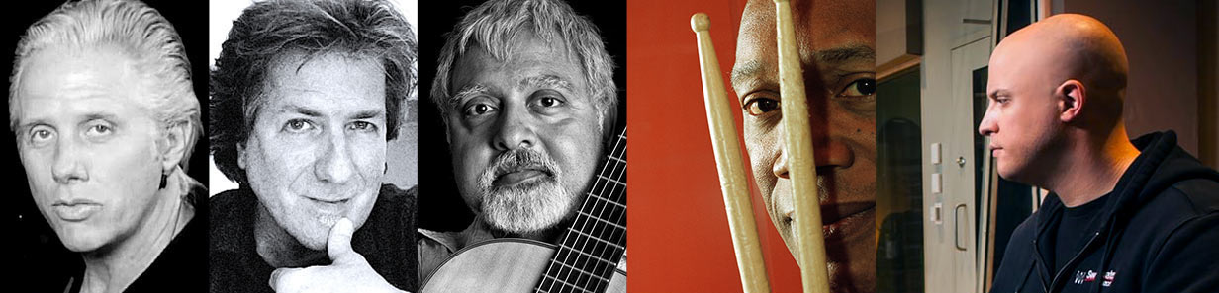
The comprehensive agenda for the in-person sessions to be held in Studio A will focus on three primary elements: Learning Pro Recording Techniques, Recording Overdubs and Editing Tracks and Mixing Tracks. Hornsby, himself veteran producer and engineer who has worked with a variety of diverse artists including Garth Brooks, Alison Krauss, Robben Ford, Godsmack and many others, will usher students through the entire process — from setting up a session, all the way through to making final tweaks in the mix.
- Who: Sweetwater Studios and Senior Producer / Engineer Mark Hornsby
- What: Recording Master Class with Billy Cobham, Fareed Haque, Tim Landers, and Scott Tibbs
- Where: Sweetwater Studios, 5501 US Highway 30 West, Fort Wayne, IN
- When: Thursday, September 6 to Saturday, September 8 between 9:00 a.m. and 6:00 p.m.
“We are very excited to host another installment of our Recording Master Classes here at Sweetwater Studios. These classes are excellent opportunity for our attendees to learn professional techniques from start to finish in our world-class studio space,” Hornsby said. “Being able to do so with the generous help of our guest artists is not only exciting, but it also adds a ‘real world’ element to the experience since these guys are working on a real album.”
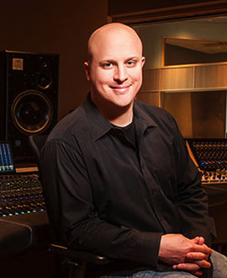
Sweetwater Studios: brimming with talent
During the three-day session, students will be able to work alongside a consummate cast of talented musicians, including drumming virtuoso Billy Cobham — whose passionate and exploratory drumming has appeared alongside many of the jazz greats including Miles Davis, John McLaughlin, and Jan Hammer.
Cobham has also appeared on celebrated pop and rock recordings by artists like Peter Gabriel, Quincy Jones, and James Brown.
Guitarist Fareed Haque, voted “Best World Guitarist” by Guitar Player Magazine in 2009, has developed a singular instrumental voice informed by classical and jazz guitar traditions and has created a diverse body of work that revels in a variety of ethnic melodic styles.
Bassist Tim Landers, a Berklee veteran who has played and recorded with the likes of Al Di Meola, Mike Stern, and Bill Frisell, has made a name for himself as one of LA’s top session bassists. His expert bass playing has appeared on recordings by artists as diverse as Tori Amos, Tracy Chapman, Al Stewart, and Beyoncé.
Finally, on keyboards is Scott Tibbs a multi-talented composer whose music has touched every corner of the current media landscape from appearances in films and commercials to recording by well-known artists such as Bruce Springsteen, Mary J. Blige, and Lil Wayne.
Registration is just $1,195 per person and includes:
- Three full days of learning sessions in Sweetwater Studios, including lunches
- Dinner with Mark, Billy, Fareed, Tim, and Scott
- Lodging for three nights
- Certificate of completion
To register, please email studio@sweetwater.com or call (800) 386-6434. To learn more, please visit http://www.sweetwaterstudios.com/mc-billy-cobham-09-06-18/.

About Sweetwater Studios
Sweetwater Studios is a wholly owned subsidiary of Sweetwater Sound, Inc., the largest online music instrument retailer in the country. With three world-class studios designed by Russ Berger and access to a greater diversity of musical equipment and professional audio gear than any other recording studio in the world, Sweetwater Studios is able to accommodate just about any recording, mixing or mastering project, no matter how simple or complex. With renowned staff producer Mark Hornsby at the helm, who has worked on many Grammy-award winning albums, Sweetwater Studios also has an exceptional staff of producers, engineers, session musicians and studio technicians. For more information on Sweetwater Studios, please visit http://www.sweetwaterstudios.com.

Media contacts
Jeff Touzeau
Public Relations
Hummingbird Media
+1 (914) 602 2913
jeff@hummingbirdmedia.com

Steve Bailey
Public Relations
Hummingbird Media
+1 (508) 596 9321
steve@hummingbirdmedia.com

