Neumann celebrates 2024 Music Producers Guild Award winners
Real World Studios wins a prestigious ‘Studio of the Year’ accolade, sponsored by Neumann, at the MPG Awards ceremony held at the Troxy in London

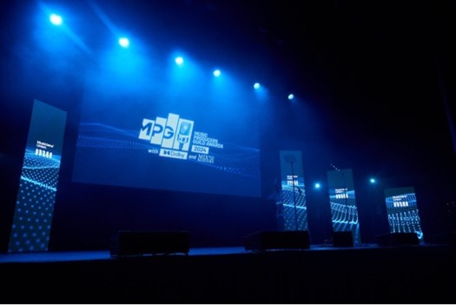
Photographer credit: David Bird
Marlow, May 10, 2024 – Now in their 16th year and celebrating the best talent working behind the scenes in the British music industry, the Music Producers Guild Awards (MPG Awards) are one of the most prestigious awards in music production. This year’s awards received a record number of open submissions from the general public, with MPG members voting to shortlist their peers in each of the 14 award categories. For the second consecutive year, Georg Neumann GmbH has sponsored the Studio of the Year category at the MPG Awards, underlining the company’s longstanding commitment to supporting the recording community and recognising excellence in studio production. This year’s awards were all the more special as Neumann’s new CEO, Yasmine Riechers, had the honour of presenting the award to the winning entry, Real World Studios, on the night.
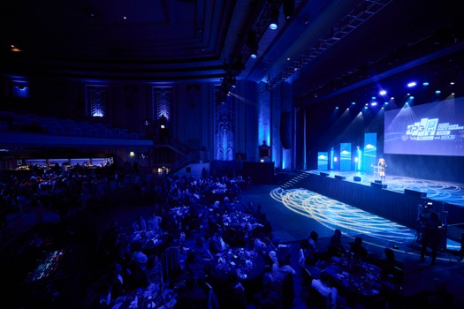
The Music Producers Guild Awards (MPG Awards) are one of the most prestigious awards in British music production Photographer credit: David Bird
“We are delighted to continue our partnership with the Music Producers Guild,” says Yasmine Riechers, CEO of Georg Neumann GmbH. “The MPG Awards celebrate the very best in British music production, and we are proud to play a role in recognising the outstanding achievements of these talented professionals. Our product portfolio helps producers and engineers in all steps of the sonic chain, whether it's microphones, monitoring or recording, so it feels like a natural collaboration.”
The MPG Awards recognises the talent and dedication of producers, engineers, mixers, and mastering engineers across a wide range of genres. As last year, the 2024 awards trophy is modelled after the iconic Neumann M 49 microphone chassis. “The M 49 microphone has been a cornerstone of studio recording for decades and is an inseparable part of the Neumann DNA, so it is only fitting that the awards used its chassis as its centrepiece,” says Riechers.
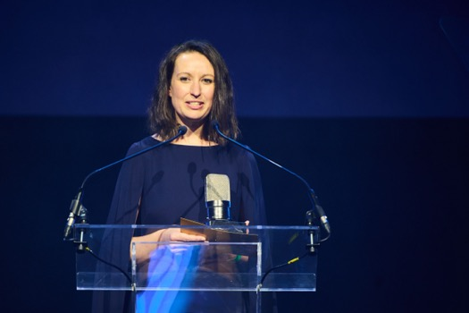
Yasmine Riechers, CEO of Georg Neumann GmbH, presented the Studio of the Year award at the 2024 MPG Awards Photographer credit: David Bird
The Studio of the Year Award is a coveted prize, acknowledging the outstanding achievements of recording studios that consistently deliver exceptional results.
Real World Studios is a renowned recording facility located in Bath, England. Founded by musician Peter Gabriel in the late 1980s, the studio was built with the intention of becoming a creative and collaborative space for artists from around the world to come together and make music.
The studios’ versatile recording, mixing and immersive spaces are some of the best sounding and most acclaimed in the world. They house an array of the finest audio equipment, which is operated by a dedicated team of recording, mixing and mastering engineers.
Over the years, Real World Studios has hosted numerous musicians and bands, including the likes of Tom Jones, Beyoncé, Harry Styles, and The 1975. “The studios’ dedication to cutting-edge technology, acoustics, and global music influence has solidified its reputation as a premier recording facility as well as being the home to world music festival WOMAD and Real World Records,” says Tim Oliver, Senior Consulting Engineer at Real World Studios.

Real World Studios wins the Studio of the Year award at this year’s MPG Awards Photographer credit: David Bird
The studio features a high-end roster of Neumann microphones, including the U 47 FET, M 49, KM 85, and the KU100 dummy head binaural stereo microphone. Additionally, the coveted U 47 and the iconic Neumann U 67, used by countless professionals in the recording industry, including the iconic bands such as The Beatles, Led Zeppelin, and Pink Floyd, are also part of studio’s microphone collection.
“Real World Studios has a substantial collection of vintage and modern audio equipment, and we’re immensely proud of the pristine condition in which it’s kept by our in-house technician,” says Katie May, Head Engineer at Real World Studios. “As well as each studio’s resident gear, a supplementary collection, including an incredible array of Neumann and Sennheiser microphones moves between rooms.”

The Studio of the Year award, won this year by Real World Studios, is a coveted prize, acknowledging the outstanding achievements of recording studios that consistently deliver exceptional results Photographer credit: Scott Garfitt
Speaking about what it means for the team to win the Studio of the Year award, the team is unequivocal in its praise: “From Claire managing the house to Lisa taking bookings, from Bob L in the workshop to the engineering team running riot, from Jerome in the kitchen to Rachel looking after the accounts, from Nat making the site look beautiful, to Gordan keeping the building in tip-top condition, running the studio is a massive team effort. To win this award as a team is something really special, so thank you!” says Oliver.
MPG Executive Director, Cameron Craig, remarks, “Following an exceptional sell-out show last year, this year's MPG Awards marked our largest and most impressive event to date. With the MPG Awards firmly established as a highlight of the awards calendar, we were thrilled to honour the most outstanding talents across all facets of music industry. We also extend our gratitude to our partners for their contributions in solidifying the MPG Award's reputation as the foremost event in music production.”
“Neumann's involvement with the MPG Awards further highlights the company's continuous support of the professional audio community,” concludes Riechers. “With a rich heritage of innovation and a dedication to quality, Neumann remains as the preferred brand for leading producers and engineers around the world.”

About Neumann
Georg Neumann GmbH, known as “Neumann.Berlin”, is one of the world’s leading manufacturers of studio-grade audio equipment and the creator of recording microphone legends such as the U 47, M 49, U 67, and U 87. Founded in 1928, the company has been recognized with numerous international awards for its technological innovations. Since 2010, Neumann.Berlin has expanded its expertise in electro-acoustic transducer design to also include the studio monitor market, building upon the legacy of the legendary loudspeaker innovator Klein + Hummel. The first Neumann studio headphones were introduced in 2019, and since 2022, the company has increased its focus on reference solutions for live audio. With the introduction of the first audio interface MT 48, and its revolutionary converter technology, Neumann now offers all the necessary technologies needed to capture and deliver sound at the highest level. Georg Neumann GmbH has been part of the Sennheiser Group since 1991 and is represented worldwide by the Sennheiser network of subsidiaries and long-standing trading partners. www.neumann.com
Stay up to date and follow us on: FACEBOOK I INSTAGRAM I YOUTUBE

Local Press Contact:
Maik Robbe
Maik.Robbe@sennheiser.com
+49 (0) 5130 / 600 1028

Press Contact Neumann:
Raphael Tschernuth
raphael.tschernuth@neumann.com
+49 (030) 417724-67

