embargo until NOVEMBER 17, 2021, 06:01 CENTRAL EUROPEAN TIME

BluOS Unleashes the Immersive Power of Dolby Atmos to the Bluesound PULSE SOUNDBAR+ and Further Expands Music Service Integrations
  - BluOS 3.16 brings an unforgettable 3D sound experience to your movies, music, games and shows.
toronto, canada, NOVEMBER 17, 2021 – BluOS™, the premium multi-room music management platform by Lenbrook International, has announced a few enhancements that will come with the release of version 3.16. Ahead of the US Black Friday holiday, users will be prompted to update their BluOS players, at which time, Bluesound customers will gain access to the immersive power of Dolby Atmos for the PULSE SOUNDBAR+ and BluOS-Enabled products will further expand their commercially-licensed music service integrations with the addition of Tunify.

AN IMMERSIVE DOLBY ATMOS EXPERIENCE
The unique BluOS implementation of Dolby Atmos in the PULSE SOUNDBAR+ features four virtualization profiles - Movie, Music, Late Night and Off - giving listeners more choice in how they enjoy an immersive home theater experience. While Dolby Atmos decoded content provides the most realistic Dolby Atmos experience, any content can be virtualized to provide users a wider, higher, and more enveloping soundstage. Great care has been taken to assure the timbre of the audio remains natural anywhere in the listening environment.

BluOS 3.16 delivers immersive Dolby Atmos experience to the Bluesound PULSE SOUNDBAR+
“The BluOS 3.16 firmware brings multiple immersive experiences to the Bluesound PULSE SOUNDBAR+ allowing every possible listening experience to be improved, says Andrew Haines, BluOS Product Manager. “For example, you can use the music or movie profile to create a completely new experience while listening to music in ways you have never heard before. With Dolby Atmos, every sound is positioned around you, creating a three-dimensional space that places you in the recording studio or in the middle of the action, bringing you closer to the artists and characters you love.”

Tunify music Service
BluOS 3.16 further expands the integrated music services available within the BluOS ecosystem with the addition of Tunify. Tunify specializes in providing commercially-licensed music to business users. Tunify allows professional business users to choose music to match the type of atmosphere and/or mood they are trying to achieve. With ease of use and several different service options, Tunify provides professional business owners an easy way to have more control over their business’s atmosphere and customer experience.

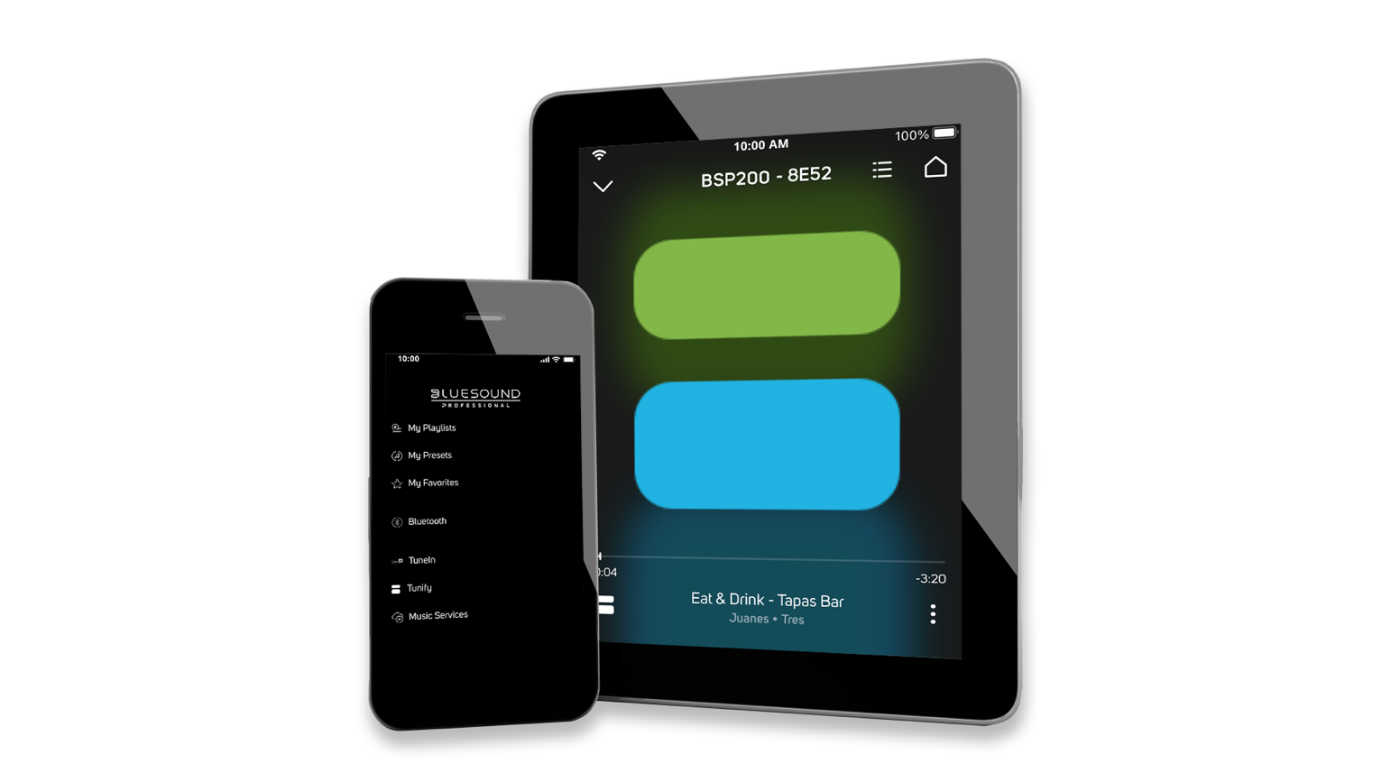
Screenshots of Tunify in BluOS 3.16 environments

About bluOS
BluOS™ is a premium multi-room audio ecosystem that manages stored and cloud music sources and playback, with support for high-resolution audio streams up to 24-bit/192kHz. Adopted by some of the most renowned HiFi audio brands and integrated with numerous smarthome and voice control systems, BluOS allows for interoperability among enabled devices across brands for maximum versatility and use cases. Integrations with popular streaming music services like Tidal, Spotify, and Deezer, as well as featuring support for FLAC, WAV, MQA, and other high-resolution formats and codecs, BluOS offers virtually unlimited access to music of all genres for any occasion. Made up of an operating system and a control application for smart phones, tablets, and PC desktops, BluOS is the ultimate choice for the modern audiophile.

Links
BluOS: https://bluos.net
Lenbrook: https://lenbrook.com
Images: https://bluos.webdamdb.com/bp/#/folder/10287654/

# # #

