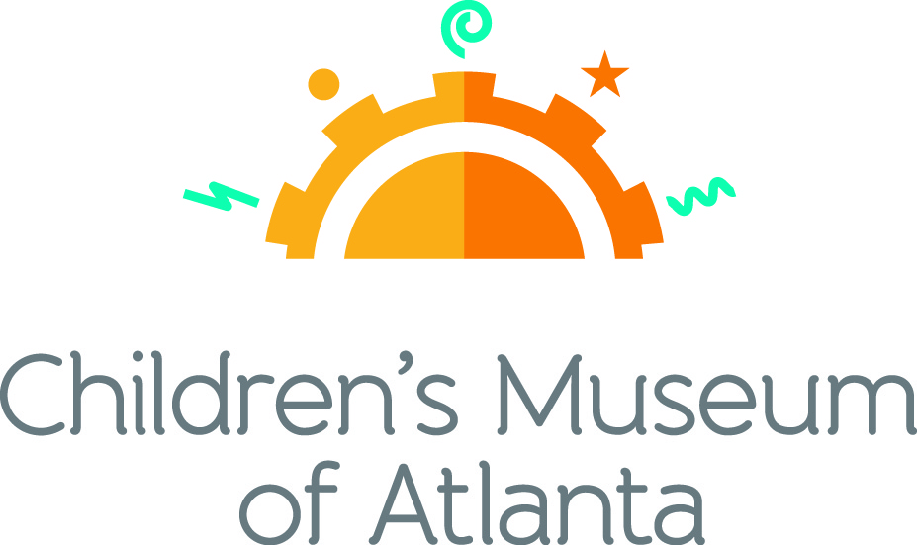

FOR MORE INFORMATION:
Becca Meyer/Jennifer Walker
BRAVE Public Relations, 404.233.3993
bmeyer@bravepublicrelations.com/
jwalker@bravepublicrelations.com

FOR IMMEDIATE RELEASE

Fun is abloom with Children’s Museum of Atlanta’s April programming
Innovative activities and special programming round out year-round offerings at Atlanta’s premier children’s attraction

ATLANTA (March 9, 2017) – Avoid the April showers with a fun-filled visit to Children’s Museum of Atlanta! Families will have a chance to explore various forms of transportation in the “From Here to There” exhibit, play egg-citing Easter games, sing and dance to the Passover song Dayenu, craft an Earth-saving superhero mask and more – all while learning through the power of play!

Feature Exhibit: “From Here to There”
Now through May 29, 2017
How are objects transported across land, sea and air? Families are invited to find out during Children’s Museum of Atlanta’s newest feature exhibit “From Here to There,” parked in Atlanta now through May 29! Developed by the Sciencenter in New York, this traveling educational exhibit showcases 12 interactive stations and teaches children about gravity, friction, the laws of motions and more physics-filled fun.

Themed daily programming during “From Here to There” exhibit will occur through May 29, 2017. Programming subject to change and may be altered during special events. All programs included with admission unless otherwise noted.

Mini-Musical: Let’s Go!
Weekdays at 11 a.m. and 12 p.m.; Saturday at 11 a.m. and 3 p.m.; Sunday at 11 a.m. and 1 p.m.
Written by Marc Farley
Children will join professors Zip and Dash on an exploration of how people get from here to there. By way of cars, bikes and even boats, the professors will teach young visitors about the science behind different methods of transportation.

Story Time
Weekdays at 1 p.m.; Saturday at 12 p.m.; Sunday at 2 p.m.
- “Motion: Push and Pull, Fast and Slow” by Darlene R. Stille
This interactive story time will explore the concepts of motion by teaching children about movement, speed, force and inertia in an easy-to-learn way!
- “Rosie Revere Engineer” by Andrea Beaty
Where some people see rubbish, Rosie Revere sees inspiration. This special story time will follow shy Rosie, as she creates great inventions –like hot dog dispensers, helium pants and python-repelling cheese hats– from odds and ends.

- “There’s No Place Like Space: All About Our Solar System (Cat in the Hat’s Learning Library)” by Tish Rabe
A reading adventure that’s out of this world! Astronomers are launched on a wild trip to visit the eight planets in the solar system, along with Cat in the Hat, Thing One, Thing Two, Dick and Sally.

Music & Movement
Weekdays and Saturday at 2 p.m.; Sunday at 3 p.m.
Children can join the Imaginators for a highly energetic music and movement, where they will pretend to be a human jetliner and “fly” around the stage, interpret how planets would dance (if they had legs!) and take a trip through time, while acting out ways people get from here to there.

Super Spectacular Science Show
Weekdays at 3 p.m. and weekends at 4 p.m.
Professor Lab Coat and his assistants will lead a mesmerizing science demonstration put on for the entire Museum.
Eat A Georgia Rainbow
Sunday at 12 p.m.
Children will embark on a scavenger hunt and cold cooking activity with the Imaginators to learn more about fruits and veggies harvested in Georgia throughout the year.
Art Studio Projects
Weekdays 10:30 a.m. –3:30 p.m.; Weekends 11 a.m. –4 p.m.
Little ones can discover colors and explore artists from around the world through various crafts like making and decorating a hot air balloon, a floating boat or designing a toy parachute.
Build It Lab
Weekdays, 10:30 a.m. –3:30 p.m.; Weekends 11 a.m. –4 p.m.
Children will put their woodworking and creative tools to the test in this supervised space where they have access to real tools and materials. Encouraging inventions, this Build It Lab will spark creativity by allowing young innovators to design and construct a sling shot car.
Science Bar
Weekdays 10:30 a.m. –2:30 p.m.; Weekends 11 a.m. –3:30 p.m.
Science is everywhere, especially on the mezzanine at the Museum! Step Up to Science is the new STEM exhibit area and features interactive exhibits about light, robotics and how the human body works! Families can saddle up to the science bar for a full menu of fun activities, knowledge and have their questions turned into answers by one of the STEM educators.
April Special Programming

Meet the Holidays: Passover
Saturday April 8 and Sunday April 9
Little ones will learn about Passover, the major Jewish spring festival that commemorates the liberation of the Israelites from Egyptian slavery.
- 12 p.m. and 2 p.m. Saturday; 2 p.m. Sunday: Special Story Time
“My First Passover” by Tomie dePaola celebrates and explains Passover to children as they learn about the history and traditions surrounding this special holiday.
- 3 p.m. Saturday and Sunday: Special Music and Movement
Grab an instrument and join the Imaginators as they teach children the Passover song Dayenu (דַּיֵּנוּ "It Would Have Been Enough") and learn why this song is significant to those who celebrate Passover.
- 11 a.m. – 4:30 p.m. Saturday and Sunday: Art Studio
In this creative workshop, children will learn the story of Passover while using different liquids to replicate their own Red Sea in a bottle.
- 11 a.m. – 4:30 p.m. Saturday and Sunday: Build It Lab
Inspired by the one Miriam played when her brother Moses parted the Red Sea and led the Jewish people out of Egypt, children will make their own tambourine to play in celebration of Passover!

The Science Wondershop with Brian “Dr. Science” Williams
Sunday, April 9 and Sunday, April 16 at 1:30 p.m. and 2:30 p.m.
Families can join Dr. Science for an interactive parent and child science workshop designed to encourage imagination, curiosity and an interest in the world. Due to limited availability, families are encouraged to arrive early to secure a spot.

Meet the Holidays: Easter
Saturday, April 15 and Sunday, April 16
Children can learn about Easter, the Christian holiday that celebrates the resurrection of Jesus from the dead, new life and rebirth.
- 11 a.m. Saturday and Sunday: Bunny Hop Relay Race
Families will hippity hop on over to the Children’s Museum of Atlanta stage for a special Easter Egg relay with an egg-tastic twist!
- 1 p.m. Saturday and Sunday: Spoon and Egg Race
The annual Spoon and Egg race is back! Children will test their balancing skills during this family-favorite event where everyone is a winner.
- Special Story Time:
  - 12 p.m. and 2 p.m. Saturday:
Pete the Cat is off to another groovy adventure – this time with the Easter Bunny! Find out if he can help the Easter Bunny save the big day before Easter is over in James Dean’s “Pete the Cat: Big Easter Adventure.”
  - 2 p.m. Sunday:
Little ones will help the famous feathered friends find the Easter Bunny during this fun, interactive story time featuring “Duck & Goose, Here Comes the Easter Bunny!” by Tad Hills.
- 3 p.m. Saturday and Sunday: Special Music & Movement
Let the celebration begin! Families can join the Imaginators for egg-ceptional Easter games and dancing that will put a spring in kids’ step. To wrap up the fun, kids can show off their smooth moves as they learn classic dances such as the “Electric Slide,” “Bunny Hop” and more!
- 11 a.m. – 4:30 p.m. Saturday and Sunday: Art Studio
Didn’t you hear? Bonnets are all the craze this season! Kids can craft their own bonnet and be the most fashionable participants in the Easter parade.
- 11 a.m. – 4:30 p.m. Saturday and Sunday: Build It Lab
In the spirit of the Easter celebration, children will have the chance to make a Bunny Basket out of paper plates and decorations and fill with candy for a sibling, parent, or special friend.

Meet the Holidays: Earth Day
Saturday, April 22
Children will learn the importance of Earth Day and how they can do their part to raise awareness around environmental issues and protections.
- 12 p.m. and 2 p.m.: Special Story Time
Children will learn how trees all over the world help clean the air, enrich the soil and provide fruit and shade during this special story time with “We Planted a Tree” by Diane Muldrow, illustrations by Bob Staake.
- 3 p.m.: Special Music & Movement
Families can celebrate with a Bee-utiful music and movement program while learning why bees are an important part of the Earth!
- 11 a.m. – 4:30 p.m.: Art Studio
Up, up and away! Children can decorate superhero masks and learn about ways they can help save the planet – even small steps can make a HUGE impact!
- 11 a.m. – 4:30 p.m.: Build It Lab
Create something beneficial for the whole family! Kids can make their own indoor planter utilizing various materials. Even after the building process is complete, families can enjoy the planters for weeks to come at home with seeds provided by the Museum.

Autism Awareness Month
In honor of Autism Awareness month, the Museum will offer Sensory Friendly Saturdays throughout the month. Beginning at 9 a.m. each Saturday, the Museum will provide a sensory-friendly experience for families with children on the autism spectrum or with sensory issues. Admission is $5 for non-members and free for members. Space is limited so booking in advance is advised. To reserve your child’s spot, please call 404.527.3693 or visit childrensmuseumatlanta.org.

For more information on the April program offerings or to support Children's Museum of Atlanta, visit childrensmuseumatlanta.org or call 404.659.KIDS [5437].

About Children’s Museum of Atlanta:
Children’s Museum of Atlanta is the only educational venue of its kind in Atlanta, presenting educational programs and exhibits designed for young children ages 0-8. The Museum’s mission is to spark imagination and inspire discovery and learning for all children through the power of play. With six permanent learning zones consisting of bright, creative and hands-on exhibits, the Museum supports inventive play-based exploration and experiential learning focused on the whole child. Core competencies for literacy, math and science are promoted throughout all exhibits and programming in alignment with the state and national Core Performance Standards. The Children’s Museum of Atlanta also offers parties, memberships, field trips, summer camp and private events. For more information or to support Children's Museum of Atlanta, visit childrensmuseumatlanta.org or call 404.659.KIDS [5437].

Museum Admission: General Admission is $14.95 (plus tax) for anyone 1 – 100 years old. Babies and members are admitted for free. All daily programs are included in price of admission. Group rates and military discounts are available. For more information regarding ticket and membership options, visit childrensmuseumatlanta.org/plan-your-visit/faqs/.

Museum Hours: Monday, Tuesday, Thursday and Friday 10:00 a.m. – 4:00 p.m.; Saturday and Sunday 10:00 a.m. – 5:00 p.m.; Closed on Wednesdays. Please check the Museum website to confirm hours of operation.

Facebook: https://www.facebook.com/childrensmuseumatlanta
Twitter: https://twitter.com/ChildMuseumATL
Instagram: https://www.instagram.com/childrensmuseumatlanta
Pinterest: http://pinterest.com/cmatlanta
###

