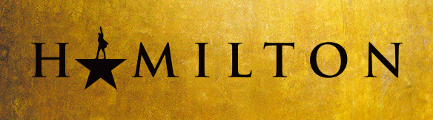

PUBLIC ON SALE SUNDAY, APRIL 8

PERFORMANCES MAY 22 – JUNE 10, 2018
AT THE FOX THEATRE

Fifth Third Bank Broadway in Atlanta announce today that single tickets for HAMILTON will go on-sale to the public on Sunday, April 8 at 10 a.m. ET at www.foxtheatre.org. Tickets will be available for performances May 22 – June 10, 2018.

There is a maximum purchase limit of four (4) tickets per account for the engagement. When tickets go on sale, prices will range from $80 to $330 with a select number of $550 premium seats available for all performances. There will be a lottery for forty (40) $10 Orchestra seats for all performances. Details will be announced closer to the engagement.

Jeffrey Seller notes, “It's tempting to get tickets any way you can. There are many sites and people who are selling overpriced, and in some cases, fraudulent tickets. For the best seats, the best prices and to eliminate the risk of counterfeit tickets, all purchases for the Atlanta engagement should be made through www.foxtheatre.org.”

HAMILTON is the story of America's Founding Father Alexander Hamilton, an immigrant from the West Indies who became George Washington's right-hand man during the Revolutionary War and was the new nation’s first Treasury Secretary. Featuring a score that blends hip-hop, jazz, blues, rap, R&B, and Broadway, HAMILTON is the story of America then, as told by America now.

With book, music and lyrics by Lin-Manuel Miranda, direction by Thomas Kail, choreography by Andy Blankenbuehler and musical supervision and orchestrations by Alex Lacamoire, HAMILTON is based on Ron Chernow’s biography of Founding Father Alexander Hamilton.

The HAMILTON creative team previously collaborated on the 2008 Tony Award ® Winning Best Musical
In the Heights.

HAMILTON features scenic design by David Korins, costume design by Paul Tazewell, lighting design by Howell Binkley, sound design by Nevin Steinberg, hair and wig design by Charles G. LaPointe, and casting by Telsey + Company, Bethany Knox, CSA.

The musical is produced by Jeffrey Seller, Sander Jacobs, Jill Furman and The Public Theater.

The HAMILTON Original Broadway Cast Recording is available everywhere nationwide. The HAMILTON recording received a 2016 Grammy for Best Musical Theatre Album.

For information on HAMILTON, visit:
- HamiltonMusical.com
- Facebook.com/HamiltonMusical
- Instagram.com/HamiltonMusical
- Twitter.com/HamiltonMusical

# # #

