SENNHEISER HONORED BY IF FOR 50 YEARS OF DESIGN EXCELLENCE

Wedemark, November 15, 2019 – “The company continuously sets the trends in the audio industry”: this is how iF International Forum Design congratulated Sennheiser when celebrating a remarkable new milestone – 50 years of iF DESIGN AWARDS. The audio specialist was presented with a certificate to mark a glittering run of 63 awards for excellence in design achieved between 1969 and the present day. Announcing the milestone, iF commented that “wherever people passionately record, broadcast or play sounds, Sennheiser is there.”

The iF DESIGN AWARD is one of the largest and most highly respected design competitions in the world. To win a coveted iF label for outstanding design achievement, products must stand out against thousands of submissions from around the globe.

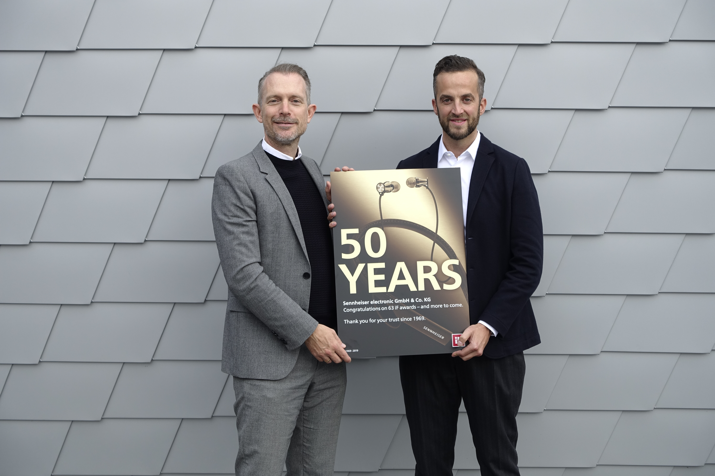 | Frank Zierenberg (left), Project Director for iF, presents Oliver Berger (right), Global Head of Brand and Design Management for Sennheiser, with the certificate for 50 years of iF DESIGN AWARDS

Frank Zierenberg, Project Director for iF, presented the certificate to Oliver Berger, Global Head of Brand and Design Management for Sennheiser at the company’s Wedemark headquarters. Commenting on the award, Oliver Berger said:

“Fifty years ago, we won the first iF award for excellent design with our HD414 - which became iconic, not least because of its yellow ear cushions. And that was just the beginning. We are truly honored by the initiative by iF to present us with a certificate for 50 years of design excellence and celebrate this history. Renowned design awards such as the iF label not only confirm to us that we are developing products that capture the zeitgeist, but also provide a seal of quality for our customers. Design, in the sense of a holistic, customer-oriented creation of high-quality products and services, will always be at the heart of our mission at Sennheiser.”

Since its foundation in 1945 by electrical engineer Prof. Dr. Fritz Sennheiser, the company has continued to set new benchmarks and trends for the audio industry. Sennheiser received its first award in 1969 for the innovative HD 414 - the world's first open headphones. Most recently, Sennheiser received an iF label for the MOMENTUM In-Ear Wireless in 2018, a product that elegantly balances form and function to combine luxurious design with outstanding audio performance.

About the iF DESIGN AWARD
Over a 66-year history, the iF DESIGN AWARD, organized by Germany’s oldest independent design organization, the Hannover-based iF International Forum Design GmbH, has been known as an arbiter of quality for exceptional design. The iF brand is internationally established as a symbol for outstanding design achievements. The iF DESIGN AWARD is one of the most important design awards in the world. It rewards design achievements in all disciplines: product, packaging, communication and service design/UX, architecture and interior design as well as professional concept.

About Sennheiser
Shaping the future of audio and creating unique sound experiences for customers – this aim unites Sennheiser employees and partners worldwide. Founded in 1945, Sennheiser is one of the world’s leading manufacturers of headphones, loudspeakers, microphones and wireless transmission systems. Since 2013, Sennheiser has been managed by Daniel Sennheiser and Dr. Andreas Sennheiser, the third generation of the family to run the company. In 2018, the Sennheiser Group generated turnover totaling €710.7 million. www.sennheiser.com

Press Contact

Sennheiser electronic GmbH & Co. KG
Anne Warnecke
PR Manager Projects
T +49 (0)5130 600-1635
anne.warnecke@sennheiser.com

