Hear it to believe it
Sennheiser’s AMBEO Soundbar will be available from May

Wedemark/Las Vegas, January 7, 2019 – Immersive 5.1.4 sound and deep bass that has to be heard to be believed: Sennheiser’s new AMBEO Soundbar will be available from May. Created by the audio specialist to be one of the world’s best soundbars, the AMBEO Soundbar places the listener inside the sound experience with incredible realism, delivering 3D sound that blurs the line between playback and reality from a single all-in-one device. Visitors to CES (January 8-11) can experience the AMBEO Soundbar at the Sennheiser booth (South Hall 1, booth no. 20200).

Sennheiser’s soundbar has been developed under the audio specialist’s AMBEO trademark. The AMBEO 3D audio technology program is dedicated to creating immersive audio solutions that deliver the ultimate in audio capture and reproduction to transform the way users experience content. Bringing this transformation to the living room, the AMBEO Soundbar is another milestone in the program. “We are thrilled to be introducing the AMBEO Soundbar as Sennheiser’s first foray into the home entertainment speaker category. We have developed it with the ambition to create one of the best soundbars on the market – an elegant all-in-one solution for all those seeking an immersive 3D, audiophile-grade home entertainment experience,” said Stephane Hareau, Global Head of Products – Consumer at Sennheiser.
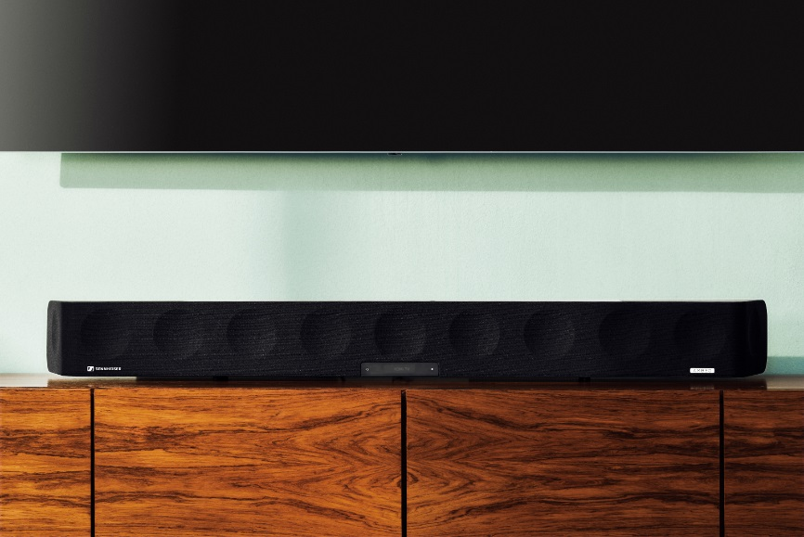

The AMBEO Soundbar delivers 3D sound that blurs the line between playback and reality from a single all-in-one device.

Beneath its lacquered and brushed aluminum surface, the AMBEO Soundbar is powered by 13 drivers and the latest virtualization technology which was jointly developed with Fraunhofer IIS. “We believe that the AMBEO Soundbar will set a new reference in sound quality,” added Maximilian Voigt, Product Manager at Sennheiser. “It delivers the spatial ‘as if there’ experience of a 5.1.4 sound system and powerful bass, but without the need for additional speakers or an external subwoofer.”

Perfectly tailored to each room
Whether watching a movie, listening to music or enjoying a football match – to truly place the listener in the center of the entertainment experience, the AMBEO Soundbar optimizes the sound for the individual room and preferred seating position.
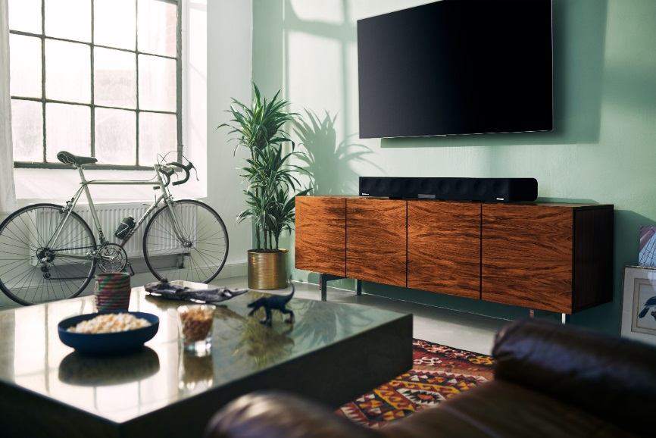

Via room calibration, the AMBEO Soundbar optimizes the sound for the individual room and preferred seating position.

This room calibration is utterly intuitive for the user as calibration with the included external microphone automatically adapts and optimizes the acoustics to fit the individual environment.

A thrillingly immersive home entertainment experience
The AMBEO Soundbar is compatible with Dolby Atmos, MPEG-H and DTS:X. Thanks to its Upmix Technology, it can also recreate stereo and 5.1 content in stunning 3D. The soundbar features five different presets (movie, music, sports, news and neutral) tailored to a range of scenarios and content types that precisely adjust not only the frequencies but also the 3D sound characteristics.

Smart and connected
Sennheiser’s AMBEO Soundbar features advanced connectivity via-built in Google Chromecast, Bluetooth and HDMI eARC/CEC. Connectivity options also include three further HDMI inputs, an optical audio port, and an AUX (RCA) input.

The audio specialist has designed every interaction with the soundbar to be effortless and intuitive. This principle is epitomized by Sennheiser’s Smart Control App for iOS and Android, which allows users to adjust acoustic settings via smart devices, including setting presets, personalizing the sound with the equalizer and selecting from three different AMBEO modes (light, standard and boost). Upcoming new features will be added to the soundbar via WiFi and app updates.

The AMBEO Soundbar will be available from May 2019 for 2,499 EUR (MSRP).

About Sennheiser
Shaping the future of audio and creating unique sound experiences for customers – this aim unites Sennheiser employees and partners worldwide. Founded in 1945, Sennheiser is one of the world’s leading manufacturers of headphones, microphones and wireless transmission systems. With 21 sales subsidiaries and long-established trading partners, the company is active in more than 50 countries and operates its own production facilities in Germany, Ireland, Romania and the USA. Since 2013, Sennheiser has been managed by Daniel Sennheiser and Dr. Andreas Sennheiser, the third generation of the family to run the company. In 2017, the Sennheiser Group generated turnover totaling €667.7 million. www.sennheiser.com

Global Press Contacts

Jacqueline Gusmag Stephanie Schmidt
Public Relations Manager Consumer Public Relations Manager Professional
T: +49 (0)5130 600-1540 T: +49 (0)5130 600-1275
jacqueline.gusmag@sennheiser.com stephanie.schmidt@sennheiser.com

