**Music Learning Software Melodics Offers Three Months Free on Annual Plan for Black Friday/Cyber Monday Sale**

*Give the gift of learning a new instrument to the music lover in your life this holiday and start 2024 with a new skill.*

**New Zealand, November 9, 2023 —** [**Melodics**](https://melodics.com/)**, creator of the world's leading music educational app, is excited to announce an exclusive Black Friday special for aspiring music creators and enthusiasts. From November 17th to November 30th, the Company will be offering three months free on an annual plan as part of its Black Friday / Cyber Monday sale.**

With the holiday season just around the corner, this presents the perfect opportunity to give the joy of learning music to your loved ones, a gift that extends well into the new year. This Black Friday, Melodics will be offering a special deal to make learning music more accessible to everyone. Whether you are a beginner or an advanced musician, Melodics provides a fun and interactive way to learn and improve skills on pads, keys, and drums. Melodics' app subscriptions are regularly priced $131.88 Billed annually (just $10.99 per month), and the Premium Annual Plan is $179.88 Billed annually, ($14.99 per month).

Known for its innovative approach to music education, Melodics combines cutting-edge technology with expertly designed lessons to help users learn music more effectively. The innovative music app, available in the iPad App Store and on the Melodics website, caters to both aspiring hobby instrument players. as well as those interested in learning keys or drums to go on to produce their own music. Melodics offers a wide range of lessons across different genres — including drums, keys, and more.

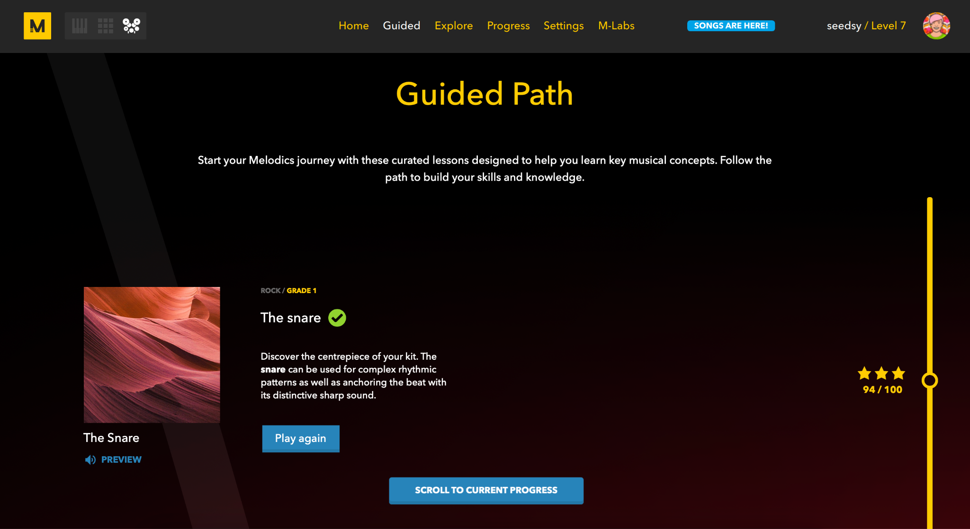

Melodics’ mission is to make learning fun and accessible for anyone, unleashing the inner musician in everyone. Melodics' unique gamified learning system ensures that users stay motivated and engaged throughout their musical journey. The Standard monthly plan features: unlimited play time, 1200+ lessons, 170+ courses, a complete guided path with advanced practice tools while the Premium Plan offers an additional 300+ song lessons.

By subscribing to Melodics, users gain unlimited access to hundreds of lessons, practice modes, as well as feedback and progress tracking tools to help them improve their skills at their own pace. Subscribing also unlocks advanced features such as playground mode, memory mode and the complete guided path, as well as regularly added content.



Take advantage of Melodics' Black Friday deals to unlock your musical potential and discover the joy of playing an instrument. Don't miss out on this limited-time opportunity to give the magic of music to yourself or others.

Visit the [Melodics website](https://melodics.com/) or download the app today to start your musical journey.

**About Melodics:**

Melodics is a music learning application for musicians and aspiring music creators. With a unique mix of application technology and human instinct, Melodics presents a revolutionary way to learn music, catering to beginners all the way to advanced musicians. With a user interface that combines a gamified way to learn alongside structured lessons, as well as song play-alongs that provide real-time feedback and progress tracking, Melodic makes learning music fun and accessible. Melodics is headquartered in Auckland, New Zealand.

**Press Contact**

Ashley Kinchen

Account Manager

ashley@hummingbirdmedia.com