

Biuro prasowe better. gaming agency
bettergamingagency.prowly.com

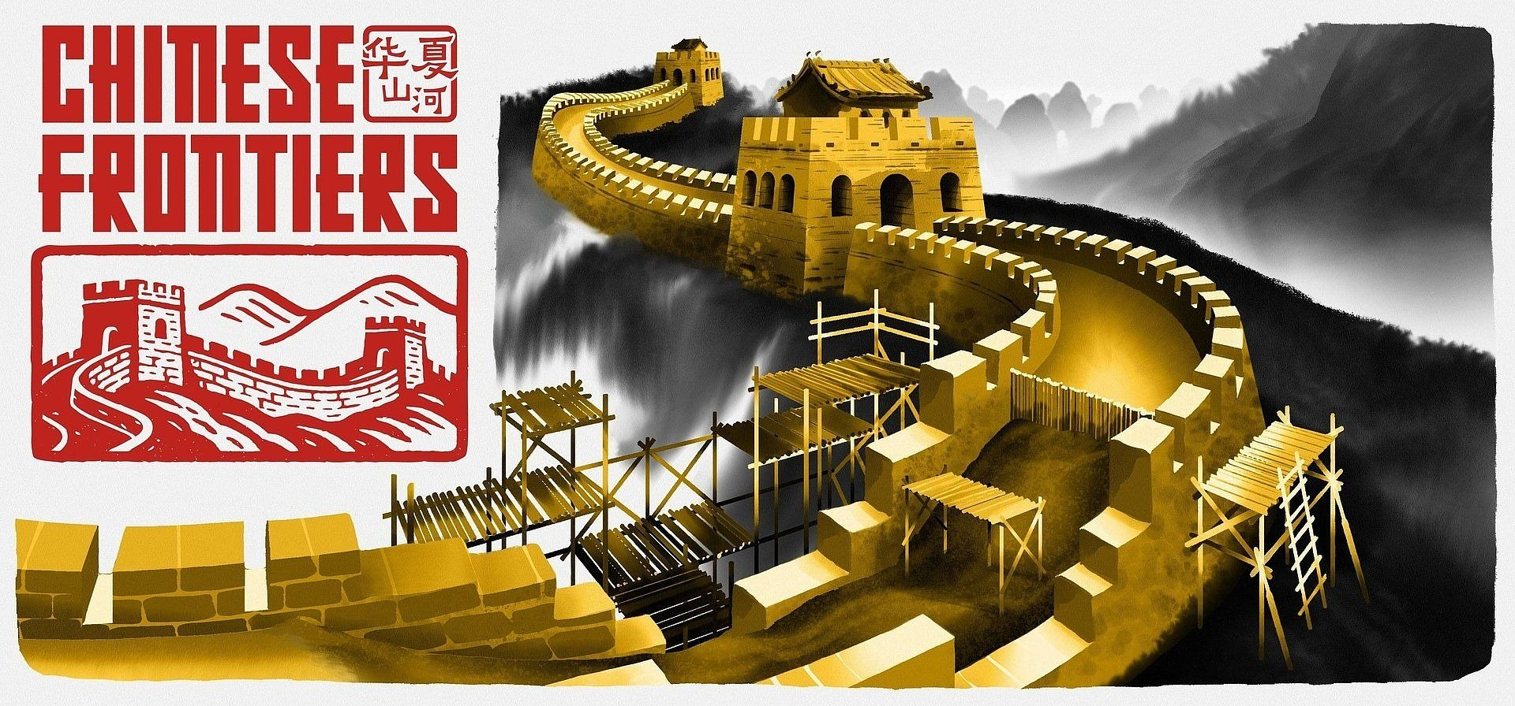

Let's get down to business – the Great Wall of China won’t build itself! Chinese Frontiers launches today!

Travel back to historical China and witness the rise of one of the world’s most legendary constructions. Chinese Frontiers is now available on Steam. Build and manage your settlement, gather resources, assign tasks, and develop production chains to turn a modest village into a major settlement shaping the future of the empire.

Life in a historical Chinese village was never boring, and grand tasks lie ahead of you. Cultivate the land, raise livestock, and gather rare ingredients to support your community. Prepare traditional Chinese dishes, decorate your settlement with handcrafted ornaments, and watch your village flourish into a thriving, vibrant town. But don’t forget your most important task – building sections of the Great Wall of China, including its most iconic structures such as the Jiayu Pass, the Jiumenkou Bridge, and the breathtaking Jiankou section. Become a legendary builder whose work earns the praise of the emperor himself.

Chinese Frontiers – launch trailer

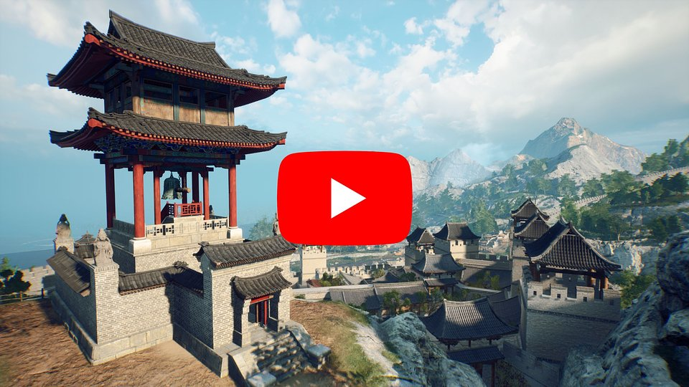
https://www.youtube.com/watch?v=05Q20tPimjg

You won’t have to carry all these responsibilities on your own. Some tasks can be handed off to other villagers, and effective management will significantly boost the speed and efficiency of your work. Your challenges will evolve as you travel through diverse biomes – majestic mountains, arid deserts, and peaceful river valleys. Each location offers unique resources, mechanics, and stunning landscapes.

On your epic quest to build one of the world’s most iconic structures, you’ll have the support of mentor Jun and his granddaughter Mei. They will introduce you to the fascinating world of Chinese legends and myths, guiding you step by step through the secrets of traditional crafts. As your bond with them grows stronger, they’ll share with you their stories buried long ago, believing that together you can create a better future for the entire community. Remember, life isn’t only about work!

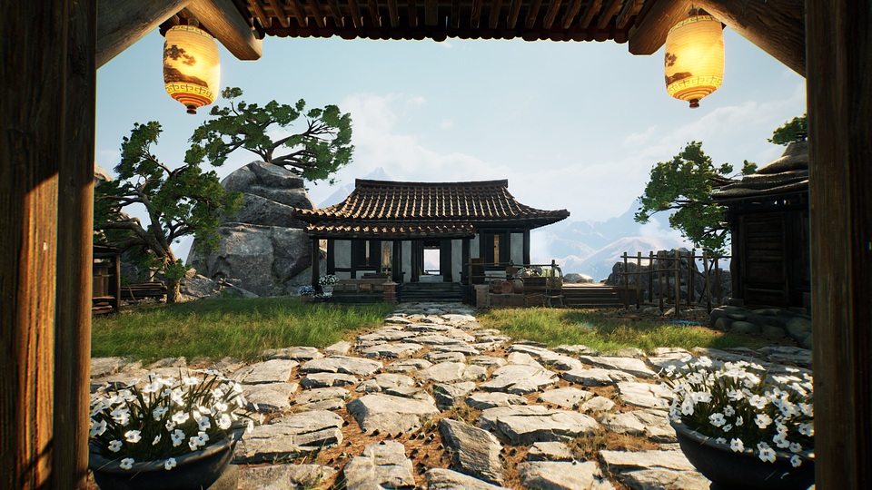

While playing, listen to the original soundtrack inspired by traditional Chinese folk music, composed exclusively for the game. The stories are brought to life with artistic cutscenes inspired by the traditional ink-wash painting style of the Middle Kingdom. For over four years, a team passionate about the culture and architecture of historical China worked on the game, supported by architects who carefully studied ancient construction techniques and building methods to faithfully recreate the era’s realities.

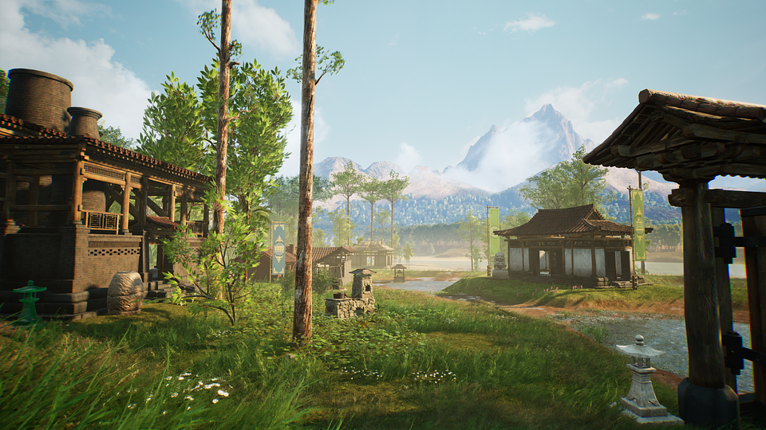

The foundations of Chinese Frontiers are built on the following features:

🔨 Step by step – in Chinese Frontiers, players will have the opportunity to build monumental structures, carefully completing each phase of construction, from the foundations to the final touches. This gives a true sense of involvement in creating something grand.

🔨 Success has many fathers – players will be responsible for coordinating the work of the village people, assigning tasks and optimizing processes to gather resources and build the necessary structures as efficiently as possible.

🔨 Three epic regions – build sections of the Great Wall of China, including its most iconic elements such as the Jiayu Pass, the Jiumenkou bridge, and the breathtaking Jiankou section. Explore three diverse areas – the rugged desert, majestic mountains, and mysterious river valleys. Each region presents new challenges, resources, and innovative construction technologies.

🔨 No routine – the gameplay offers a dynamic mix of building, crafting, farming, and exploration, allowing for seamless interaction between various aspects of village life. In Chinese Frontiers, there's always work to be done.

🔨 From the heart of China – Chinese Frontiers captures the spirit of traditional China, drawing inspiration from the architecture and construction techniques of that era.

🔨 Building one of the world's wonders - the opportunity to witness the process of building the Great Wall, uncovering not only its most iconic structures, but also the values of cooperation, sacrifice, and the wisdom of ancestors.

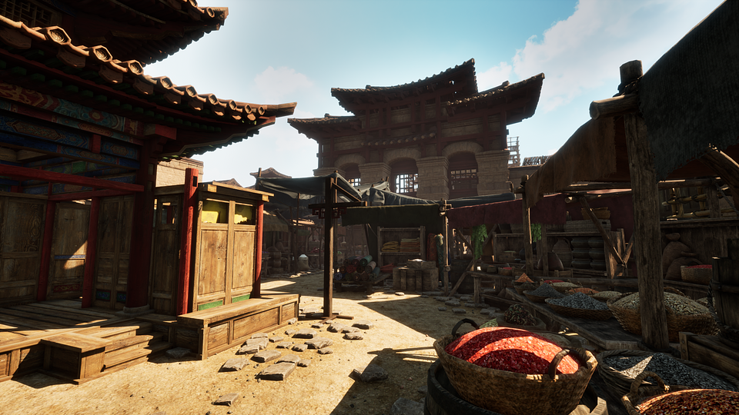

Chinese Frontiers is now available on Steam for 24.99 USD / 24.50 EUR, with a launch discount of 20% available during the release period. If you want to see if you have enough courage to take on the challenge of building the Great Wall of China, try the free demo. To learn more and stay up to date, follow the developers on social media and share your suggestions and feedback on the official Discord channel.

● Discord
● TikTok
● Instagram
● X
● YouTube

Full press kit is available HERE.

About SolidGames:

SolidGames is a rapidly growing independent studio based in Warsaw, Poland, that focuses on creating ambitious, immersive games. With a team of 25 skilled professionals, they have been working on their debut project, Chinese Frontiers, since February 2021. This title is a simulator that allows players to immerse themselves in a world inspired by historical China, where they will build the Great Wall of China and other iconic structures.

