Sonarworks Announces 60 New Headphone Profiles, Increased DAW Support with Reference 4 update
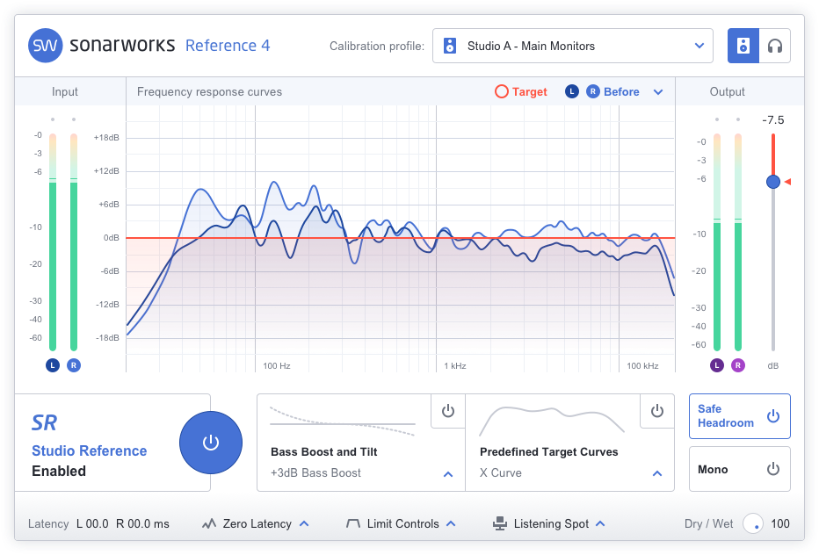
Reference 4.1.6 adds 32-bit support and headphone models by Audio Technica, Pioneer, Sennheiser and more
Riga, Latvia, October 31, 2018 – Sonarworks, the European company behind the Reference studio calibration software, announced a significant update to its best-in-class software. Key updates in in the 4.1.6 version include a 32-bit plugin in addition to the existing 64-bit one, enabling users with older DAW platforms to take advantage of Reference’s robust measurement and calibration capabilities. Additionally, users are now able to download the latest headphone profiles directly from the software itself, either through the DAW plug-in or in systemwide mode. Newly supported headphone models include offerings from AKG, Audio Technica, Beats, Behringer, Focal, Fostex, Meze, Pioneer, Sennheiser, and many more.

“We are on a constant mission to refine Reference and make it as easy to use as possible,” said Martins Popelis, Vice President and Co-Founder, Sonarworks. “A big part of this has been cultivating an active relationship with our user base and utilizing their feedback to improve Reference with each update.”

The award-winning Reference software utilizes patented technologies and advanced filtering algorithms to establish a common sonic reference point, enabling engineers, producers and musicians the ability to record, mix and master across multiple monitoring devices and environments.
In addition to standard feature upgrades, version 4.1.6 also fixes routine bugs including systemwide over-power consumption, installer malfunctions and other miscellaneous functionality refinements.

To get the latest software update, reactivate your software here or visit http://www.sonarworks.com/ to enjoy a free 21-day trial.

A list of all current supported headphone models can be found at https://www.sonarworks.com/reference/headphones.

About Sonarworks
Sonarworks is a Europe-based audio software development company specializing in acoustic calibration and DAW plugins. Accurate sound is our passion. The company was founded in 2013 and entered the pro audio market in 2015. Sonarworks software is relied upon by many Grammy winning artists and engineers around the world.

Media Contact:
Steve Bailey
Hummingbird Media
+1 (508) 596-9321
steve@hummingbirdmedia.com
Jeff Touzeau
Hummingbird Media
+1 (914) 602-2913
jeff@hummingbirdmedia.com

