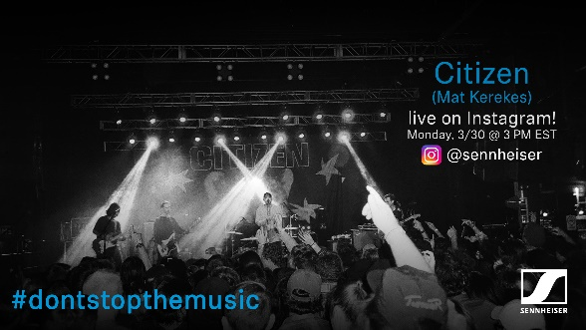

#DontStopTheMusic

Kick off this week in style!

Marlow/U.K., March 30, 2020 – Tune in to Sennheiser’s #DontStopTheMusic series to experience fantastic live performances! Broadcast live via IGTV, artists Citizen (Mat Kerekes), Bob Sinclar and Third Eye Blind will turn your home into a concert stage.

Live concert streams from Monday, March 30 to Tuesday, March 31
Please note that some countries changed to daylight saving time last weekend – make sure to follow @Sennheiser on Instagram and switch on notifications in IGTV to receive alerts: This is also helpful as dates and artists may be subject to change at short notice.

- Citizen – Mat Kerekes (@matkerekes):
Monday, March 30 at 19:00 UTC (15:00 New York time, 20:00 London time)
- Bob Sinclar (@bobsinclar):
Monday, March 30 at 12:00 UTC (8:00 New York time, 13:00 London time)
- Third Eye Blind (@thirdeyeblind):
Tuesday, March 31 at 20:00 UTC (16:00 New York time, 21:00 London time)

More music
Please also check out http://www.sennheiser.com/anniversary. for the next livestream dates. There’s also a great selection of music videos to watch and listen to, ranging from immersive jazz club recordings, to living room electro sets, to live takes from recording studios. Just put on your headphones (or turn up the speakers) and immerse yourself in the music!

It’s free but why not donate to fight the coronavirus?
At Sennheiser, we’re delighted to be working with these fantastic artists to help spread positivity by putting on exclusive concerts. They’re totally free, but if you do want to say thank you, do consider supporting the WHO in its fight against the coronavirus:
https://www.who.int/emergencies/diseases/novel-coronavirus-2019/donate

For your social media channels:
Enjoy your favorite artists at home and check out the exclusive concerts in Sennheiser’s (@Sennheiser) streaming concert series – live on Instagram! #DontStopTheMusic

About Sennheiser
Founded in 1945, Sennheiser is celebrating its 75th anniversary this year. Shaping the future of audio and creating unique sound experiences for customers – this aim unites Sennheiser employees and partners worldwide. The independent family company, which is managed in the third generation by Dr. Andreas Sennheiser and Daniel Sennheiser, is today one of the world’s leading manufacturers of headphones, loudspeakers, microphones and wireless transmission systems. In 2018, the Sennheiser Group generated turnover totaling €710.7 million. www.sennheiser.com

Press Contacts

Maik Robbe
maik.robbe@sennheiser.com
T +44 (0) 7393 462484

