Our History
Milestones of 75 Years Sennheiser

When Fritz Sennheiser founded the company in 1945, he started a venture that we call today a “start-up”. While the company didn’t start in a garage, the story very closely resembles the classic start-up tale, with the venture initially founded in a farmhouse near Hanover. Fritz Sennheiser soon discovered fast-growing business opportunities, using the knowledge and skills that he gained in his prior scientific career to respond to a high demand for measuring devices and microphones.
This was just the start of a story of innovation and the pursuit of new ideas. Today, the story continues: When you visit our headquarters for listening sessions, product consultation or for a factory tour, you can still feel the same passion and an unceasing drive for excellence and discovery.

1945 to 1982: Foundation of the company by Prof. Dr. Fritz Sennheiser
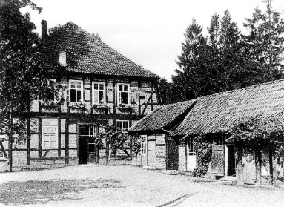
Fritz Sennheiser founded the Laboratorium Wennebostel (Lab W) in June 1945. At the time of its foundation, the young company produced measuring instruments and sold them to Siemens. The farmhouse where the company was founded is still part of our business premises. The company was renamed in 1958 to Sennheiser electronic and changed its legal form to Sennheiser electronic.
Sennheiser was founded in this farmhouse in the Wedemark.

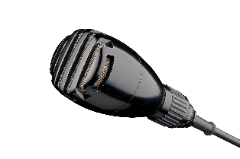
In 1945, Siemens commissioned the laboratory to rebuild a microphone from an Austrian supplier, which was launched in 1946 as the MD 1. In the same year, Sennheiser began developing its own microphone: The MD 2 expanded the company's portfolio from 1947.
The first microphone developed by Lab W, the MD 2.

The MD 82, the first shotgun microphone, was produced in 1956. At the beginning of the 1960s, Sennheiser commenced research and development in the field of condenser microphone technology, a technology that found further applications in recording audio for film sets and TV studios.

In 1957, Labor W introduced a wireless microphone system for professional TV use, developed in cooperation with NDR. The wireless microphone system was marketed together with Telefunken from 1958 as “Microport”.

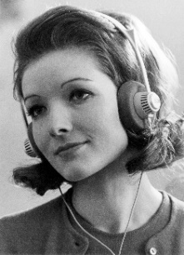
In 1960, Sennheiser introduced the MD 421 dynamic microphone, which is still produced and sold today.
The world's first open headphones, the HD 414.

In 1968, Sennheiser launched the HD 414, the world's first open-back headphones, which remain the bestselling full-size headphones of all time. Did you know that we still stock spares of the cables and iconic yellow ear pads?

1971: The MD 441 is introduced: the model has gone on to become
a microphone classic.

Sound became spatial in 1974: The MKE 2002 head-worn stereo microphone enables binaural audio recordings according to the dummy head principle.

At the end of the seventies, the first Microport multi-channel receiver and the development of a compander system contributed to a decisive improvement in wireless microphone technology.

1982 to 2012: Internationalization under Prof. Dr. Jörg Sennheiser
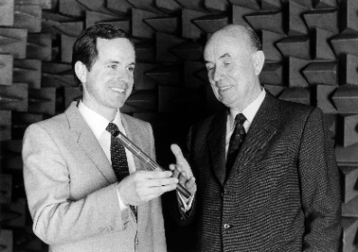
In 1982 Prof. Dr. Fritz Sennheiser handed over the management of the company to his son, Prof. Dr. Jörg Sennheiser.
Fritz Sennheiser hands over the management of the company to his son, Jörg Sennheiser.

1988 was the starting point for the internationalization of the family business: The first sales subsidiary, Sennheiser France, was founded. Over time, further subsidiaries were launched; Nowadays, we have 21 subsidiaries worldwide.

1988: The HD 25 headphones enter the market. Originally conceived as professional monitoring headphones, they were also used as high-class in-flight headphones on board Concorde, before going on to conquer DJ booths the world over. In 2013, we marked the 25th anniversary of the HD 25, revisiting and celebrating the history of these legendary headphones.

Sennheiser took over the Berlin studio microphone manufacturer Georg Neumann in 1991, integrating its microphone production into Sennheiser’s own factory in Wennebostel.

In 1991, the Orpheus electrostatic headphones entered the market. The limited-edition model was considered the best headphones in the world for decades. In 2015, Sennheiser presented the HE 1 as the successor to the legendary Orpheus.

1998: The evolution microphone series was launched, followed by the evolution wireless microphone series in 1999. Up to this very day, many of the world’s biggest stars are using our evolution microphones– a runaway success that we celebrated on reaching “20 years of evolution” in 2018.

In 2000, the MKH 800 was the first studio condenser microphone to cover the entire frequency range of the new digital audio formats with just one transducer system.

2005: Sennheiser acquired the speaker manufacturer, Klein + Hummel.

Daniel Sennheiser, grandson of the founder, joined the company in 2008. He was joined in 2010 by his brother Dr. Andreas Sennheiser. Both are shareholders of the company.
2009: Sennheiser presented the HD 800, a new high-end reference headphone.

The Digital 9000 radio microphone system was introduced in 2012. It is the only digital wireless UHF microphone system in the world that can work without data reduction.

The first model of the MOMENTUM headphone series was launched in 2012. Several wired and wireless products entered the market.

Since 2013: Dual leadership with Dr. Andreas Sennheiser and Daniel Sennheiser
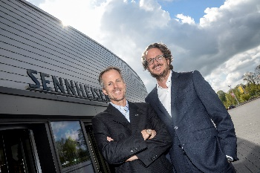
In 2013, Dr. Andreas and Daniel Sennheiser took on responsibility as managing directors for Sennheiser electronic GmbH & Co. KG. They manage the company as co-CEOs with equal rights in a dual leadership without division of responsibilities. From 1996, Prof. Dr. Jörg Sennheiser was the chair of Sennheiser’s supervisory board, a role he handed over in 2015.
Daniel and Dr. Andreas Sennheiser take over the company management (from right).

In 2014, Sennheiser founded the new subsidiary "Sennheiser Streaming Technology GmbH (SST)", which develops streaming solutions for software and hardware.

In 2016, the company presented its AMBEO 3D audio technology program, launching the AMBEO VR Mic in 2016. As the first AMBEO product for the consumer market, the AMBEO SMART HEADSET was announced in 2017. In 2019, the AMBEO Soundbar was launched, a product that enables a spatial sound experience in 5.1.4 format. Find out more about AMBEO here.

In 2017, Sennheiser introduced TeamConnect Ceiling, a ceiling microphone for conference rooms that automatically records the speakers in a room using dynamic beamforming technology.

The Digital 6000 wireless microphone series was launched in 2017.

2019: Sennheiser acquired a majority stake in Dear Reality, a company that specializes in spatial audio algorithms and VR/AR audio software.
About Sennheiser
Founded in 1945, Sennheiser is celebrating its 75th anniversary this year. Shaping the future of audio and creating unique sound experiences for customers – this aim unites Sennheiser employees and partners worldwide. The independent family company, which is managed in the third generation by Dr. Andreas Sennheiser and Daniel Sennheiser, is today one of the world’s leading manufacturers of headphones, loudspeakers, microphones and wireless transmission systems. In 2018, the Sennheiser Group generated turnover totaling €710.7 million. www.sennheiser.com
Global Press Contact

Mareike Oer
mareike.oer@sennheiser.com
T +49 5130 600 1719

Local Press Contacts

Sarah James Maik Robbe
sarahj@gasolinemedia.com maik.robbe@sennheiser.com
T +44 (0) 1483 223333 T +44 (0) 7393 462484

