Smartphone Cravings: Findings from our Global Mobile Value Index Survey
February 26, 2017

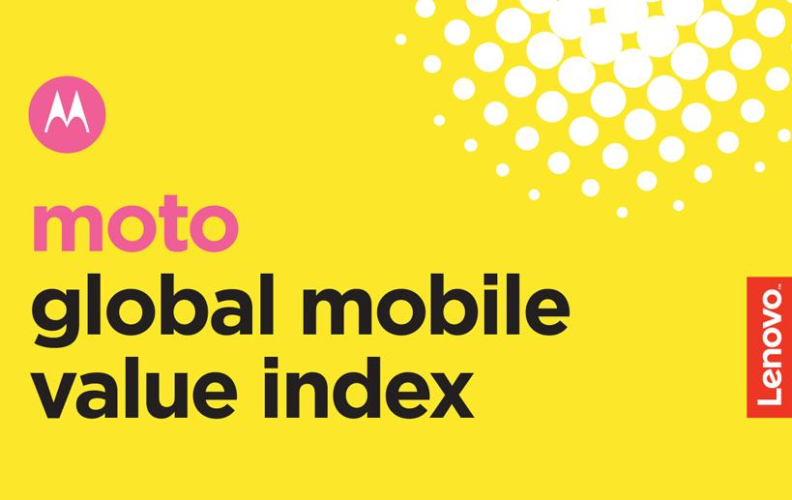

We know you want and expect a lot out of your smartphone, which is why we set out to learn exactly what that means. What are the most important features? What makes a device premium? Our global survey -- the Global Mobile Value Index -- gave us intel on the most desired smartphone features and what those features are worth to your wallet. In the process, we found phone quality has a significant impact on quality of life. What’s more -- over half of our survey respondents around the world say they didn’t know they needed the features available on their smartphones, but now they can’t live without them (we get it, that’s how we feel about Moto Experiences, too).¹

Nearly 12,000 adults from nine different countries later, when it comes to smartphone technology and the features you crave, we heard it all. Here’s what we uncovered:

(see infographic)

