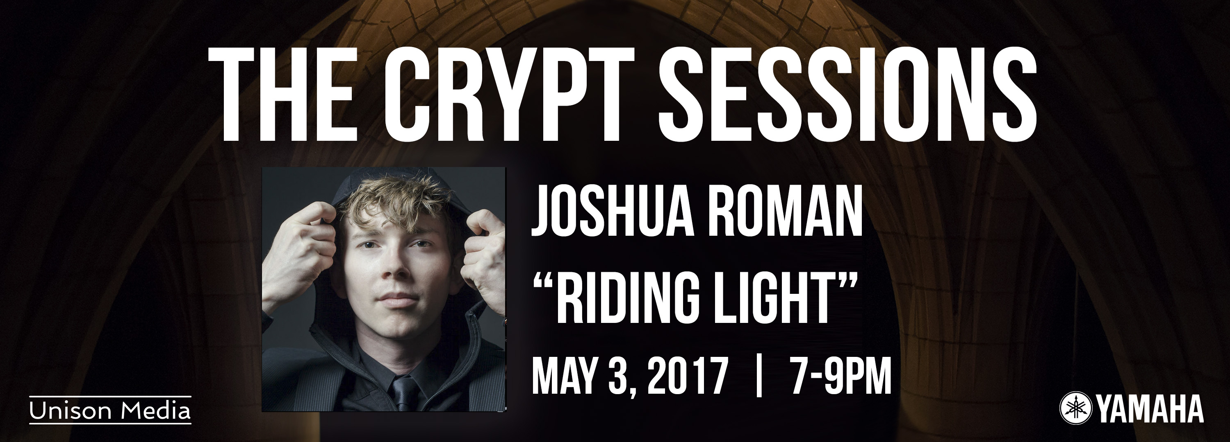

The Crypt Sessions presents cellist Joshua Roman, May 3 2017

Unison Media’s acclaimed concert series continues its second season on May 3, with American cellist Joshua Roman performing a solo recital program that begins in darkness and culminates in Roman’s own composition Riding Light
The performance will feature a pre-concert tasting of food and wine paired to the program, curated by Ward 8 Events and Magnvm Opvs
Thursday, April 6, 2017 — The Crypt Sessions Season 2 continues on May 3, 2017 with American cellist Joshua Roman performing a solo recital which begins in darkness with Bach’s spare, haunting Suite No. 2 in D Minor, before moving through sonatas by György Ligeti and George Crumb - both written during the period of lovestruck adolescence, with music that alternates between shaded meditation and stormy intensity - and finishing with a composition of his of his own, the transcendently radiant Riding Light.
Roman performed in the Crypt with Gregg Kallor in last season’s finale concert of The Tell-Tale Heart, and his playing was praised by Berkshire Fine Arts, saying: "Roman is a musician who can afford to expose his talent in long drawn out single tones..often miraculously drawn from his instrument."
Roman has earned an international reputation for his wide-ranging repertoire and his commitment to communicating the essence of music in visionary ways. As well as being a celebrated performer, he is recognized as an accomplished composer and curator, and was named a TED Senior Fellow in 2015 - his post-election Livestreamed performance of Bach on TED’s Facebook page was viewed by over 1.7 million people. Next season, he celebrates ten years as Artistic Director of the TownMusic series at Seattle’s Town Hall, while continuing to serve as Artistic Advisor to Seattle based new music radio station Second Inversion. Roman has recently premiered three new cello concertos written specifically for him, including Aaron Jay Kernis’ Dreamsongs, Mason Bates’ cello concerto, and his own cello concerto, Awakening.
The performance will feature a pre-concert reception included in the ticket price, where Magnvm Opvs hosts a tasting of wines specially chosen to suit the music of that evening's concert, and Ward 8 Events provides hors d'oeuvres similarly tailored to the wine and the performance.
Due to rapid sell-outs and waiting lists, each new concert will be announced immediately after the one preceding it, first to the mailing list, then via The Crypt Sessions website (http://deathofclassical.com/) and Facebook page.
The Crypt Sessions is made possible by the extraordinarily generous sponsorship of Yamaha, who provide their wonderful pianos for the performances.

Listing Info
The Crypt Sessions Presents: Joshua Roman - Riding Light
May 3, 2017 | Wine & Food Tasting 7PM | Show 8PM
Tickets: $50, including Wine & Food Tasting (Direct Link)

Program
Bach: Suite No 2 in D minor
Ligeti: Sonata
Crumb: Sonata
Roman: Riding Light

About The Crypt Sessions
The Crypt Sessions (http://deathofclassical.com/) is a concert series presented and produced by Unison Media (http://www.unison.media/) and curated by Andrew Ousley, located in the crypt chapel underneath the Church of the Intercession in Harlem. The series features intimate performances by some of the world’s top classical music and opera stars, with programs tailored to the crypt’s extraordinary atmosphere and remarkable acoustic.
Season One of the Crypt Sessions was featured in NPR, New York 1, The New York Times, The Wall Street Journal (twice), The Philadelphia Inquirer, The New Yorker, The New York Observer, WQXR (twice), The Christian Science Monitor, Parterre Box, SuperConductor, Berkshire Fine Arts, Voce di Meche, Agence France-Presse and many more.
Season Two incorporates a pre-concert tasting of wines tailored specifically to the music by Magnvm Opvs and themed food prepared by up-and-coming New York City chefs. Each concert is announced immediately after the preceding one. Every Season One concert sold out, with waiting lists of more than 100 people.
All proceeds from ticket sales of The Crypt Sessions are donated to the Church of the Intercession, where the crypt is located. Unison Media gave over $10,000 to the church over the course of Season 1.
The Crypt Sessions is made possible by the extraordinarily generous sponsorship of Yamaha, who provide their wonderful pianos for the performances.

About Unison Media
Unison Media is a publicity, marketing, digital media and production company committed to exploring new ways to present and promote classical music and the people who make it. We take an open-minded, entrepreneurial approach, recognizing that our world has changed, and that branding, publicity, social media or marketing done in a vaccuum no longer have the same impact they once did. Our mission is to combine these disparate elements into a cohesive, coordinated whole, taking the wonderful music our clients make and getting it out into the world in the most impactful way possible.

About Joshua Roman
Joshua Roman has won praise and renown for playing a wide range of repertoire with a communicative sense of musical curiosity, and a commitment to get to the interpretive core of every piece of music he performs. He is also recognized as an accomplished composer, curator, and programmer, particularly in his work as Artistic Director of Seattle Town Hall’s TownMusic series and in his appointment in 2015 as the first Artistic Advisor of Seattle’s Second Inversion, with his vision to engage and expand the classical music audience. For his creative initiatives in classical music, Roman was named a TED Senior Fellow, joining a select group of innovators of unusual accomplishments who show potential to affect the world in a positive way.

