Solid State Logic ORIGIN Captures TEC Award for Outstanding Technical Achievement

ORIGIN in-line analogue mixing console takes top honours in Large Format Console Technology category at 36th Annual NAMM TEC Awards

OXFORD ENGLAND, January 26, 2021 — Solid State Logic (SSL) was recognized for Outstanding Technical Achievement during the 36th Annual NAMM TEC Awards. This year, the TEC Awards were hosted last week as part of Believe in Music Week — NAMM’s new online digital event. ORIGIN, SSL’s new 32-channel in-line analogue mixing console, was awarded the top spot in the Large Format Console Technology category.

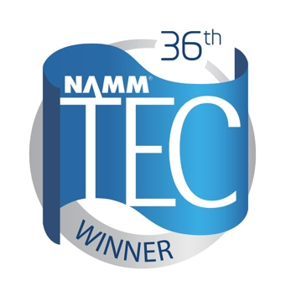
Phil Wagner, North American Senior Vice President of SSL, commented: “ORIGIN delivers SSL’s sonic excellence and advanced workflow at a price point that is truly revolutionary. It combines everything you would expect from a classic SSL in-line analogue console, along with advanced routing options that make it perfect for a modern hybrid studio. We are pleased that this milestone innovation has been recognized by the NAMM Foundation.”

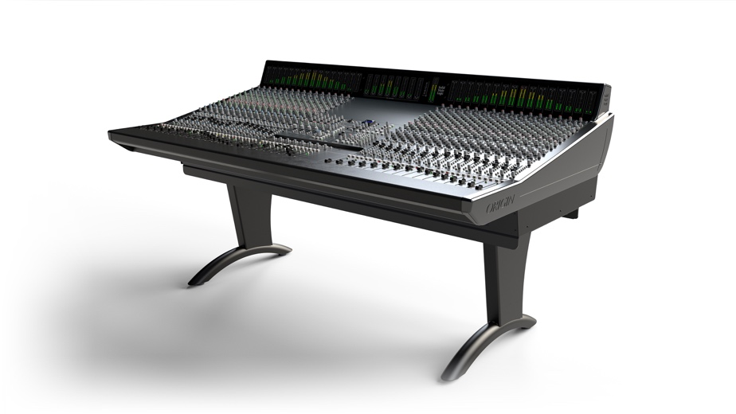
Presented by The NAMM Foundation, The NAMM TEC Awards are bestowed annually in celebration of the pro audio community by recognizing the individuals, companies, and technical innovations behind today's sound recordings, live performances, films, television, video games and other media.

This year, SSL hosted several well-attended music production sessions at NAMM’s Believe in Music Week, covering products and platforms including SiX, SSL 2/2+, SSL Live and of course the new ORIGIN analogue console. Guests included mixing legend Chris Lord-Alge, live sound veteran Simon Thomas and many others.

To learn more about ORIGIN, please visit https://www.solidstatelogic.com/products/origin.

###

Solid State Logic is the world’s leading manufacturer of analogue and digital audio consoles and provider of creative tools for music, broadcast, live and post production professionals. For more information about our award-winning products, please visit: www.solidstatelogic.com.

###
For further information contact:
Ross Gilbert
+44 (0) 1865 842300
rossg@solidstatelogic.com

