Automatic Room Correction of Neumann Studio Monitors – Now Also for Multichannel Systems
Neumann Releases MA 1 v2.0 with Optional Multichannel Extension
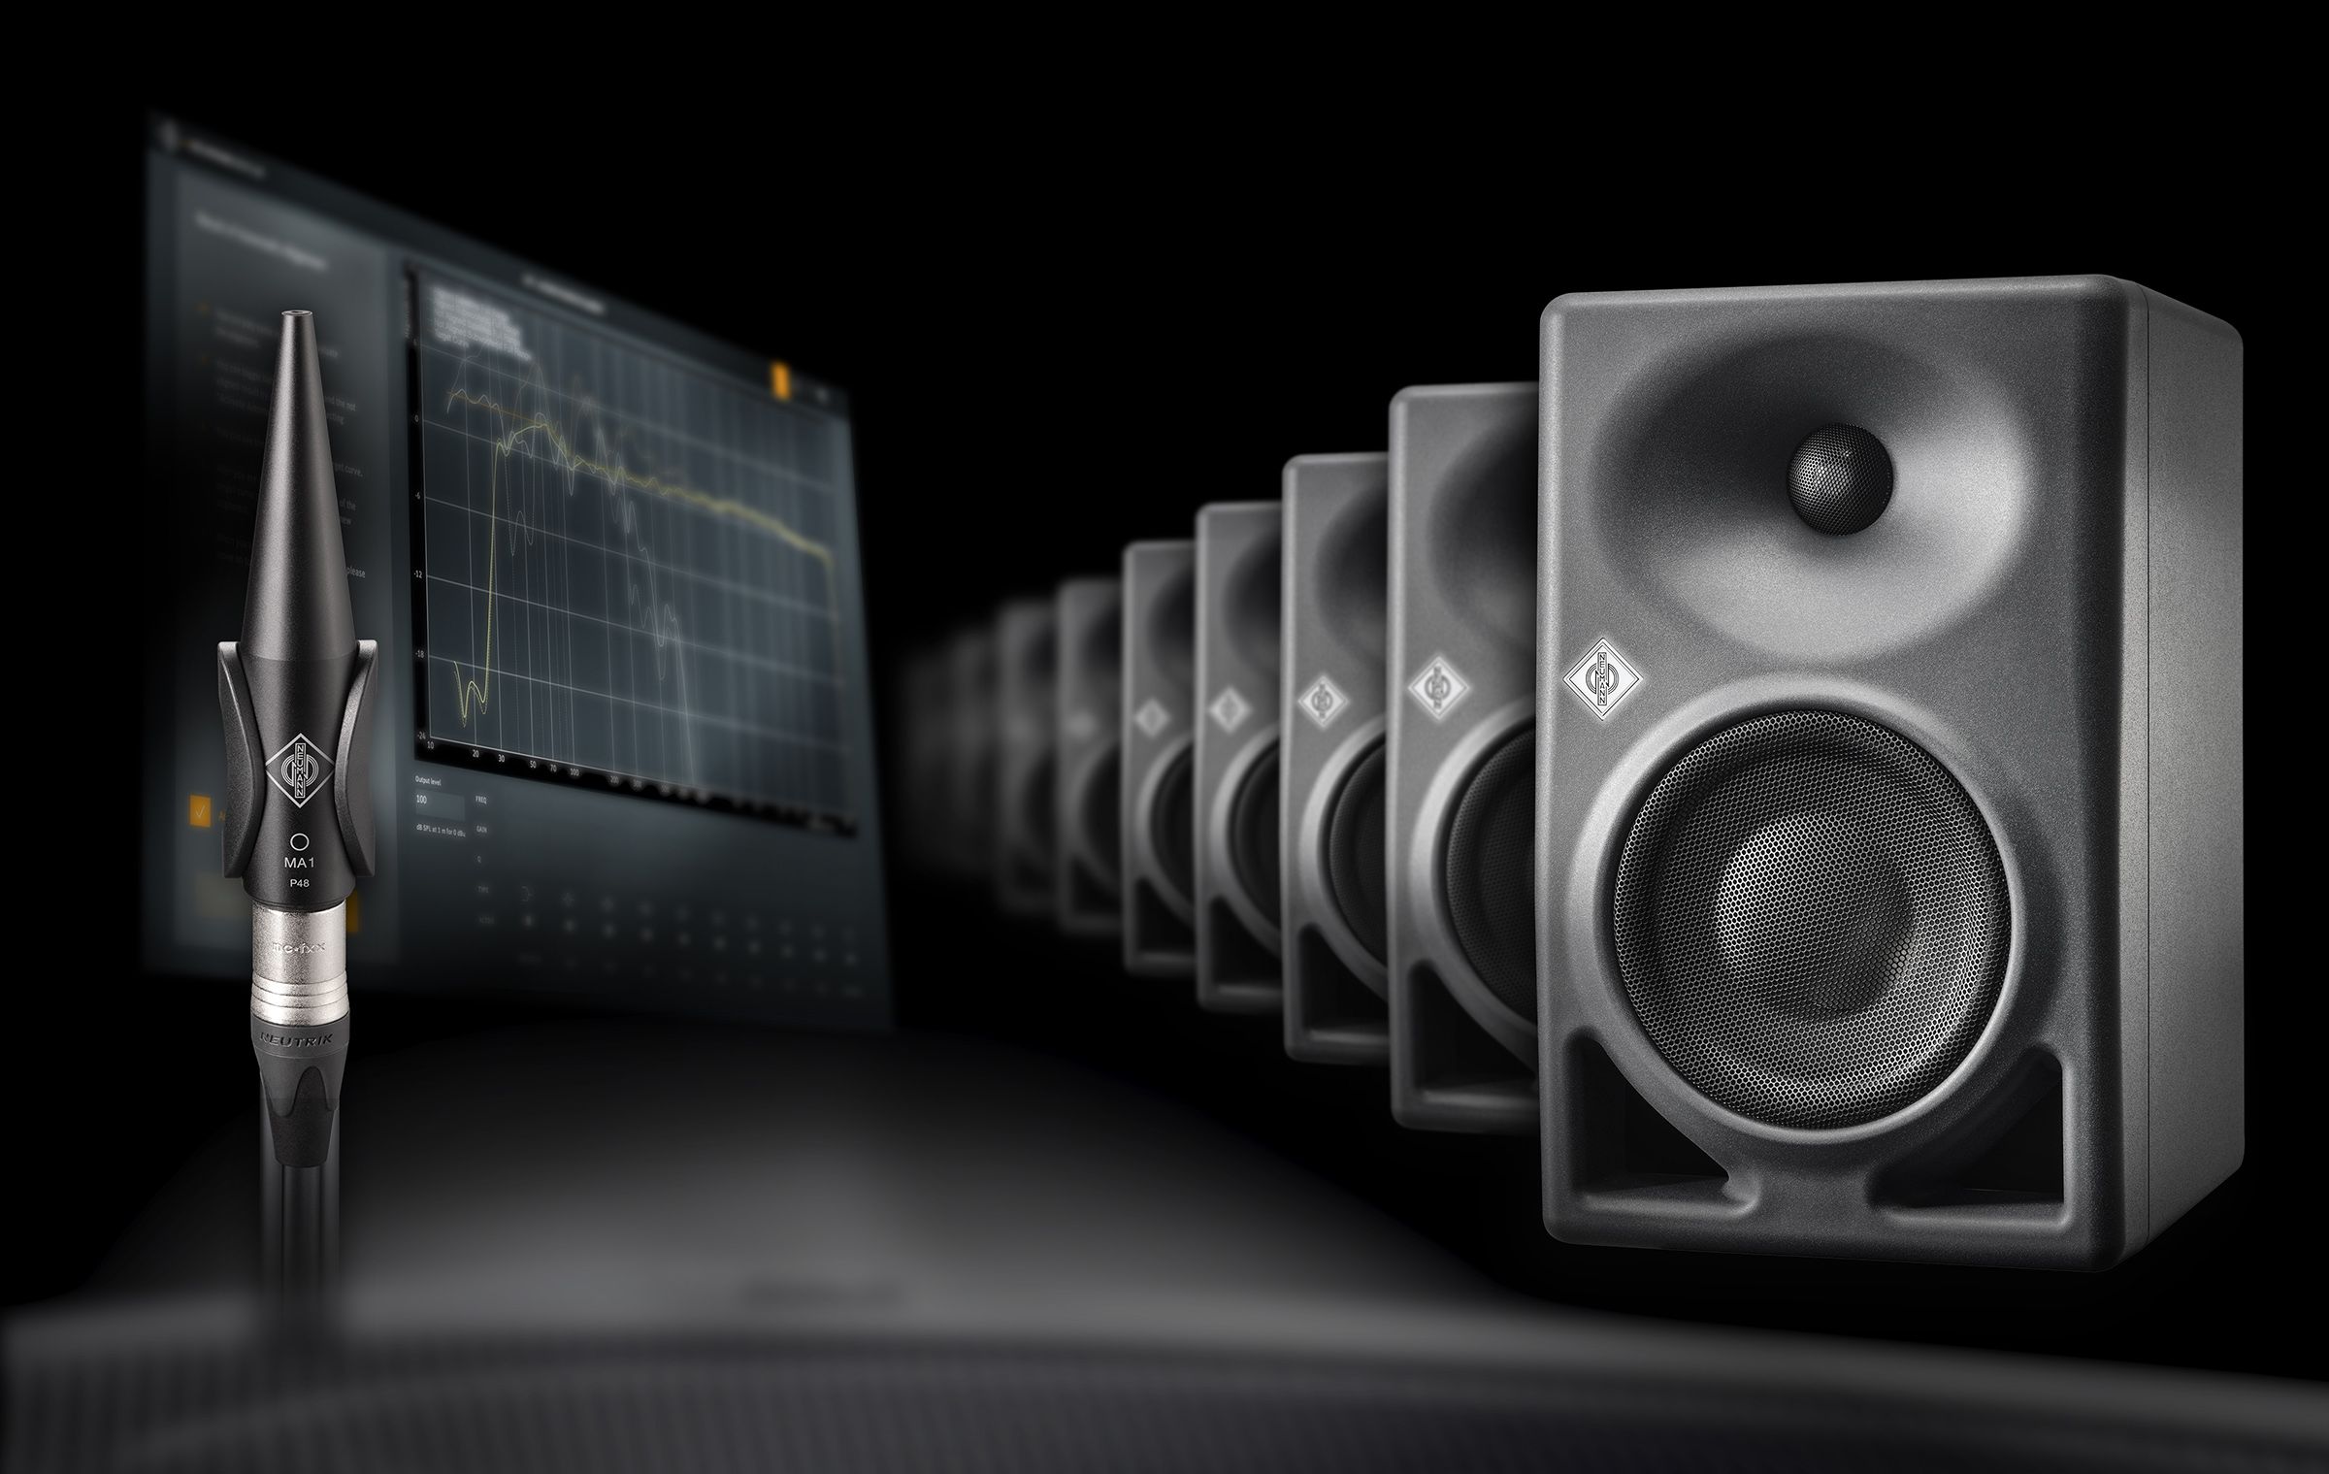

Berlin, November 2023 – The legendary studio equipment manufacturer Neumann.Berlin presents the latest version of its MA 1 Automatic Monitor Alignment room correction solution. In addition to many detail improvements, Release 2.0 introduces multichannel capability. For the first time, the optional Multichannel Extension for MA 1 makes it possible to align surround and immersive installations with the same Neumann precision.

Immersive audio is becoming increasingly popular in film, music, gaming and other applications. Yet few listening environments are optimised for these new formats. Extending a stereo control room to multichannel playback creates a whole new set of challenges. In many cases, loudspeakers have to be installed in acoustically unfavorable positions, and it is not uncommon for architectural constraints to necessitate deviations from the recommended loudspeaker positioning.

Therefore, even more than with stereo systems, room correction becomes an indispensable tool for reliable multichannel monitoring in reference quality. The Multichannel Extension for MA 1 allows to achieve optimal sound results under real-world conditions. But even in a control room specifically designed for multichannel formats, audible improvement can be achieved by precise room adjustment.

MA 1 linearises the frequency response and optimises the localisation of the entire system. This is especially important in multichannel applications to avoid changing the sound character of sources when panning. It also prevents misinterpretation of tonal changes as directional information. After all, the human brain relies on head-related filtering to localise sound sources. Consistent reproduction from all directions is therefore essential for accurate and reliable multichannel monitoring and a truly immersive listening experience.

“Like the stereo version, Multichannel Extension generates a room-adaptive target curve based on on-site measurements. This incorporates the extensive knowledge gained by Neumann engineers in analysing and calibrating countless control rooms,” explains Portfolio Manager Stephan Mauer. “MA 1 detects room modes and automatically optimises the correction filters in order to eliminate acoustic problems in the best possible way. In addition, level and delay differences are compensated, resulting in a three-dimensional sound image with extremely precise localisation and spatial resolution.”

In its first version, the Multichannel Extension for MA 1 supports surround systems such as quad, 5.1 and 7.1, as well as immersive setups in 5.1.4 or 7.1.4 – consisting of network-enabled Neumann loudspeakers and up to four subwoofers.

In addition, MA 1 v2.0 offers a number of detail improvements for stereo systems, too. User guidance has been optimised, and for a better overview, the corrected and uncorrected frequency responses are now displayed simultaneously.

Pricing and Availability
MA 1 v2.0 for stereo systems is a free update for all MA 1 owners.
The upgrade to MA 1 Multichannel Extension is available immediately at authorised dealers and requires an MA 1 measurement microphone and an installation of MA 1 v2.0.

List price MA 1: EUR/USD 299 , List price Multichannel Extension for MA 1: EUR/USD 299

Features:
- For quad, 5.1, 7.1, 5.1.4 and 7.1.4 configurations
- Works with all network-enabled KH Line studio monitors
- Room adaptive target curve
- Upgrade license for existing MA 1 hardware/software solution
- For Mac and PC

More information:
https://www.neumann.com/en-en/products/monitor-accessories/multichannel-extension-for-ma-1/

Screenshots of the software are downloadable in our newsroom.

About Neumann
Georg Neumann GmbH, known as “Neumann.Berlin”, is one of the world’s leading manufacturers of studio-grade audio equipment and the creator of recording microphone legends such as the U 47, M 49, U 67, and U 87. Founded in 1928, the company has been recognised with numerous international awards for its technological innovations. Since 2010, Neumann.Berlin has expanded its expertise in electro-acoustic transducer design to also include the studio monitor market, mainly targeting TV and radio broadcasting, recording, and audio production. The first Neumann studio headphones were introduced in 2019, and since 2022, the company has increased its focus on reference solutions for live audio. With the introduction of the first audio interface MT 48, and its revolutionary converter technology, Neumann now offers all the necessary technologies needed to capture and deliver sound at the highest level. Georg Neumann GmbH has been part of the Sennheiser Group since 1991 and is represented worldwide by the Sennheiser network of subsidiaries and long-standing trading partners. www.neumann.com

Press Contact Neumann:
Andreas Sablotny
andreas.sablotny@neumann.com
T +49 (030) 417724-19

Raphael Tschernuth
raphael.tschernuth@neumann.com
T +49 (030) 417724-67

