Compact New SV8 Monitor by BASSBOSS at Home On Stage or in the Studio

Single 8” Speakers Deliver the Response and Output of Competitors’ 12” Models for Use as Mains, Monitors, or Fills
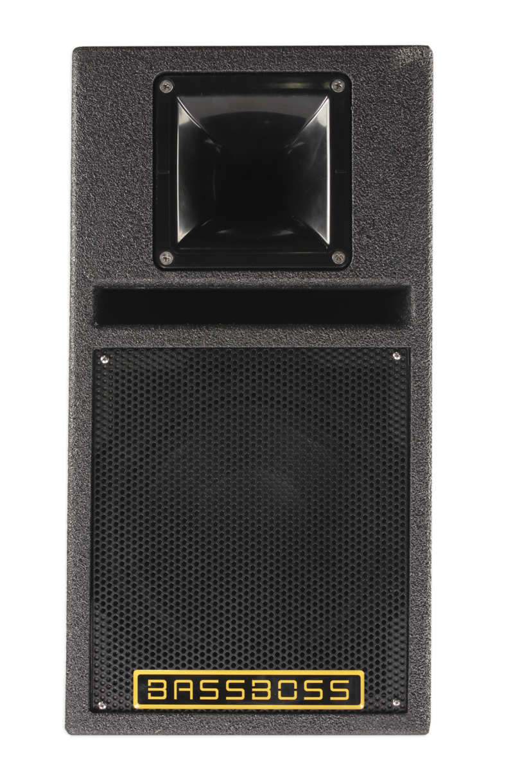
Austin, TX, December 5, 2016 — Austin-based powered loudspeaker manufacturer BASSBOSS is bridging the gap between live and studio speaker performance with the new SV8 Powered MicroMain. Featuring outstanding sound quality and remarkable bass performance for its size, the SV8 can wear more hats than any other compact loudspeaker on the market, equally at home as a main or fill speaker in clubs, gyms, or restaurants, or as a recording studio monitoring solution. “Most small loudspeakers don't perform well at high levels nor at low frequencies, so I thought it would be useful to create a box that could do both,” says BASSBOSS president David Lee. The resulting speaker leverages advanced speaker and cabinet design to achieve big, rich and finely detailed sound from an elegantly diminutive enclosure.

The Priority of Purity
With 117dB of sustained output in satellite mode and maximum output of 120dB, the SV8 Powered Micromain is capable of output levels that compare to some 12” powered boxes, but the SV8 offers superior quality and detail. BASSBOSS is able to achieve this remarkable feat with innovative speaker and cabinet design. “In designing the SV8, I wanted to deliver a lot of warm, rich output from a very small space,” says Lee. “Our 8” woofer has a rubber surround which provides excellent edge damping, low distortion, and smooth midrange response.” To enhance low-frequency performance, the SV8 cabinet features a large port above the woofer grill. “The large port helps maintain low frequency performance to higher levels than other boxes this size by minimizing air velocity and port turbulence. The result is a very compact box that delivers studio-quality sound and is unobtrusive even in the smallest venues.”

Active Flexibility
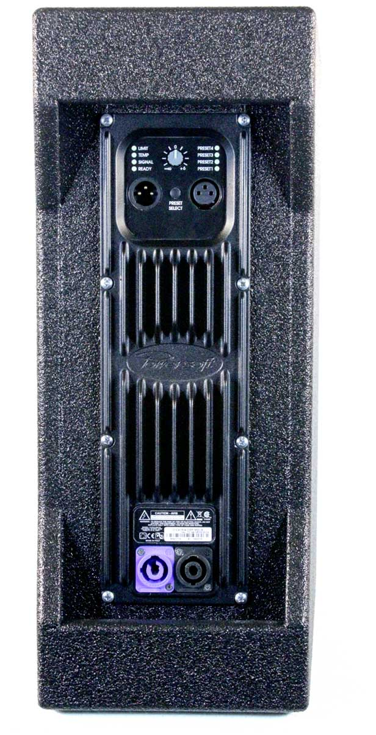
All BASSBOSS loudspeakers feature high-quality power amplification built in. The SV8 includes a comprehensive digital signal processor built right into its 700 watt Powersoft amp, providing four presets designed to maximize utility. The presets allow the speaker to be used either as a full-range system, a satellite for a small subwoofer, or as a main speaker with a larger subwoofer. “By diverting power away from the lowest frequencies when that range is covered by a subwoofer, the amplifier is able to push the midrange to higher levels,” Lee explains. Preset 1 has the SV8 in full-range mode, offering an impressive frequency response down to 40Hz. Preset 2 offers slightly more SPL and response down to 60Hz. Preset 3 provides another step up in SPL with the high-pass filter moved to 80Hz. Preset 4 offers the highest peak SPL with the high-pass filter set at 100Hz. These presets ensure that the SV8 is achieving peak efficiency for any application and helpfully eliminates the need for any external processing. All presets have limiting to protect the drivers and maintain balanced response at all levels. The built-in comprehensive processing is optimized for use with BASSBOSS subwoofers but also ensures they are compatible with all subwoofer options.

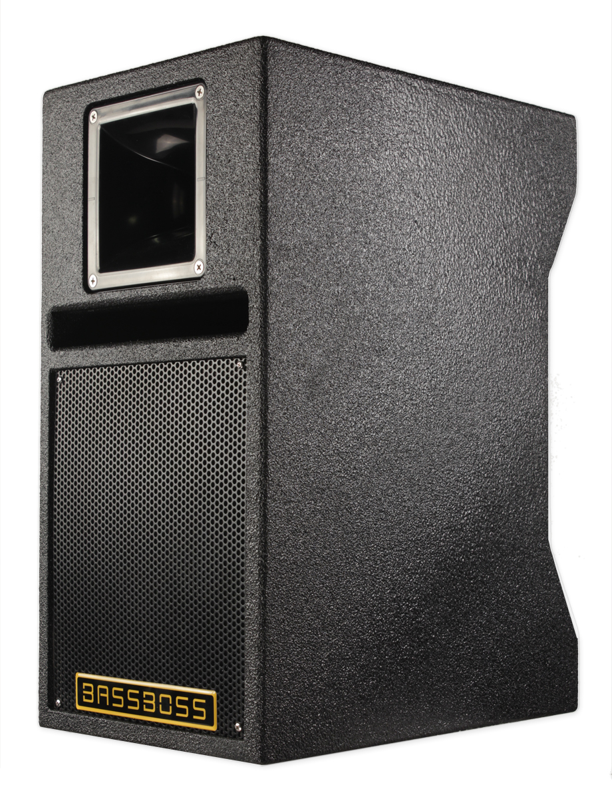
Studio Quality in Any Environment
With its extremely flat frequency response and neutral character, the SV8 delivers high-fidelity sound reproduction that makes it an ideal solution for critical listening in the studio. “The SV8 offers the resolution necessary to hear the finest details in the mix,” says Lee. It also boasts a higher output than many comparably sized studio monitors. “The additional power allows the producers to listen at club and performance levels and ensure the mix works in most contexts without switching to different boxes. Similarly, the producer may find it useful to demonstrate a mix to their client at these levels.”

Like a Glove
The SV8’s compact footprint enables it to fit like a glove in even the most space-conscious applications. The sturdy all-Baltic birch enclosure is available in black touring polymer coating or UV-stable white. The integrated handles make it durable and easy to transport for quick setup and strike for event work, while its clean, elegant lines make it ideal for the demands of high-end clients. “The SV8 is powerful enough to be part of a club sound system, but also space-efficient enough for smaller installation environments like gyms, restaurants, or museum galleries,” says Lee. “We are excited to offer the BASSBOSS promise of superior low-end performance in a product so compact, practical and flexible.”

The BASSBOSS SV8 is shipping now and is priced at $1495.00 USD.
About BASSBOSS
BASSBOSS creates premium, ultra high-fidelity sound systems for the professional consumer, live sound and systems integration markets. The company was founded on the design and engineering expertise of David Lee, a pioneer in subwoofer design whose work has transformed the audio systems for hundreds of venues across North America. BASSBOSS systems are easily integrated, compact and power-efficient. Each cabinet is self-contained, with comprehensive amplification and processing capabilities. For more information on BASSBOSS, please visit www.bassboss.com

Press contact:
Jeff Touzeau
Public Relations
Hummingbird Media, Inc.
(914) 602-2913
jeff@hummingbirdmedia.com

