For more information, please contact Marta de Paco
On +34 670 780 664 or email press@comunicahair.com

Important:
These images are only available for editorial content.
Credits must be included.
Notification of their publication is expected.

CHRISTIAN RÍOS
NÁCAR Collection

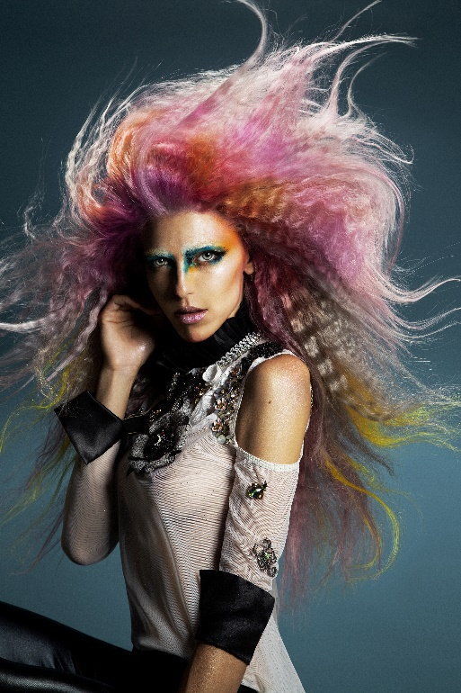

Hair: Christian Ríos @khrystyan28 @christianriossalon
Photography: Esteban Roca @esteban_roca_photo
Retouching: Esteban Roca
Make up: Nacho Sanz @nachosanzmakeup
Styling: Christian Ríos and Chary
Products: Revlon Professional España @revlonprofessional_es
Kevin Murphy Spain @kevinmurphyspain

CHRISTIAN RÍOS
NÁCAR Collection

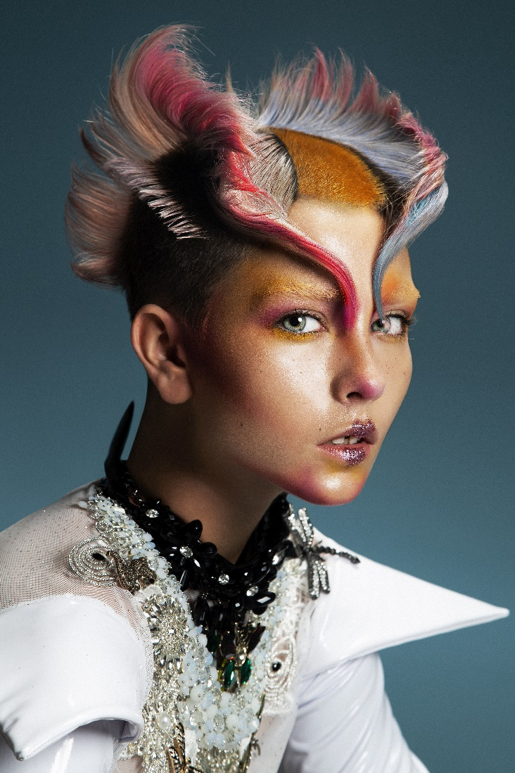

The seabed is a capricious and changing mantle of chromatic shades that varies as the light moves. An unprecedented color transition, but at the same time harmonious and always full of beauty. These are the motifs that inspire this collection with iridescent tones, with gradations and soft, sinuous shapes that reproduce the movement of currents, the emerging richness of tones from a hidden universe that emerges in hair.

