For immediate distribution

Tails of Legendary Reverberation: Sweetwater Studios Captures the Essence
of Beth Hart at Royal Albert Hall
Veteran Producer Mark Hornsby Tapped to Handle Remote Recording at Iconic Venue
for New Album, Blu-Ray and DVD Release
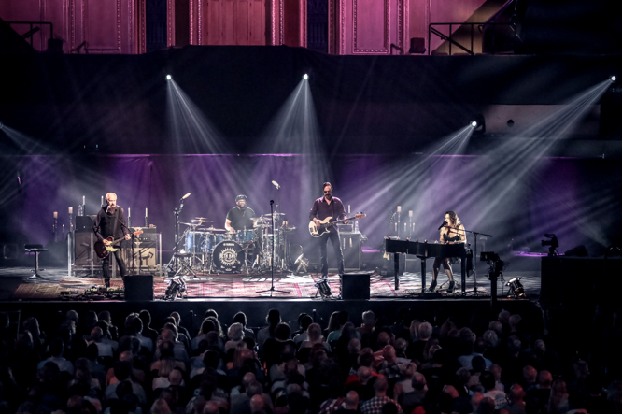
November 13, 2018, London — Beth Hart’s artistry has always been a study in emotional contrasts. From exhilarating joyful highs to solemn and soulful lows, the 46-year-old singer-songwriter has made her career on her ability to capture the essence of these moments with memorable, narrative song writing and passionate live performances that have moved listeners and concertgoers for nearly twenty years. One Friday night last May, Sweetwater Studio’s Senior Producer/Engineer Mark Hornsby was called on to record and engineer her new live album Live at the Royal Albert Hall.

The importance and gravity of the request was not lost on Hornsby, who knew that the recording had to be nothing less than perfect: “Beth is a very emotional performer and it’s pretty epic to put her in a space like that,” he says. “You have one shot when you’re trying to capture something like that, so you’ve got to make it count.”
Making tracks in London
Hornsby’s impressive track record of capturing 5.1 recordings in both the studio and in live spaces made him and Sweetwater Studios the first choice of film director Nigel Dick, who has directed videos for everyone from Paul McCartney to Gloria Estefan. With years of experience having done surround sound mixes for the likes of George Strait, Allison Kraus, and also with his experience as staff engineer at Nashville’s Seventeen Grand Recording — one of the first 5.1 high definition mix rooms in the country — Hornsby was the right man for the job.

Having already been worked on several other high-profile video concert performances, Hornsby was already aware of the requirements for a 4k video shoot and set up for a 24/96kHz 5.1. surround sound mix that entailed roughly 40 tracks and an array of microphones placed on the stage and at strategic places within the theatre to capture the audience. “I’m creating what Nigel is going to use to edit the entire show,” Hornsby explains. “You have to mix it like it’s a live show, bringing up the faders for solos, while keeping a close ear open for anything that could possibly go wrong.”
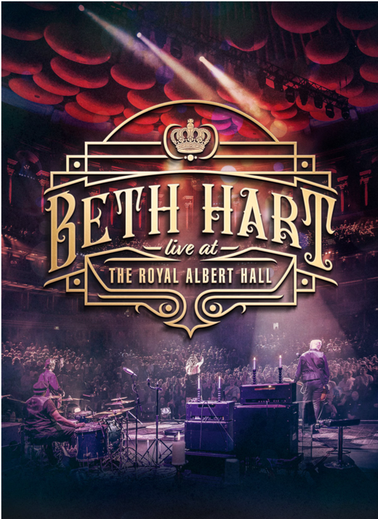
Arriving in London on the day of the performances, Hornsby worked in tandem with Hart’s crew and the video team to set the stage for the evening. “All the microphones had been shipped ahead of time and the crew had been using them on all of the preceding European tour dates,” Hornsby explains. “The main things we had to accomplish on arrival were tweaking the stage mic setup and make sure that the communication with the video team was solid.” With the video team working underneath the stage of the Hall, Hornsby set up his tracking and monitoring station in remote recording truck outside of the venue.

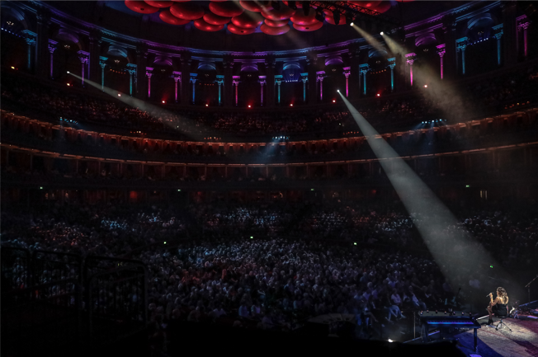
Throughout the evening, the audio was fed to the remote truck via fiberoptic cables sent from Front of House, running through a set of Sony DMX preamplifiers before entering the DAW. The feed was monitored by a Solid State Logic broadcast console, along with a pair of ATC SCM25a’s — also part of the monitoring set up back in Studio B at Sweetwater Studios in Fort Wayne.
Tails of Legendary Reverb
The Royal Albert Hall is not only a legendary performance venue, but also a sonic gem that lends itself to acoustic scale and grandeur. Hornsby, who has attended many concerts there over the years, already had intimate knowledge of the venue. “It’s got an iconic sound,” he says. “If you go with the room and just let it sound big, it works.” The room’s natural acoustics and long reverb tails left an exhilarating sonic footprint on the recordings. During the setup phase, Hornsby took great care to mic the room accordingly, with several audience mics as well as a matched pair in the Hall’s famous domed ceiling.
Controlling the natural reverb occasionally became a challenge when Hart belted out louder portions of the performance, but as Hornsby wisely adds with a chuckle, “You can’t fight the room. If you try to dial it back down then you might as well have just recorded somewhere else.”
Achieving intimacy in a 5,000 seat venue
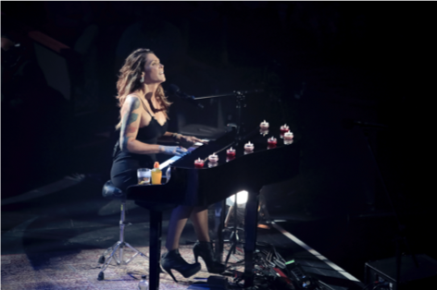
Although there are plenty of fiery performances on Live at the Royal Albert Hall, it’s the intimate emotional moments that Hart shares with her audience that really help exhibit the entirety of her artistic talent. “There are four songs she did with just herself and the piano, where we were really able to take advantage of the openness of the space,” Hornsby says, “You can really hear the connection she’s making to the audience in those songs and when I returned to Sweetwater Studios they were the first things I wanted to work on to set the tone for the rest of it.”

Once the recording was completed, Hornsby and the crew met backstage to plan the next leg of the journey. For him, it’s returning to Sweetwater Sound in Fort Wayne, IN to create the surround sound mix of the audio in Sweetwater’s Studio B, making use of the studio’s Solid State Logic AWS 948 Delta console and ATC SCM45A monitors to recreate the stunning performances that he captured. While he’s spent a lot of time engineering on both the stage and in the studio, Hornsby says that ultimately the objectives are the same. “You want to capture the energy of a good performance and you want that to translate whether you are listening to it or watching it. Beth has got soul for days and it’s something special. Being able to capture that in a live performance like this is really incredible.”

# # #

About Sweetwater Studios
Sweetwater Studios is a wholly owned subsidiary of Sweetwater Sound, Inc., the largest online music instrument retailer in the country. With three world-class studios designed by Russ Berger and access to a greater diversity of musical equipment and professional audio gear than any other recording studio in the world, Sweetwater Studios is able to accommodate just about any recording, mixing or mastering project, no matter how simple or complex. With renowned staff producer Mark Hornsby at the helm, who has worked on many Grammy-award winning albums, Sweetwater Studios also has an exceptional staff of producers, engineers, session musicians and studio technicians. For more information on Sweetwater Studios, please visit http://www.sweetwaterstudios.com.

Media contacts
Steve Bailey
Public Relations
Hummingbird Media
+1 (508) 596 9321
steve@hummingbirdmedia.com

Jeff Touzeau
Public Relations
Hummingbird Media
+1 (914) 602 2913
jeff@hummingbirdmedia.com

