

Biuro prasowe better. gaming agency
bettergamingagency.prowly.com

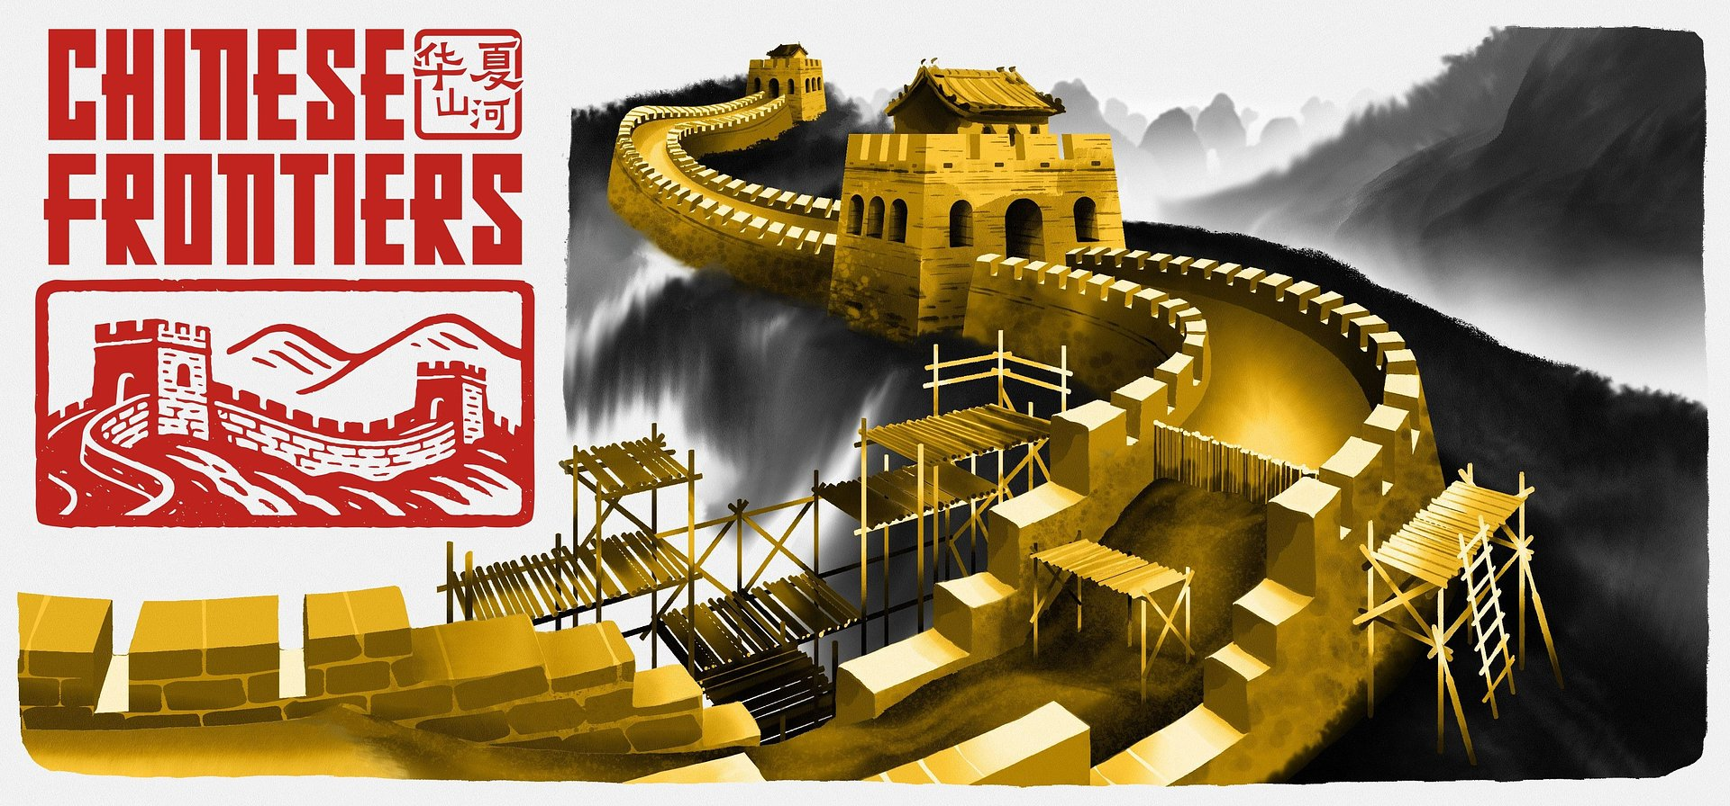

The Great Wall of China wasn't built in a day. Chinese Frontiers is coming to Steam on June 19th – check out the new trailer!

Building a legend, brick by brick.

Chinese Frontiers will give players the opportunity to face the challenges of building the Great Wall of China. Today, the developers at SolidGames announced the release date and unveiled a new trailer. The game is coming to Steam on June 19th. The video offers a closer look at the features of this building simulator, letting players experience the monumental task of constructing one of the world’s most iconic fortifications. For those who want to take on the challenge themselves, a demo will be available in early June.

In Chinese Frontiers, players begin their journey as novice builders, gaining knowledge and skills step by step, task by task. Naturally, this will go hand in hand with the development of the village they live in and managing it will be part of the job. The goal of all this is to help in the construction of the Great Wall of China and its monuments.

Chinese Frontiers - latest trailer

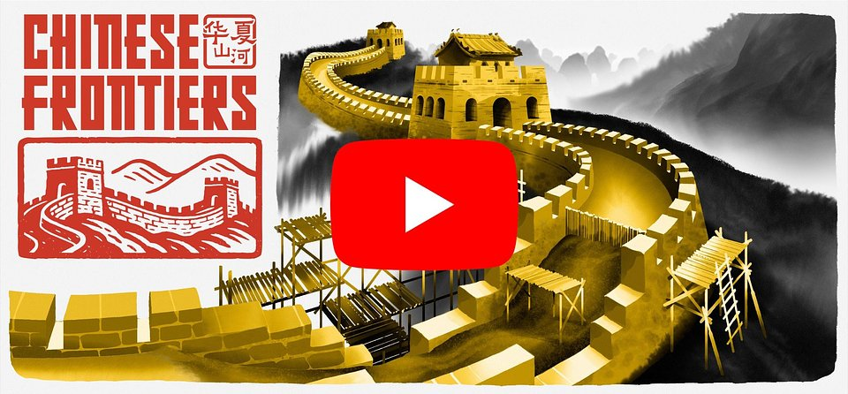
https://youtu.be/lyEAPMh6b3o

As the leader of the village, the player will need to take care of its internal economy, manage supply chains, and ensure the well-being of its inhabitants. This involves a variety of activities, such as farming, cooking, fishing, working in various workshops, and constructing new buildings. Helpful villagers will assist with these tasks, and the player can assign them to specific duties. The time saved will certainly be well-spent exploring the surrounding area and admiring the stunning Asian landscapes.

In the epic task of building one of the most famous structures in the world, players will be assisted by mentor Jun and his granddaughter Mei. They will not only introduce the fascinating world of Chinese legends and myths, but will also guide players in the arts of various crafts. As the bonds of friendship grow stronger, they will reveal secrets from the past, believing that this will bring a better future to the people.

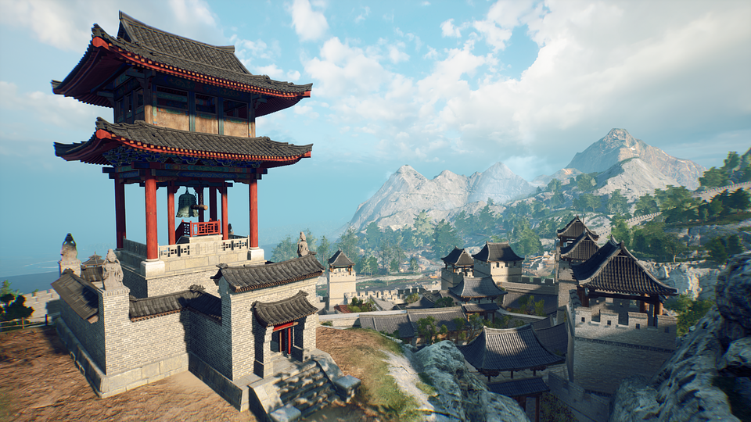

The foundations of Chinese Frontiers are built on the following features:

🧱 Step by step – in Chinese Frontiers, players will have the opportunity to build monumental structures, carefully completing each phase of construction, from the foundations to the final touches. This gives a true sense of involvement in creating something grand.

🧱 Success has many fathers – players will be responsible for coordinating the work of the village people, assigning tasks and optimizing processes to gather resources and build the necessary structures as efficiently as possible.

🧱 Three epic regions – build sections of the Great Wall of China, including its most iconic elements such as the Jiayu Pass, the Jiumenkou bridge, and the breathtaking Jiankou section. Explore three diverse areas – the rugged desert, majestic mountains, and mysterious river valleys. Each region presents new challenges, resources, and innovative construction technologies.

🧱 No routine – the gameplay offers a dynamic mix of building, crafting, farming, and exploration, allowing for seamless interaction between various aspects of village life. In Chinese Frontiers, there's always work to be done.

🧱 From the heart of China – Chinese Frontiers captures the spirit of traditional China, drawing inspiration from the architecture and construction techniques of that era.

🧱 Building one of the world's wonders - the opportunity to witness the process of building the Great Wall, uncovering not only its most iconic structures, but also the values of cooperation, sacrifice, and the wisdom of ancestors.

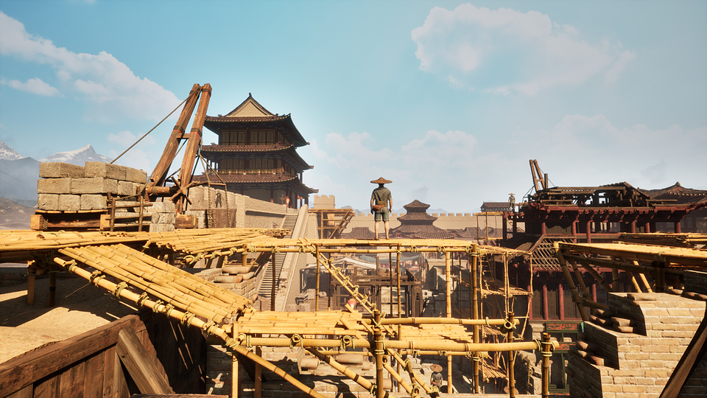

Chinese Frontiers is coming to PC on June 19th, and those not afraid of honest work can already wishlist the game on Steam. The demo will be available in early June. To learn more and stay up to date, follow the developers on social media and share your suggestions and feedback on the official Discord channel.

Discord
TikTok
Instagram
X
YouTube

The full press kit is available here.

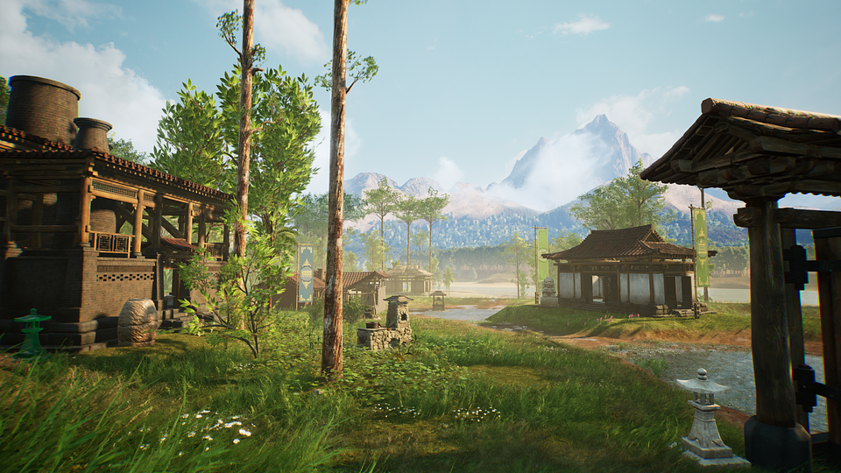

About SolidGames:

SolidGames is a rapidly growing independent studio based in Warsaw, Poland, that focuses on creating ambitious, immersive games. With a team of 25 skilled professionals, they have been working on their debut project, Chinese Frontiers, since February 2021. This title is a simulator that allows players to immerse themselves in a world inspired by medieval China, where they will build the Great Wall of China and other iconic structures.

