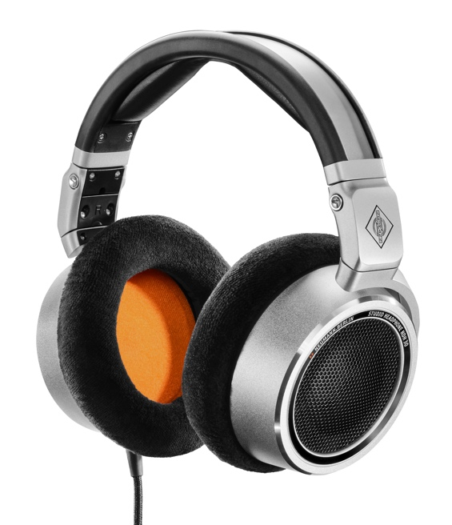
Neumann Expands its Headphone Portfolio
with the Open-Back NDH 30
Berlin, Germany, May 10, 2022 – The German studio specialist Neumann.Berlin presents the NDH 30 open-back headphone. Following the success of the award winning NDH 20, released in 2019, the NDH 30 is a reference-class studio headphone for the most demanding mixing and mastering applications in both stereo and immersive formats. The NDH 30 reproduces the linear sound image of a Neumann loudspeaker setup, perfectly calibrated via MA 1 Automatic Monitor Alignment, in a portable format.

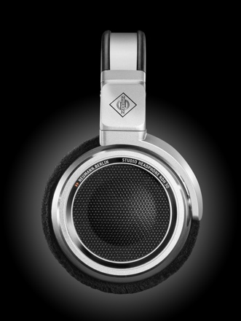
While the NDH 30 retains the high-quality metal construction of the closed-back NDH 20, it is way more than just an open-back version. The entire acoustic system is a new design, including optimized and perfectly positioned dynamic drivers that rival the sonic resolution of planar magnetic transducers. Harmonic distortion is extremely low and, thanks to frequency selective absorbers, the NDH 30 has a remarkably even response across the entire audio spectrum.

“We wanted to create a headphone that is totally reliable and gives you the confidence you need to make the right decisions. The NDH 30 will tell you exactly if your bass is too loud or your vocal needs de-essing,” explains Portfolio Manager Sebastian Schmitz. “The spatial resolution, too, is outstanding because the drivers are made to extremely low tolerances. And because the NDH 30 comes with an internally balanced cable, which improves channel separation.”

Long term wearing comfort is excellent, of course, thanks to large, soft earpads. For easy transportation, the NDH 30 is foldable. The NDH 30 is thus a portable alternative to a Neumann KH line loudspeaker setup, offering full sound and mix compatibility.

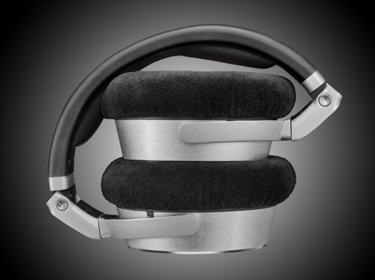
At the same time, the NDH 30 is a reference in its own right for headphone compatibility, which is paramount for commercial success, given today’s listening habits. Its extraordinary spatial resolution also recommends the NDH 30 for creating binaural mixes of immersive content, including gaming and VR – rapidly growing markets.

“Neumann is quickly becoming the global reference in high-quality monitoring. From Oscar-awarded blockbuster filmscores to the most recent Grammy-winning ‘Best Immersive Audio Album’ – all mixed on Neumann monitors. Our customers have been asking for a similar reference when mixing for headphones. After all, headphones are becoming the dominant playback system among consumers – in particular for immersive sound. The NDH 30 is our answer to those demands,” summarizes Neumann’s CEO Ralf Oehl.

The list price of the NDH 30 is €649/$649.
Available May 2022.

Features:
- Linear sound, similar to a perfectly calibrated Neumann loudspeaker system
- High-resolution stereo panorama with precise localization
- Transparent, detailed sound image, ideal for mixing & mastering
- Excellent wearing comfort, easy to transport

More information at https://en-de.neumann.com/ndh-30

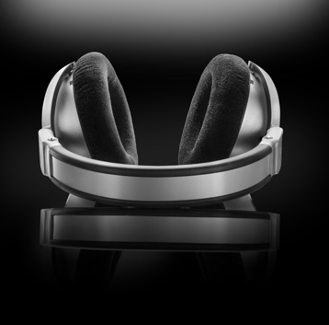
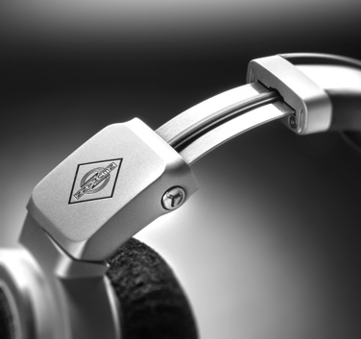
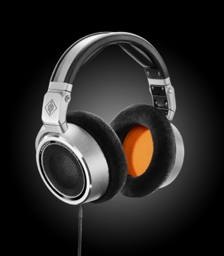
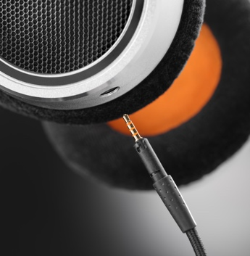

About Neumann
Georg Neumann GmbH, known as “Neumann.Berlin”, is one of the world’s leading manufacturer of studio-grade audio equipment and the creator of recording microphone legends including the U 47, M 49, U 67 and U 87. Founded in 1928, the company has been recognized with numerous international awards for its technological innovations. Since 2010, Neumann.Berlin has expanded its expertise in electro-acoustic transducer design to also include the studio monitor market, mainly targeting TV and radio broadcasting, recording, and audio production. The first Neumann studio headphone was introduced at the beginning of 2019. Georg Neumann GmbH has been part of the Sennheiser Group since 1991, and is represented worldwide by the Sennheiser network of subsidiaries and long-standing trading partners. www.neumann.com

Press Contact Neumann:
Andreas Sablotny
andreas.sablotny@neumann.com
T +49 (030) 417724-19

