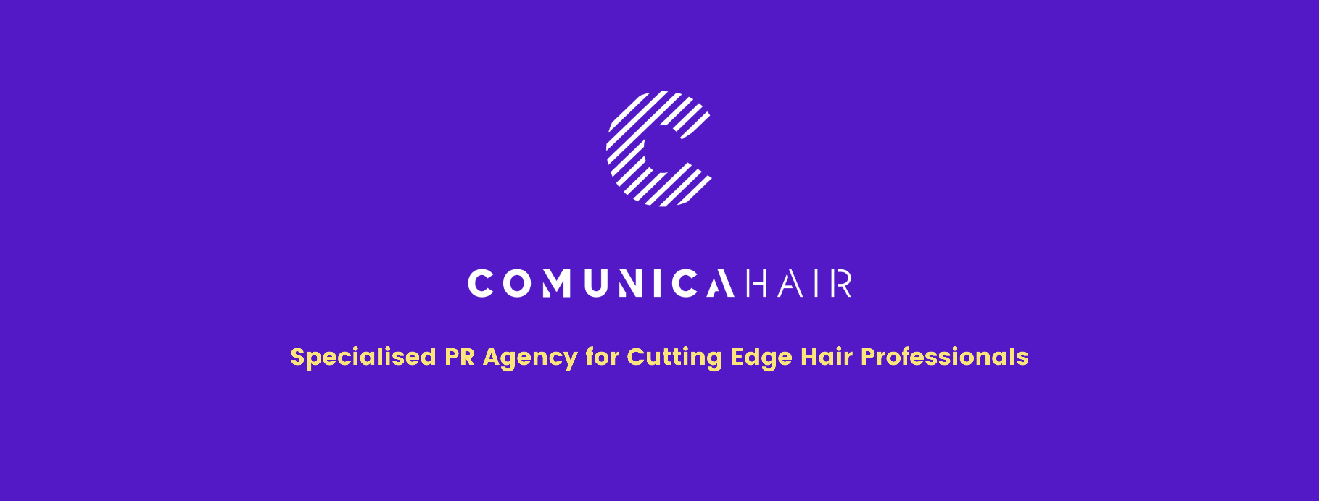

For more information, please contact Marta de Paco
On +34 670 780 664 or email press@comunicahair.com

Important:
These images are only available for editorial content.
Credits must be included.
Notification of their publication is expected.
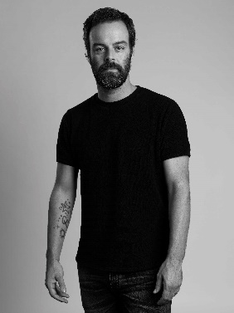
ARJAN BEVERS
PHOTOGRAFICA Collection
NETHERLANDS

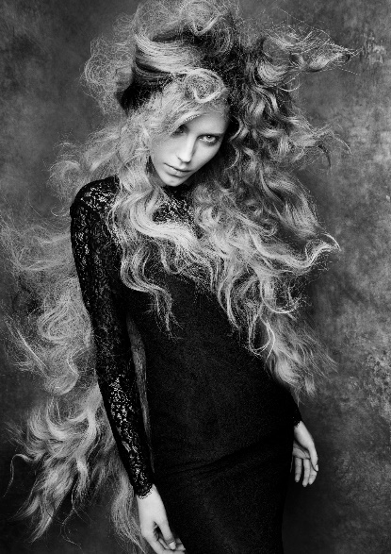
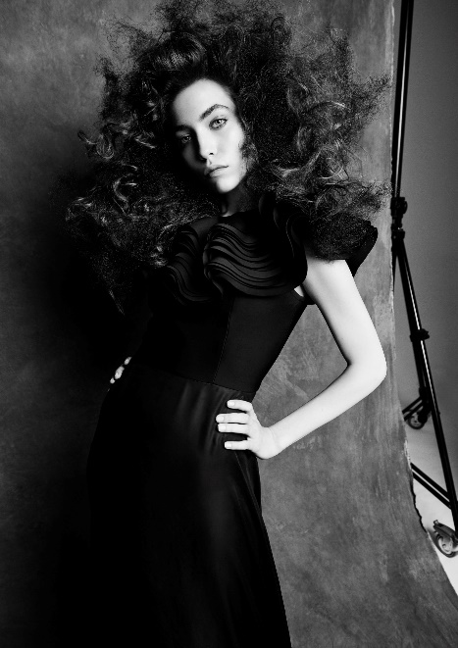

Hair: Arjan Bevers @arjanbevers
Salon: Avanti @avantikappers
Photographer: Andrew O’Toole @andrewotoolestudios
MUA: Mireille Bevers Brunt @mireillebeversbrunt
Styling: Luca Termine @lucatermine

ARJAN BEVERS
PHOTOGRAFICA Collection
NETHERLANDS

This collection fuses the energy of hair, represented as a force that emerges from within, with the plasticity of a photographic perspective capable of capturing the intensity of a second of life. Beauty becomes a living being that moves in the landscape created between the visible and the subtle, in which the dreamlike takes shape and in which femininity is a powerful attitude, aware of its full scope, impacting those who watches it until moved. PHOTOGRAFICA, the second collaboration between Arjan Bevers and Andrew O'Toole, is a tribute to the most iconic masters of photography in a raw and unpolished version that seeks the maximum expression.

