BJOOKS ANNOUNCES ‘PATCH & TWEAK WITH KORG’, AVAILABLE IN AN EXCLUSIVE BUNDLE WITH KORG’S NEW Nu:Tekt NTS-2 Oscilloscope Kit

This 216-page hardcover book takes readers on a hands-on journey through patching and tweaking KORG’s popular semi-modular synthesizers – bundled with the new KORG Nu:Tekt NTS-2 Oscilloscope Kit

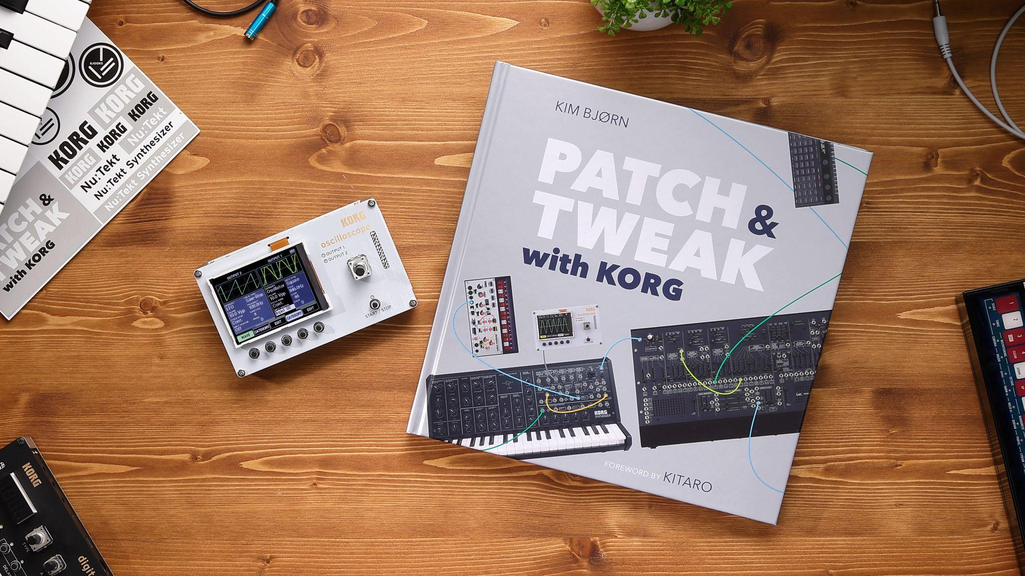

MAY 10, 2022 — COPENHAGEN, DENMARK — Bjooks, publisher of acclaimed music technology books PUSH TURN MOVE, PATCH & TWEAK, PEDAL CRUSH, PATCH & TWEAK with Moog and SYNTH GEMS 1, has announced the release of PATCH & TWEAK with KORG, a colorful 216-page journey through semi-modular synthesis seen through the lens of KORG and ARP synthesizers.

This new book features a multitude of patch tips, tutorials, historical explorations, and more, along with a Foreword by world-famous New Age artist (and longtime KORG fan) Kitaro, and dozens of exclusive interviews with renowned artists and producers — including Pete Townshend, Jean-Michel Jarre, and Richard Devine.

Both synth beginners and seasoned pros alike will find this journey through KORG history and technology, not just educational but also inspirational and full of new discoveries. The book features multiple tips that make use of the new KORG Nu:Tekt NTS-2 oscilloscope/waveform generator/spectrum analyzer/tuner that’s bundled with the book.

PATCH & TWEAK with KORG: a deep dive into three iconic synthesizers
PATCH & TWEAK with KORG is the latest title in Bjooks’ acclaimed PATCH & TWEAK series. This beautifully photographed and printed hardcover book takes readers deep into the possibilities of three patchable synthesizers — the popular MS-20 mini, the quirky and powerful volca modular, and the legendary ARP 2600 M. Synth lovers, experienced professionals, KORG enthusiasts, and electronic music fans will all enjoy meandering through the book's pages to explore the principles of semi-modular synthesis, while discovering dozens of tips, techniques and patches that can help them along their own musical journey.

Throughout PATCH & TWEAK with KORG, more than 25 artists and producers offer a special glimpse into their workflow by sharing their favorite tricks and patches with readers. The list includes Pete Townshend, Jean-Michel Jarre, Richard Devine, Andrew Huang, Red Means Recording, Kabuki, Kristin Hsiao, TALsounds, Robby Stambler, ALOO, Chris Lody, Olga Prudey, On High Mountains, Loopop and more.

PATCH & TWEAK with KORG will also introduce you to the creative minds of KORG’s history, from MS-20 designer Fumio Mieda to volca mastermind Tatsuya Takahashi and the latest generation of KORG engineers, as well as the keepers of the ARP legacy: Dina Pearlman, David Friend, and David Mash.

A photo-packed timeline of KORG synthesizers and a look into KORG today, as well as a reference guide to educational resources, round out this amazing book.

NTS-2 – The Modern Musician’s Swiss Army Knife
Bundled with PATCH & TWEAK with KORG is a brand-new KORG Nu:Tekt kit, designed in cooperation with author Kim Bjørn. The NTS-2 Oscilloscope is a pocket-sized, easy-to-assemble studio companion that’s not only a 4-input full color oscilloscope, but also a tuner, spectrum analyzer, and even a dual waveform generator to give any synth rig an extra pair of oscillators or LFOs.

The NTS-2 kit and PATCH & TWEAK with KORG were developed to complement each other, providing not only fundamental knowledge, but also a handy set of tools to guide and inspire synth lovers through their creative adventures.

“Working with KORG – not only on PATCH & TWEAK with KORG, but also the accompanying NTS-2 – was a dream come true,” said Kim Bjørn, CEO and founder of Bjooks. “The influence the KORG MS-20 and the ARP 2600 have had on music culture cannot be understated, and KORG has honored their importance through the lovingly recreated modern versions that form the basis for this book.”

“Today, the company is still helping electronic musicians find their voice with newer instruments like the volca modular,” Bjørn continued. “Hopefully, this book will not only educate readers on the legacy and innovations of KORG, but also inspire future music makers by putting useful tools in their hands — literally, in the case of the NTS-2 oscilloscope!”

PATCH & TWEAK with KORG will be sold with the KORG Nu:Tekt NTS-2 Oscilloscope Kit in a special package with exclusive extras, available soon from KORG dealers worldwide.

Bjooks is an environmentally responsible publisher with all of its books — including PATCH & TWEAK with KORG — printed on high-quality, environmentally friendly paper from responsible sources.

For more information on the Bjooks collection of music technology titles, please visit http://www.bjooks.com.

About Bjooks:
Bjooks is the boutique publishing company founded and run by author, designer, and musician Kim Bjørn. His first book, PUSH TURN MOVE, was published in 2017. This was followed by PATCH & TWEAK in 2018, which has since been referred to as the 'Bible of Modular Synthesis’; PEDAL CRUSH - Stompbox Effects for Creative Music Making in 2019; PATCH & TWEAK with Moog in 2020; and SYNTH GEMS 1 in 2021. The mission of Bjooks is to create exciting titles about music technology, artists, and makers, in order to document, inspire, and explore the world of music creation.

Press Contacts:
Katie Kailus
Hummingbird Media
katie@hummingbirdmedia.com
www.hummingbirdmedia.com

Jeff Touzeau
Hummingbird Media
jeff@hummingbirdmedia.com
www.hummingbirdmedia.com

