flydubai celebrates 10 years of bringing people together
The number of Boeing 737aircraft in flydubai’s fleet and number of destinations on the flydubai network at year end (2019)
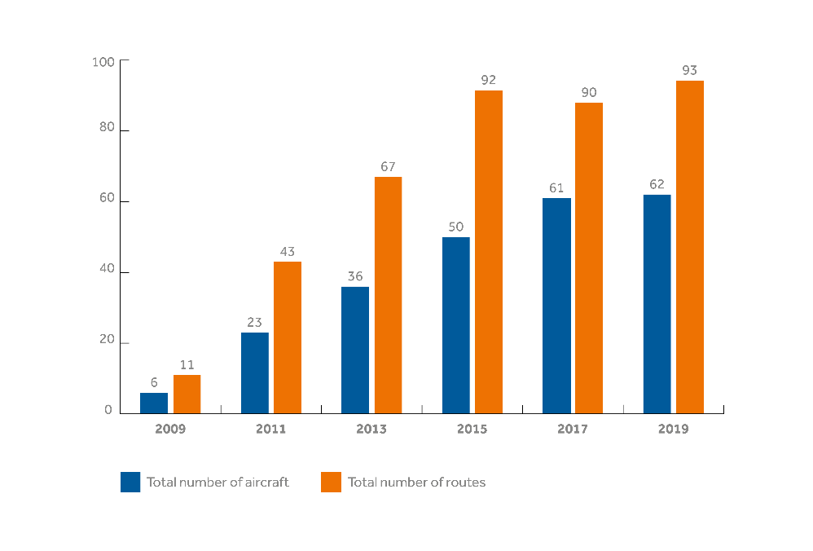
The total number of passengers carried since inception and the overall market growth of the first 3 destinations on the flydubai network
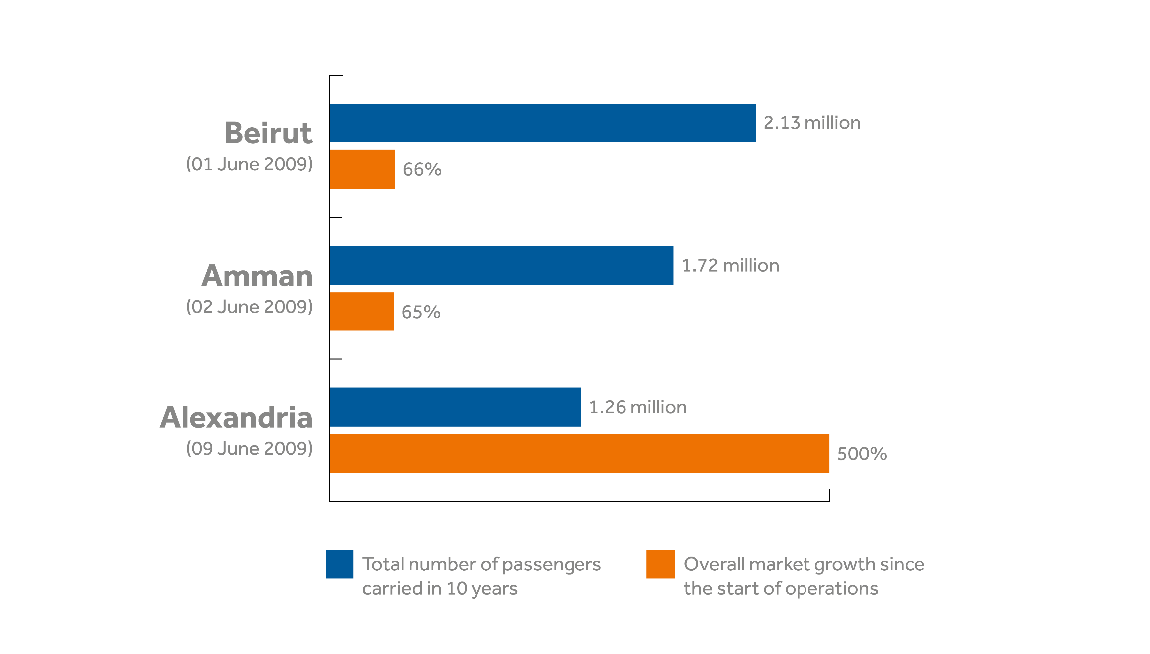
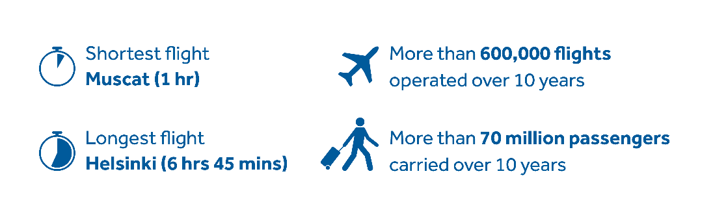
flydubai milestones
History at a glance:
March 2008 | The Government of Dubai announced formation of a new airline.
25 June 2008 | The airline is to be named flydubai.
14 July 2008 | flydubai placed its first aircraft order for 50 Next-Generation Boeing 737-800s at the Farnborough Air Show.
11 March 2009 | flydubai announced its home base to be Terminal 2 at Dubai International.
April 2009 | flydubai announced its launch date, routes and prices.
18 May 2009 | HH Sheikh Ahmed bin Saeed Al Maktoum, flydubai’s Chairman, unveiled the carrier’s first Next-GenerationBoeing 737-800.
01 June 2009 | flydubai officially took off with its first commercial service from Dubai to Beirut.
31 August 2009 | Over 100,000 passengers travelled on flydubai within the first three months of operations.
November 2010 | flydubai launched Inflight Entertainment.
01 January 2012 | flydubai launched its cargo services.
13 February 2013 | flydubai announced its financial results for the first time, for the full year 2012.
08 October 2013 | flydubai launched Business Class.
17 November 2013 | flydubai placed its second aircraft order for 75 Boeing 737 MAX aircraft and 11 Next-Generation 737-800s.
6 July 2014 | flydubai opens its Business Lounge at Terminal 2.
2014 | flydubai launched 23 new routes in 2014.
14 January 2015 | flydubai celebrated the listing of 500 million US dollar Sukuk on NASDAQ Dubai.
25 October 2015 | flydubai started operations from Dubai World Central, DWC.
26 April 2016 | flydubai launched onboard WiFi and live television.
05 July 2017 | flydubai launched its new uniform.
17 July 2017 | Emirates and flydubai announced an extensive codeshare agreement. More than 3.29 million passengers have benefitted from the codeshare over a period of 18 months. The combined Emirates and flydubai network is estimated to reach 240 destinations by 2022.
11 November 2017 | flydubai took delivery of its first Boeing 737 MAX 8 aircraft.
15 November 2017 | flydubai placed its third and largest single-aisle aircraft order in the Middle East for up to 225 Boeing 737 MAX aircraft at the Dubai Airshow.
14 December 2017 | flydubai started building its new headquarters.
27 March 2018 | flydubai launched Holidays by flydubai.
29 March 2018 | flydubai launched the flydubai mobile application.
01 June 2019 | Celebrates 10 years of successful operations, opening up 71 underserved markets and carrying more than 70 million passengers.

