Neumann plays crucial role in groundbreaking aural production at Dublin Fringe Festival
Neumann KU 100 binaural head deployed to create intimate storytelling experience told through WhatsApp voice notes
Dublin, Ireland, November 2021 - Lark are a new international performance collective and their presentation of ‘I Feel You Apart From Me’ by Emer Heatley featured as part of the Pan Pan Platform at the 2021 Dublin Fringe Festival, which ran from September 11th to 26th, with Neumann’s KU 100 used to create a wide variety of audio content for this unique project.

During the pandemic many of us were, and still are, forced to be apart from those we love. The show’s creators wanted to encapsulate those feelings, describing ‘I Feel You Apart From Me’ as, ‘...a show about missing what you love. It’s about holding onto each other when we’re forced apart, the tender power of a voice note sent across the sea, and how we find ways to communicate when we can’t hold hands but we can still whisper into each other’s ears. ‘I Feel You Apart From Me’ is a show for anyone who has missed a person, a place, a feeling, a moment in time.’ Speaking about this impulse for creating the work, the show’s Creative Producer, Tilly Taylor said “The team are currently based in Dublin, Bristol and Berlin and it was our geographical separation that formed the show’s initial inspiration. It’s about missing. We have tried to encapsulate that feeling, how longing for someone or somewhere far away can remove us from our reality. Voice notes kept us connected through multiple lockdowns. Whether ten second snippets or twenty-minute sagas, we observed that we could use their intimacy and immediacy to connect with each other and tell stories in a new way.”

Written and performed by Emer Heatley and directed by Julia Head, the piece features original composition by Brian Fallon. It is an intimate storytelling experience told through WhatsApp voice notes. The performance began from a place of familiarity for audiences, it presented voice notes that sounded like ones they might expect from their own friends and family. For this, the creative team worked to faithfully capture the many sounds and aural textures within the performance. However, it then brought the audience on a journey into a sonic soundscape that is both ethereal and moving, exploding expectations of the form and transporting the listener from their reality into the mind of someone else. This is where the Neumann KU 100 binaural head was crucial in creating a transformed audio landscape for listeners.

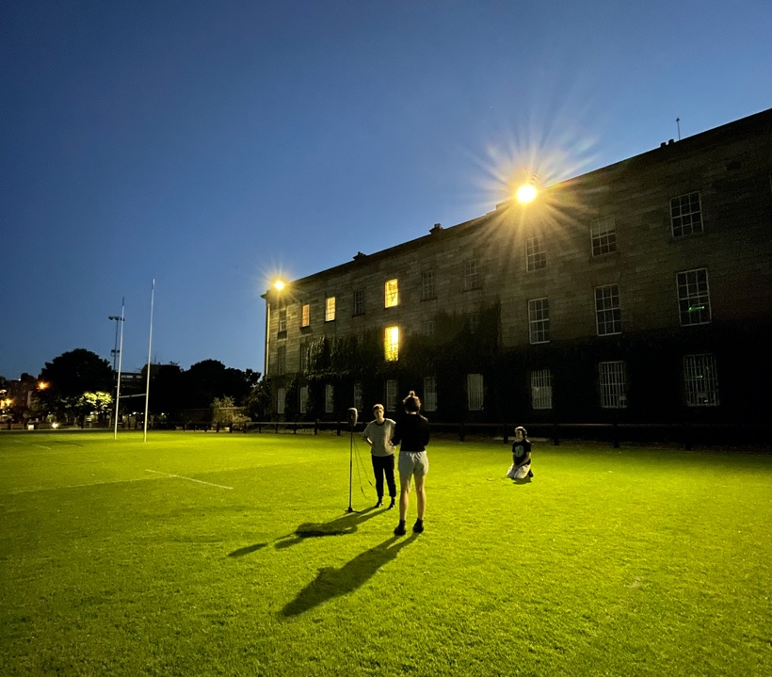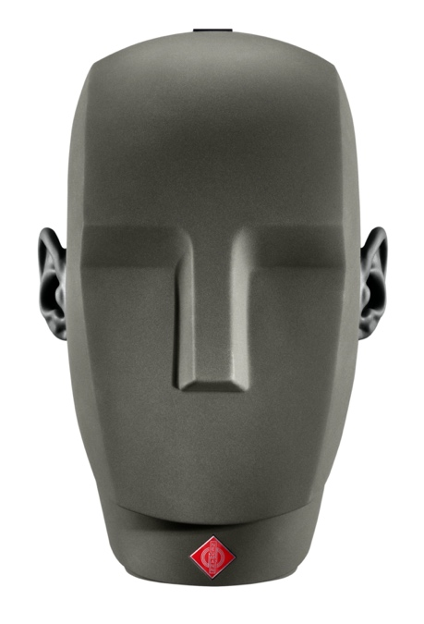

“The piece relies primarily on audio, so it was crucial that we used the right equipment to create a smooth and immersive experience for the listening,” says Taylor. “We used WhatsApp voice notes to ensure the recordings sounded like a real-life voice note, with audio captured at an array of everyday locations, including rugby pitches, DIY dance floors, the seaside, on a train, on busy streets, in the bath, even in a festival portaloo, to create a sense of authenticity. When the performance then transformed into a more ethereal and surreal soundscape, we deployed Neumann’s KU 100 binaural head microphone to capture recordings that placed the listener within the sound in a completely immersive way. Emer was able to direct her performance to different areas around the binaural head, which subsequently placed the listener in relation to her.”

Neumann’s KU 100 binaural head microphone, which is used regularly to great effect in music and audio drama productions, helped to create a truly immersive binaural listening experience with headphones. “Although it uses only two channels, its spatial depiction appears three-dimensional and shockingly realistic,” according to Taylor.

“Binaural recordings captured with the KU 100 are very high-fidelity and consequently listening to them brings immersive experience,” Tilly notes. “We wanted the listener to feel that they were in real space with the speaker, so creating a sense of movement around the listener’s head was crucial for this. The KU 100 not only allowed us to achieve this effect, but also helped us build a strong sense of intimacy with the lead character, played by Emer Heatley.

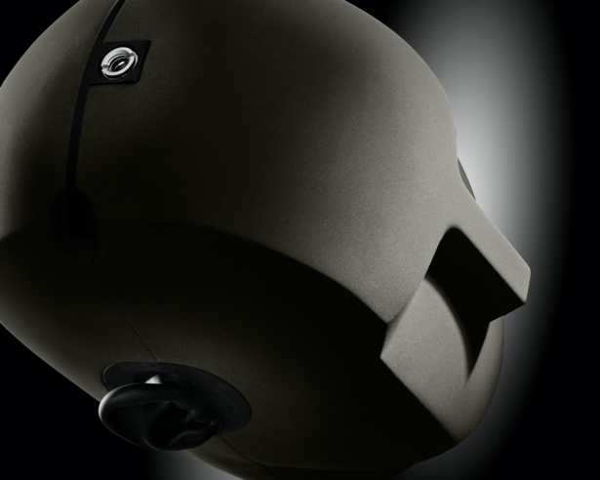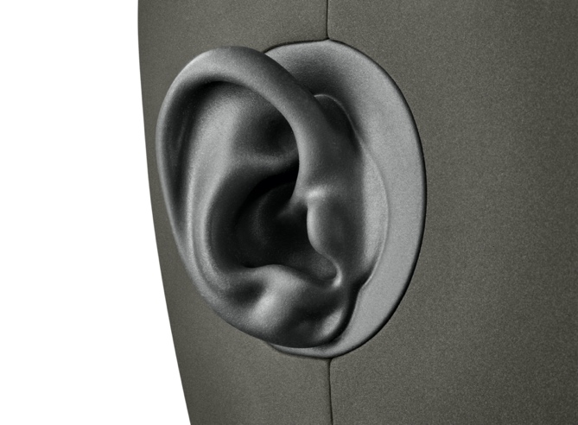

“We didn't consider other brands as we know Sennheiser and Neumann to be top class and having used their microphones in previous projects, we know them to be reliable and high quality. This piece was about intimacy and immediacy, and this would not have been possible without the truly immersive binaural recordings delivered by the KU 100. We have received an amazing response to the show at Dublin Fringe Festival, and ‘I Feel You Apart From Me’ is now available for booking. We can’t wait to travel with it to other venues and festivals!”

About Neumann
Georg Neumann GmbH, known as “Neumann.Berlin”, is one of the world’s leading manufacturers of studio-grade audio equipment and the creator of recording microphone legends including the U 47, M 49, U 67 and U 87. Founded in 1928, the company has been recognized with numerous international awards for its technological innovations. Since 2010, Neumann.Berlin has expanded its expertise in electro-acoustic transducer design to also include the studio monitor market, mainly targeting TV and radio broadcasting, recording, and audio production. The first Neumann studio headphone was introduced at the beginning of 2019. Georg Neumann GmbH has been part of the Sennheiser Group since 1991, and is represented worldwide by the Sennheiser network of subsidiaries and long-standing trading partners. www.neumann.com

Local press contacts UK:
Sarah James
sarahj@gasolinemedia.com
+44 1483 223 333

Global press contact:
Andreas Sablotny
andreas.sablotny@neumann.com
+49 (030) 417724-19

