Sennheiser MOMENTUM 4 Wireless - key features revealed
The forthcoming Sennheiser MOMENTUM 4 Wireless has an all-new design and promises exceptional sound & performance

Marlow, UK, June 15, 2022 – The Sennheiser MOMENTUM range continues to redefine the standard for sophisticated listening through superior sound. Now, the upcoming MOMENTUM 4 Wireless over-ear headphones raise the bar even higher, with best-in-class sound, advanced Adaptive Noise Cancellation and an all-new design offering exceptional comfort. The battery life is rated at an outstanding 60 hours.
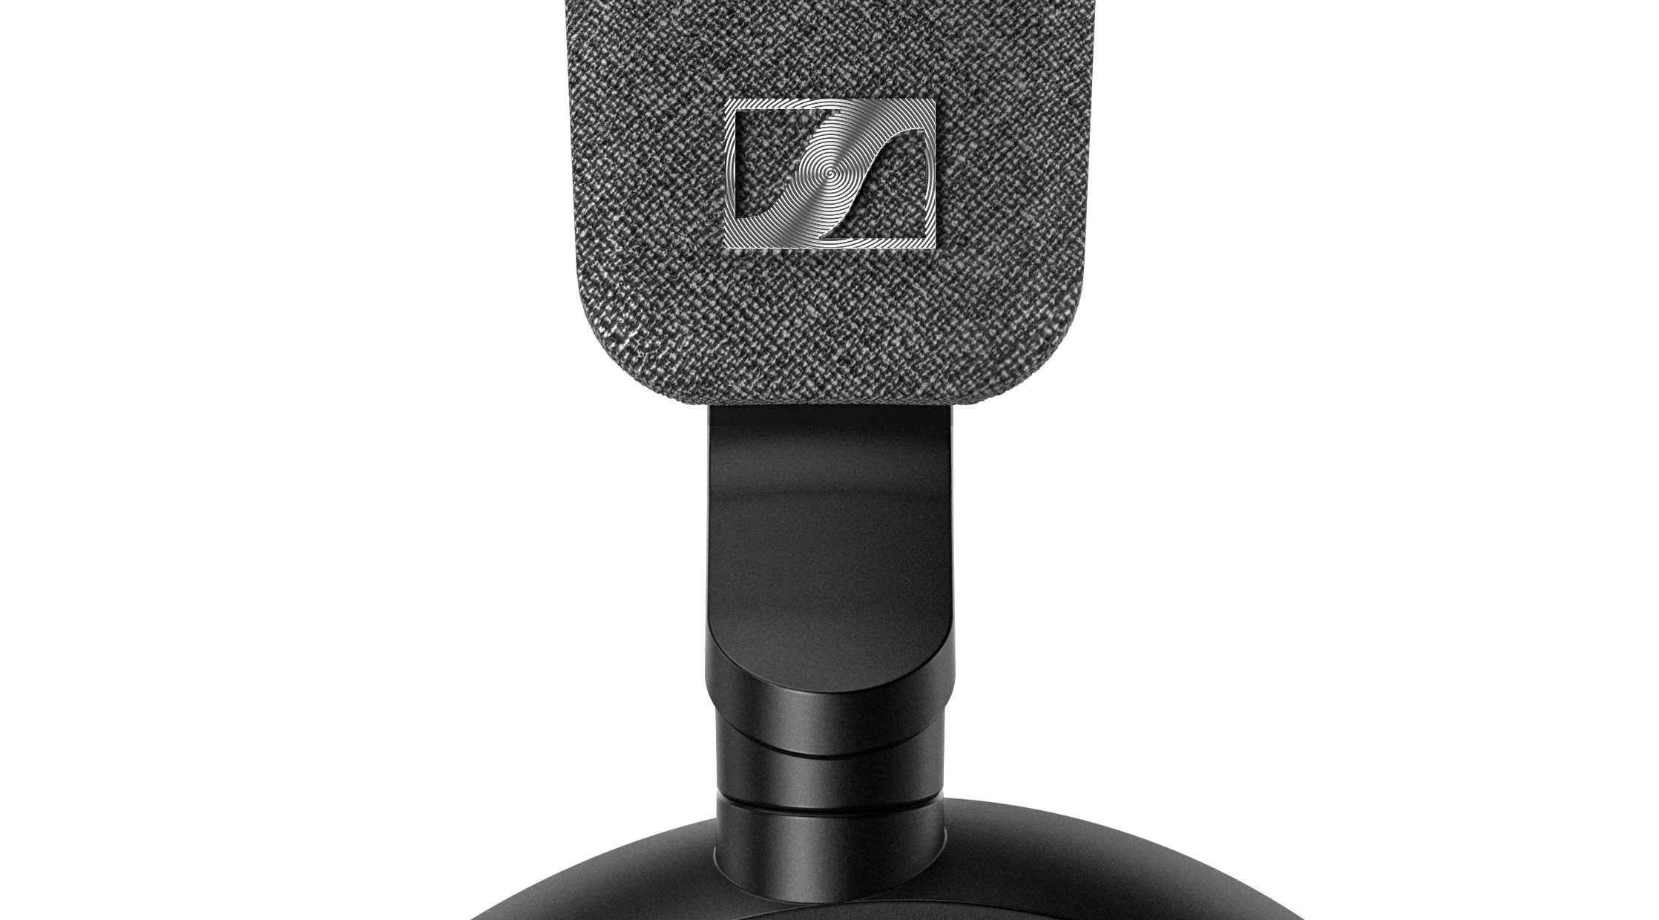

Best-in-class sound
The MOMENTUM experience starts with Sennheiser’s Signature Sound that surpasses everything in its class – letting users enjoy music as never before. An audiophile-inspired 42mm transducer system delivers brilliant dynamics, clarity, and musicality for exceptional high-fidelity sound. The angled speakers ensure sound is channeled slightly from the front towards the user’s ears to give a more natural soundstage. Advanced voice pick up provides for optimised calls and easier voice assistant access.

Advanced customisation and a new design
MOMENTUM 4 Wireless offers multiple customisations to enable users to adapt the sound to their unique preferences. An all-new lightweight design is optimised for acoustic performance, with deep cushioned earpads to ensure exceptional and long-lasting wearing comfort. The synthetic leather ear pads offer both optimum comfort and high precision in reproducing sound and ANC performance.

Availability
The Sennheiser MOMENTUM 4 Wireless will be available globally from August 2022.
About the Sennheiser brand
We live and breathe audio. We are driven by the passion to create audio solutions that make a difference. Building the future of audio and bringing remarkable sound experiences to our customers – this is what the Sennheiser brand has represented for more than 75 years. While professional audio solutions such as microphones, meeting solutions, streaming technologies and monitoring systems are part of the business of Sennheiser electronic GmbH & Co. KG, the business with consumer devices such as headphones, soundbars and speech-enhanced hearables is operated by Sonova Holding AG under the license of Sennheiser.
www.sennheiser.com
www.sennheiser-hearing.com

Press contact

Milan Schlegel
PR and Influencer Manager EMEA, Sennheiser Consumer
Milan.Schlegel@sennheiser-ce.com

Harvard PR
Sennheiser UK&I PR agency
sennheiser@harvard.co.uk

