eneloop™ prize winner in own right

Zellik, 20 December 2016 – Following the eneloop European Photo Challenge Summer edition, eneloop is once again making a donation of 5000 Euros to two lucky charities: Animal Rescue Kefalonia and WWF Netherlands. They will use this money to protect and help stray animals in Greece and life in the North Sea, respectively. In addition to providing financial support to organizations that share its green vision, eneloop itself has also won a prize. This sustainable battery brand has won first prize in the ‘Electronic’ category for its eneloop gold display in the Polish competition POS STARS 2016.

eneloop gives two donations of €5,000 to Animal Rescue Kefalonia and World Wildlife Fund (WWF)
The eneloop European Photo Challenge has been designed to highlight (amateur) photographers but also to support environmental charities and organisations. In addition to awarding prizes for the most popular photos, the brand donates €5,000 to two green organisations. In doing so, Panasonic highlights the importance that the brand places on sustainablilty, by not just offering superior environmently friendly products with its rechargeable eneloop batteries, but also by providing financial support to organisations that share the same green vision.

The main winner of the Summer edition went to a Dutch woman: she received the most votes (i.e. 2376) and is now a proud owner of a Panasonic HC-VX870 video camera (worth €680). In addition, she earns €5,000 for her selected environmental organisation: Animal Rescue Kefalonia. This organisation helps stray animals on the Greek island of Kefalonia: all stray animals are rescued and taken care of, given shelter and a new home.

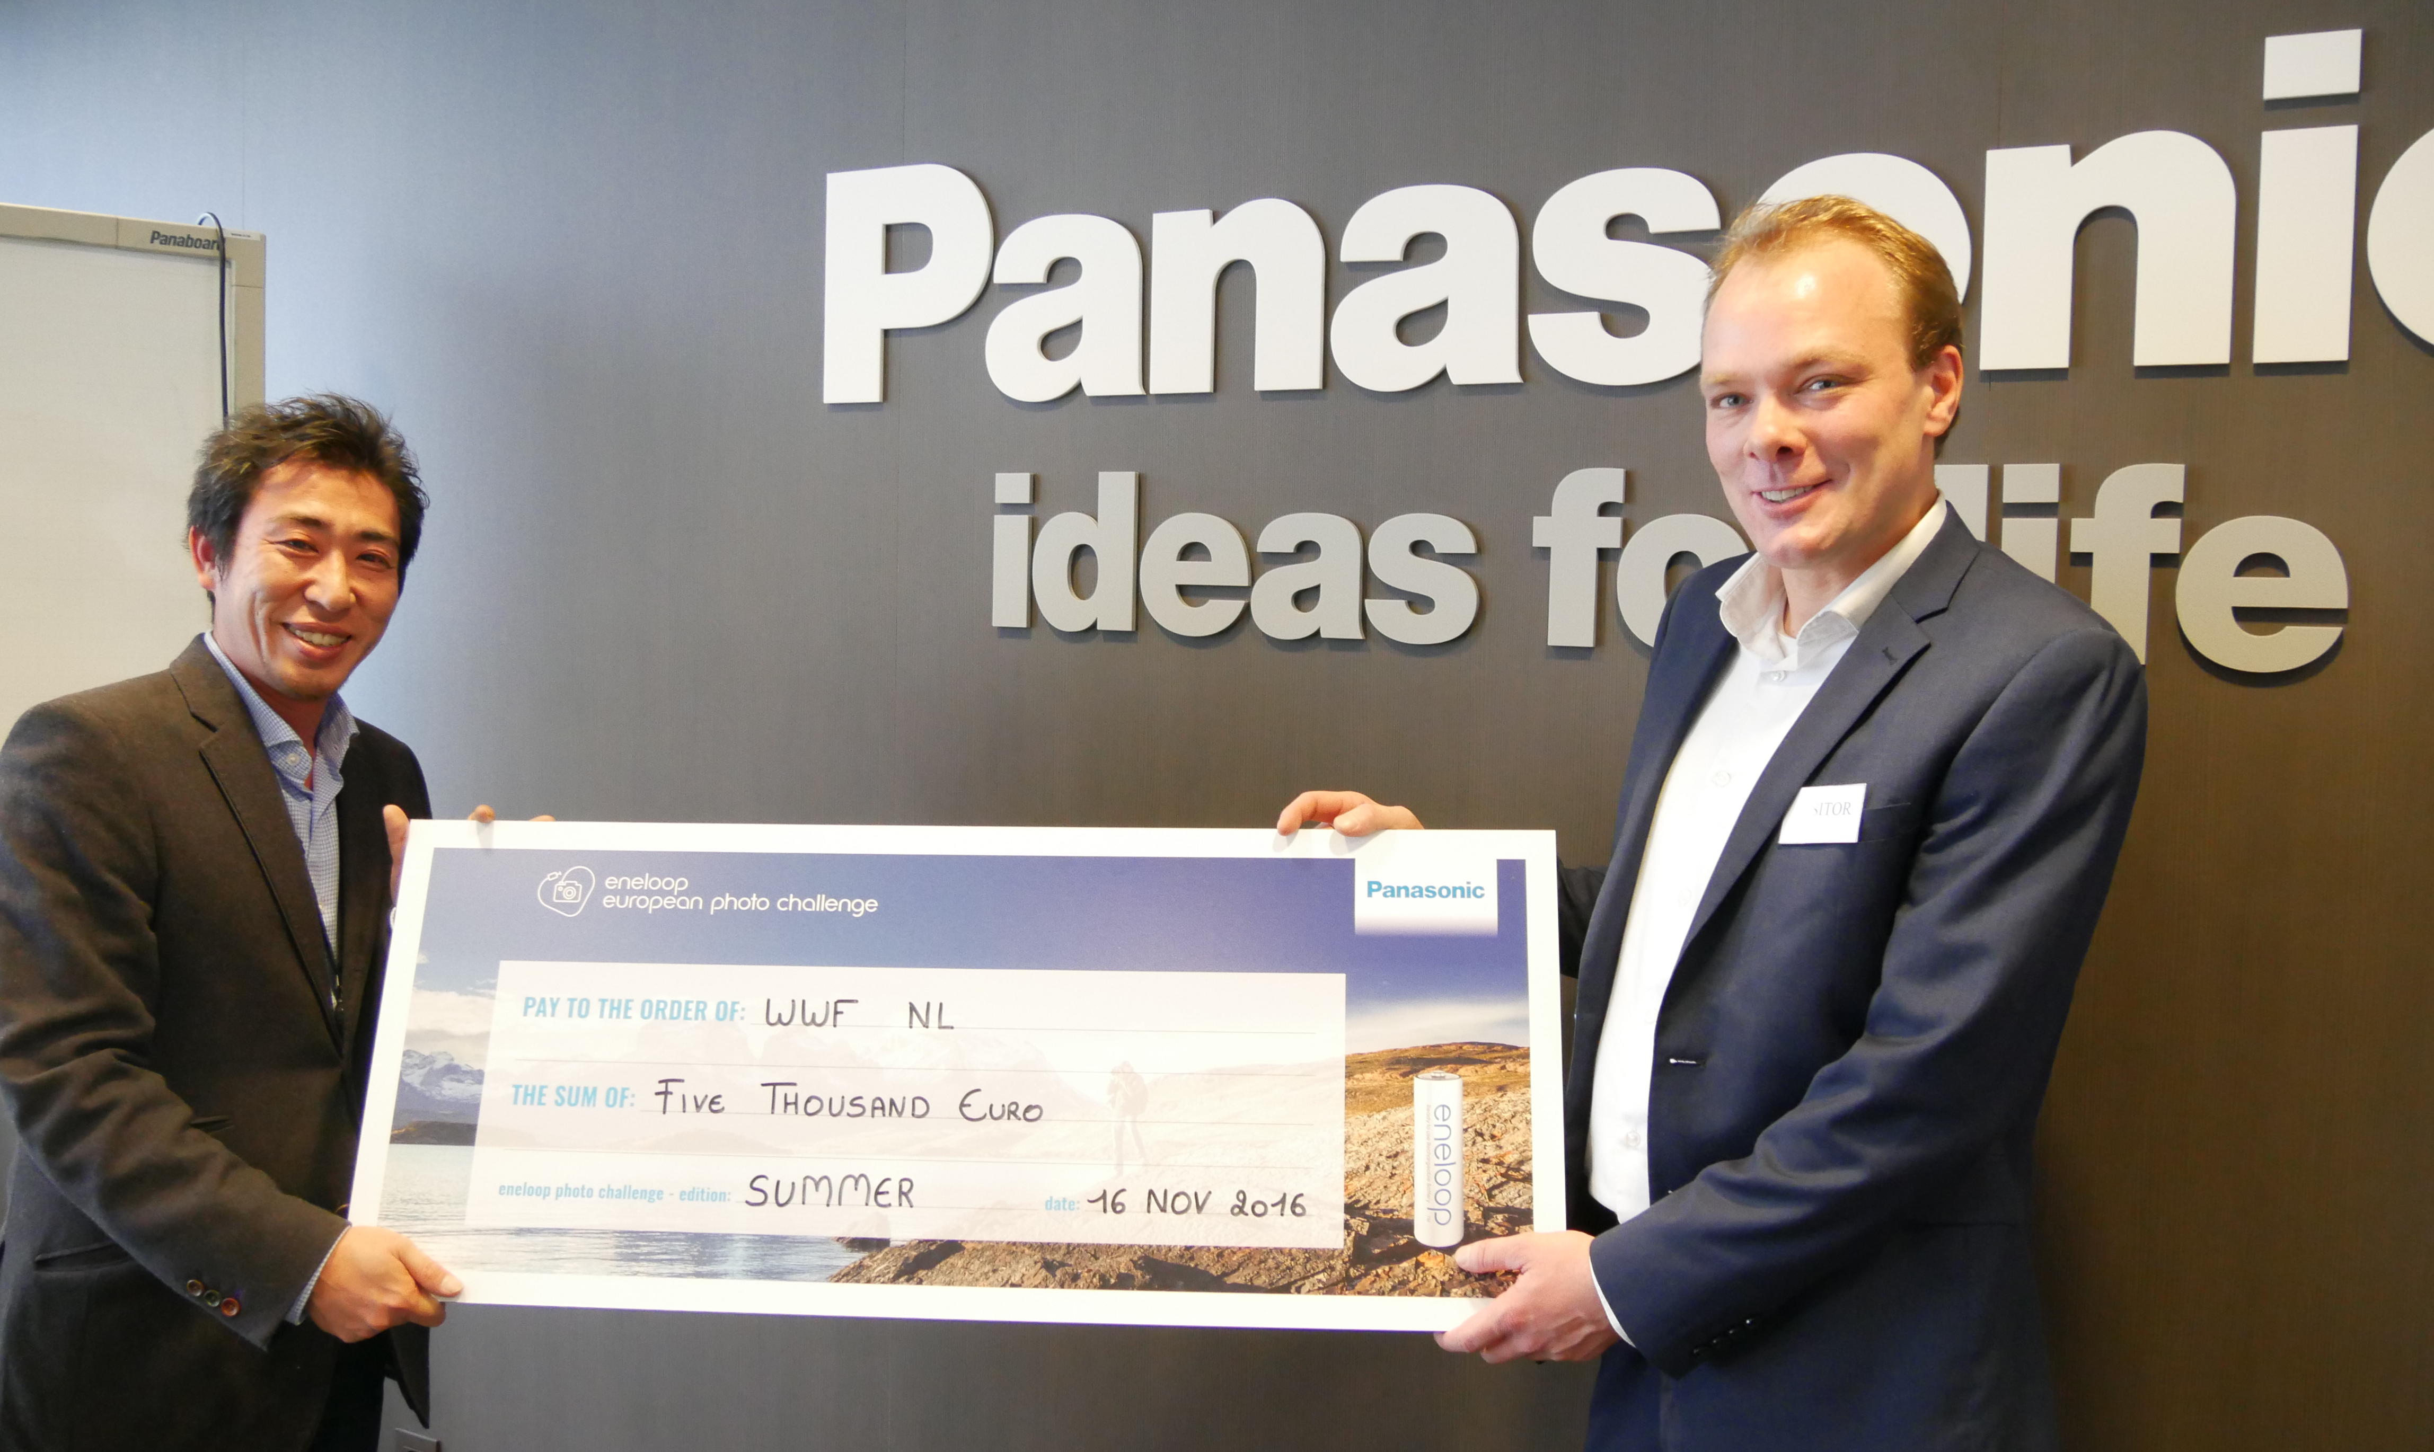
Taishi Maeda – Marketing Director Panasonic Energy Europe (left) and Rikkert van Erp – Account Manager World Wildlife Fund (right).

Moreover, eneloop is donating €5,000 to the World Wildlife Fund (WWF) in the Netherlands – the organisation to which the most photos were linked. WWF will use the money to protect life in the North Sea. “By the word oceans people often think of icy or tropical seas far away, but our own North Sea is special too. One of WWF’s aims is to bring back oyster beds – which have almost completely disappeared. A huge loss, as oysters are vital for a wide variety of sea life: lots of fish, crabs, even sharks, rays and sea birds depend on oyster beds for food and as a place to reproduce and hide”, according to Aafke Braber, North Sea expert with World Wildlife Fund.

Extra donations thanks to the Ocean and Communication edition
Good news for (amateur) photographers and charities, as eneloop is organising another two European Photo Challenge competition editions: up to 29 December 2016, 10.00 o’clock, photographers from all over Europe can send in their best Ocean themed photo. The photographer that snaps the Ocean themed photo with the most votes will win a Lumix DMC FT5 worth €330 and photograpers in each country will all have an opportunity to win limited edition Ocean rechargeable batteries and a smart & quick charger – and once more €5000 for two environmental organisations.

The limited edition Ocean pack batteries can be recharged up to 2100 times, last longer than alkaline batteries and perform better at low temperatures (as low as -20°C). Furthermore, they supply energy for longer than traditional Ni-MH batteries. Traditional Ni-MH batteries fail to work once the voltage drops below 1.1 volts, whereas eneloop batteries only fall below just before they are totally empty. For photographers who use very high drain equipment, eneloop can therefore be the difference between missing and capturing that perfect shot.

Discover here all participating environmental organisations, read more about the competition rules or take a look at the most popular entries so far. The final competition edition starts on 5 January 2017, 10.00 AM: Communication. From this date eneloop asks you to send in photographs that show communication in nature.

eneloop wins a prize too
In addition to handing out prizes, eneloop wins a prize itself too. During the Polish competition POS STARS 2016 TFP GRAFIKA – the Polish display builder of this sustainable battery brand – won first prize with its eneloop gold display. A jury made up of professionals from the sector judged all the entries sent in and awarded a prize to the best creations of the POS industry in twelve categories, including eneloop’s display in the electronics category. TFP GRAFIKA was awarded the prize on 9 September 2016.

Read more about the revolutionary eneloop batteries here.
Or take a look at previous press releases.

About Panasonic Energy Europe
Panasonic Energy Europe is headquartered in Zellik, near Brussels, Belgium. The company is part of the Panasonic Corporation, a leading global manufacturer of electronic and electrical goods. Panasonic’s vast and lengthy experience in the consumer electronics field has helped make Panasonic the largest battery manufacturer in Europe today. The European production facilities are located in Tessenderlo, Belgium, and Gniezno, Poland. Panasonic Energy Europe supplies ‘mobile’ energy solutions to more than 30 European countries. The company’s diverse product range includes rechargeable, chargers, zinc carbon, alkaline and specialty batteries (such as zinc air, photo lithium, lithium coin, micro alkaline, silver oxide).
For more information, visit: www.panasonic-batteries.com.

About Panasonic
The Panasonic Corporation is a leading company worldwide in the development and manufacture of electronic goods for a wide range of private, trade and industrial uses. Panasonic, based in Osaka, Japan, in financial year ended 31 March 2015 posted consolidated net sales of around 57.28 billion EUR. Panasonic is committed to creating a better life and a better world, continuously contributing to the evolution of society and to the happiness of people around the globe.
More information about the company and the Panasonic brand name at www.panasonic.net.

PRESS CONTACT

ARK Communication
Ann-Sophie Cardoen
Content & PR Consultant
T +32 3 780 96 96
ann-sophie@ark.be
www.ark.be

Panasonic Energy Europe NV
Vicky Raman
Brand Marketing Manager
T +32 2 467 84 35
vicky.raman@eu.panasonic.com
www.panasonic-batteries.com
www.panasonic-eneloop.com

