For immediate distribution

CES 2019: The Ultimate Sound Experience — Sonarworks Releases Mobile App, Making the Ultimate Sound Experience Accessible Anywhere
Sonarworks Redefines Music Experience for Mobile Devices,
Delivering Accurate Sonic Reference for nearly 300 Headphone Models
Las Vegas, January 7, 2019 – Pioneering audio calibration software company Sonarworks has announced the launch of its new Sonarworks True-Fi mobile app at CES 2019 [Tech West, Venetian Suites, Booth #31-209]. The revolutionary mobile app, which provides audio calibration references on both iOS and Android for nearly 300 headphone models, has already launched in ‘early access’ and will be available for purchase later this year in the App Store and Google Play at a price of $3.99 USD per month, or as a lifetime license for $99 USD. Existing Sonarworks customers who already own the desktop version will be provided a free upgrade option to a lifetime license for the mobile app.
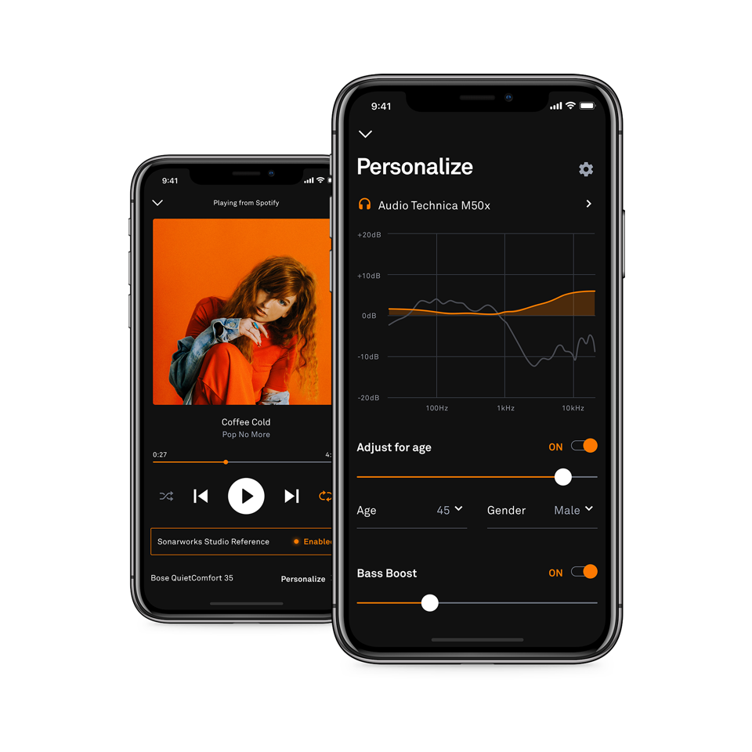
Sonarworks True-Fi mobile app — provides consumers with the ultimate sound experience ‘while on the go’ — supports wide a range of native file formats as well as content from iTunes and Android local content libraries. True-Fi mobile supports native file formats including MP3, WAV, AIFF, AAC and ALAC (iOS) and MP3, WAV, OGG (Vorbis) and AAC (Android).
A Milestone for Mobile Consumers
“All headphones invariably color sound, and this is a simple physical reality,” commented Jānis Spoģis VP of Consumer Products, Sonarworks. “Our software uses patented measurement and calibration system for ‘studio sound’, while also enabling users to customize their own listening preferences based on age and other parameters. The new True-Fi mobile app represents an enormous milestone for both artists and consumers, while helping bridge sonic translation issues that are routinely apparent between artists and millions of music fans.”

In addition to providing groundbreaking headphone calibration capabilities, True-Fi also allows the user to apply age-related hearing loss compensation and gender-based adjustments and create customized sound preferences. These features, combined with revolutionary headphone calibration capabilities, enable mobile users to have an unprecedented degree of personalization and control over their audio — anywhere they go.

Reference quality audio ‘to go’
The new mobile app, which supports nearly 300 headphones, takes just seconds to configure and is simple to operate. Once the headphone model is chosen, the user simply presses an onscreen button to engage the selected headphone configuration and the sonic profile is changed instantaneously.

Currently during the early access period, the software will support the highest sample rates possible, depending on the processing power of the hosting system. For iOS, users can expect 96kHz and higher, and Android users can currently expect sample rate performance of up to 48kHz. During the beta / early access phase, FLAC and high sample rate playback will be continually improved across all devices.

For a current list of Sonarworks supported headphones, please visit: https://sonarworks.com/truefi/headphones. Or, for a list of Sonarworks individually calibrated headphones available for order, visit: https://www.sonarworks.com/reference/individual-calibration.

For more information about Sonarworks' True-Fi, please visit https://www.sonarworks.com/truefi.
Mobile App Early Access: https://www.sonarworks.com/truefi/early-access

About Sonarworks
Sonarworks is a Europe-based audio software development company specializing in acoustic calibration software. Accurate sound is our passion. The company was founded in 2013 and entered the pro audio market in 2015. Sonarworks software is relied upon by over 30,000 recording studios and many Grammy winning artists and engineers around the world.

Media Contact:
Jeff Touzeau
Hummingbird Media
+1 (914) 602-2913
jeff@hummingbirdmedia.com
