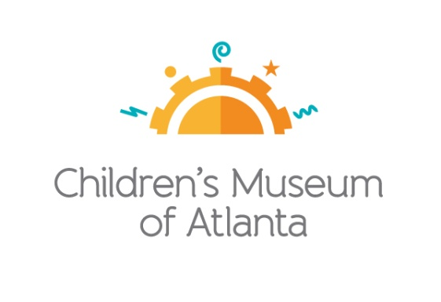

CONTACT
Becca Meyer / Jennifer Walker
BRAVE Public Relations, 404.233.3993
bmeyer@bravepublicrelations.com/
jwalker@bravepublicrelations.com

*MEDIA ADVISORY*
Beat the heat with Children’s Museum of Atlanta’s Summer Sampler Membership
Seasonal memberships available for a limited time

ATLANTA (May 1, 2017) – Children’s Museum of Atlanta invites families to steer clear of summer boredom with its new Summer Sampler Membership! Available for purchase through May 31, the special membership provides the opportunity for two adults to sign up and bring any four children to the Museum until August 31 at a discounted rate of $75.

The Summer Sampler Membership will provide free general admission and discounts at the gift shop as well as member-only rates for programs, birthday parties and special events that are held during the membership.

WHAT: Summer Sampler Membership
Family membership includes two named adults and any four children

WHEN: Available for purchase until May 31; membership valid through August 31

WHERE: Children’s Museum of Atlanta
275 Centennial Olympic Park Drive, NW
Atlanta, GA 30313

HOW: Summer Sampler Memberships are $75 and may be purchased online, on-site or by calling 404.527.5910. Some restrictions apply.

For more information or to support Children's Museum of Atlanta, visit childrensmuseumatlanta.org
or call 404.659.KIDS [5437]

###

