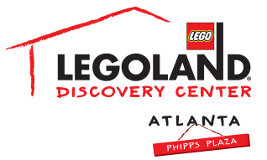
Contact information:
Katie Clark
BRAVE PR, 404.233.3993
kclark@bravepublicrelations.com

**MEDIA ADVISORY**

LEGOLAND® Discovery Center Atlanta offers LEGO® NINJAGO escape
for families this Fall Break, October 11 – 13

ATLANTA (October 10, 2017) –LEGOLAND® Discovery Center Atlanta has plenty of exciting activities to keep kids entertained this fall break! From October 11 – 13, guests can experience more LEGO® NINJAGO happenings, such as a themed scavenger hunt, LEGO build activities and so much more!

WHAT: Fall Break
More LEGO NINJAGO happenings with a themed scavenger hunt, LEGO build activities and more!

WHEN: October 11 – 13, 2017

WHERE: LEGOLAND Discovery Center Atlanta
Phipps Plaza | Buckhead
3500 Peachtree Road NE
Atlanta, GA 30326

HOW: For more information, please visit atlanta.legolanddiscoverycenter.com.

Visit facebook.com/LDCatlanta or atlanta.legolanddiscoverycenter.com.

###

