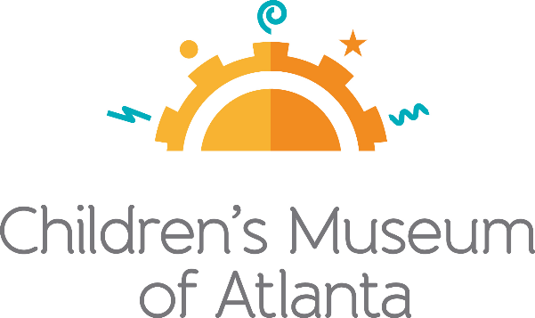

FOR MORE INFORMATION
Sarah Wynn Benton
BRAVE Public Relations
404.233.3993
sbenton@emailbrave.com

FOR IMMEDIATE RELEASE

Children’s Museum of Atlanta set to welcome limited-time exhibit,
Wild Kratts®: Creature Power®!, June 11
Featured exhibit explores the secret lives of creatures around the world

ATLANTA (May 25, 2022) –Wild Kratts®: Creature Power®!, an interactive exhibit based on the popular PBS Kids series, opens at Children’s Museum of Atlanta on Saturday, June 11. In this exhibit, created by Minnesota Children’s Museum in collaboration with the Kratt Brothers Company, kids and families will explore four animal habitats and the creatures within them. This adventurous exhibit, which focuses on cultivating STEM skills in children ages 3 to 9, invites guests to explore animal habitats from around the globe, discover incredible creature powers and go on missions to foil the villains’ nefarious plans. Kids will get moving and thinking while they explore important concepts in science and the natural world. The limited-time exhibit will continue through Sept. 5, 2022.

Building on children’s natural interest in animals, Wild Kratts®: Creature Power®! transports visitors to the Wild Kratts world, where creature adventures engage them in wide-ranging STEM experiences. Diverse environments immerse children and families in explorations of animals, habitats, and the relationships between them where they can take on challenges and missions centered around the lives of animals and their creature powers. Using an inquiry-based approach, visitors will make investigations and observations and apply what they learn in order to complete missions and challenges. Along the way, they will join the Wild Kratts team to undermine villains Zach, Donita, Dabio, Gourmand, and Paisley’s outrageous plans, using Kratts technology and the powers of science and teamwork to learn about and help animals.

Little ones will get the chance to explore four animal habitats including the Tropical Rainforest, Antarctic, Australian Outback and North America. Visitors will be able to attempt various Creature Powers® such as sneaking through the forest using the stealth of a jaguar, swinging through the tress like a spider monkey, testing their hops against kangaroos and more!

Wild Kratts®: Creature Power®! is supported by Children’s Museum of Atlanta’s generous sponsors, the city of Atlanta and the Fulton County Arts & Culture through the Fulton County Board of Commissioners and the Mayor’s Office of Cultural Affairs.

Annual Memberships provide the best value for guests and can be purchased online, in person and over the phone – providing families the gift of play and education through interactive, hands-on learning experiences all year long. Annual members receive unlimited, FREE timed entry for one year; 10% off general admission for accompanying guests; discounted admission to select ticketed museum events, museum store purchases, virtual programs and parties and invitations to members-only exhibit sneak previews.

###
About Children’s Museum of Atlanta:
Children’s Museum of Atlanta is the only educational venue of its kind in Atlanta, presenting educational programs and exhibits designed for young children ages 0-8. The mission of Children's Museum of Atlanta is to change the world by sparking every child's imagination, sense of discovery and learning through the power of play. With learning zones consisting of bright, creative and hands-on exhibits, the Museum supports inventive play-based exploration and experiential learning focused on the whole child. Core competencies for literacy, math and science are promoted throughout all exhibits and programming in alignment with the state and national Core Performance Standards. Children’s Museum of Atlanta also offers memberships. For more information or to support Children's Museum of Atlanta, visit childrensmuseumatlanta.org or call 404.659.KIDS [5437].
Museum Admission: Online ticketing only is available at this time. Phone booking is available with ample notice and will be booked via online reservation. Members must pre-book and will be able to redeem their $5 voucher online. Babies 11 months and younger and members are admitted for free and must reserve their free ticket online prior to arriving at the Museum. All daily programs are included in price of admission. For more information regarding ticket and membership options, visit childrensmuseumatlanta.org
Museum Hours: The Museum will operate in 2 three-hour sessions from 9:30 a.m.-12:30 p.m. and 1:30-4:30 p.m. with one-hour cleaning between sessions. The Museum will be closed on Wednesdays. Please check the Museum website to confirm hours of operation.

