Crisis Info 2 – South Sudanese refugees in northern Uganda
19 June 2017

1. Essential context update (mostly external)

- Uganda continues to receive new arrivals from South Sudan. The total number of South Sudanese refugees in Uganda is reportedly more than 950,000, which will reach one million in the coming weeks, with on average 1,613 new refugee arrivals each day in May.
- In the northern Ugandan districts of Adjumani, Yumbe and Moyo, more than 30% of the current population are refugees.
- Food is becoming an increasing concern for both the host population and the refugees. WFP cut food rations by 50% due to lack of funding, while a continued drought is impacting food prices throughout northern Uganda. In some of the refugee settlements, tensions have risen among people reacting to cuts in food rations and some refugees are even returning to South Sudan because of a lack of food.
- Imvepi refugee settlement, where newly arrived refugees have been relocated to since February 2017, is expected to be full in the coming weeks. A new settlement, an extension of Rhino, is planned to open in the coming weeks.
- On 22-23 June, the Uganda Solidarity Summit on Refugees will be held in Kampala to mobilise international support and funding to meet the needs of both refugee and host communities as well as to showcase Uganda’s model of refugee management, protection and social integration. A team from MSF will attend the summit and do advocacy rounds on the side lines.

2. MSF highlights – essential info

- With the rainy season underway, floods have affected parts of Palorinya refugee settlement and further displaced more than 100 households and necessitated an extension of the refugee settlement to be opened. MSF donated latrines as people were moved before the site had been prepared. Heavy rain has also caused the roads to deteriorate, leading to decreased access to clean water as well as poorer sanitation services in the areas affected; there is a high risk of cholera and other waterborne diseases. An E-prep plan is ongoing for a potential cholera outbreak.

- Due to the rains, MSF is seeing increasing numbers of malaria cases. Between 22-28 May, MSF treated 853 patients for malaria in the Palorinya and Rhino settlements, compared to 488 in the week 15-21 May. Plans are in place to start mobile clinics/malaria points in the settlements to improve access to patients and decrease the load on the clinics. In Bidi Bidi and Imvepi, malaria is also the top morbidity.

- There has been a continuous increase in the total number of consultations, which could be attributed to the increase in the number of malaria cases.

- Initial discussions have begun on a possible handover of MSF’s medical activities to Medical Team International (MTI) – UNHCR’s health implementing partner – in Palorinya and Rhino and Bidi Bidi refugee settlement; additional partners are being identified, but these do not look promising due to a lack of funding of implementing partners. In Bidi Bidi, MSF handed over the main water and sanitation activity to OXFAM and will start motorising a new borehole in June.

- Due to flooding in some zones in Bidi Bidi, MSF set up a mobile clinic once a week for a month in order to prevent diarrhoea outbreak and built 10 communal latrines as an emergency response.

3. MSF factsheet
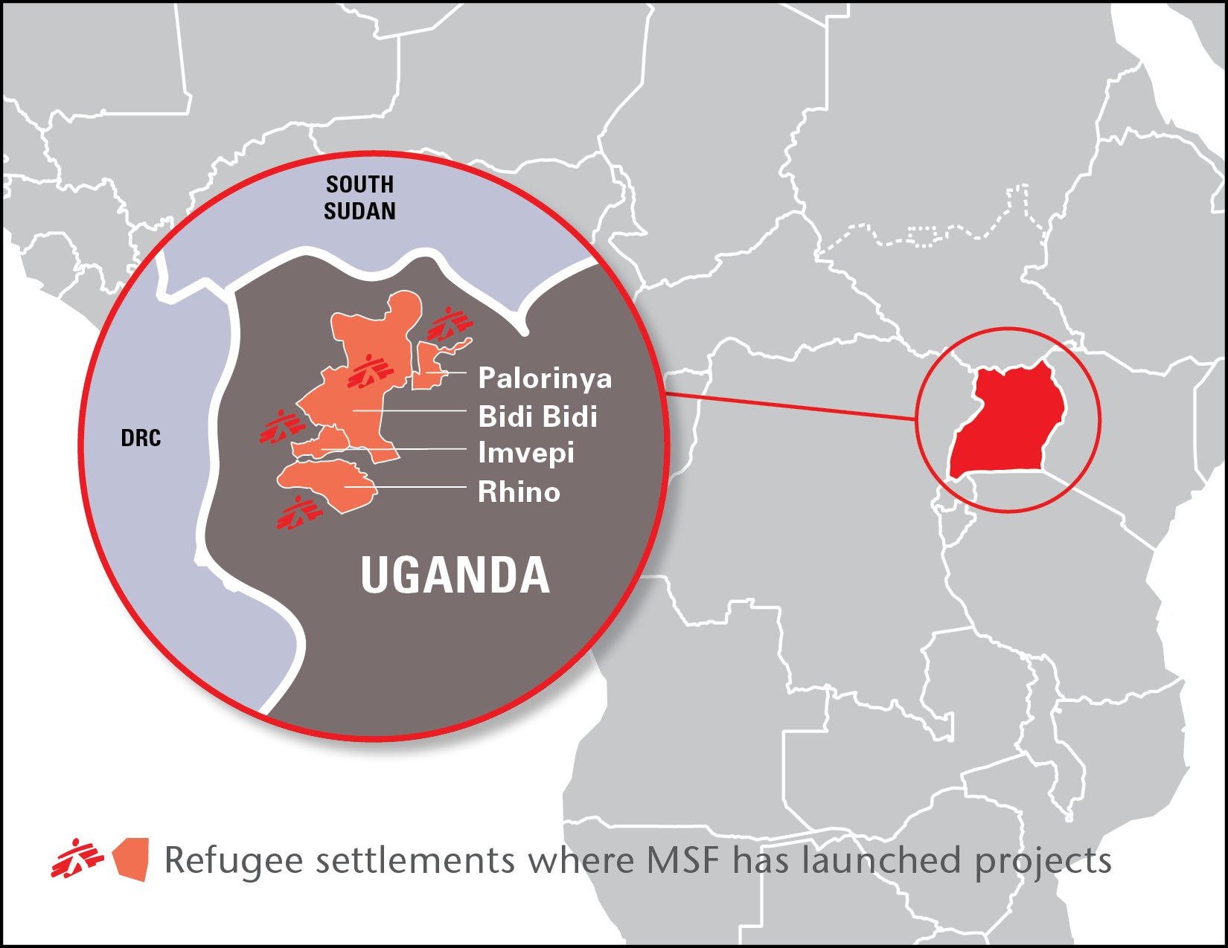

- International staff: 46
- Ugandan and South Sudanese staff: 853
- Medical data – May (April)

Outpatient consultations: 33,442 (21,092)  Inpatient: 228 (171)  Deliveries: 100 (32) | ATFC: 53 (74)  Vaccinations: 19,304 (23,606)  Malaria cases: 10,926 (3,307)  SGBV: 31(-)

- Malaria: Cases almost doubled from 488 in week 20 (15-21 May) to 853 in week 21 (22-28 May) in Palorinya and Rhino. In an inpatient clinic in Rhino, there were 54 admissions during the week from 19 May to 4 June out of which 74% was due to malaria. In Bidi Bidi, there were 8623 malaria cases in May in comparison to 5390 cases in April.

- Rubella: 18 cases of suspected rubella in Palorinya and five in Rhino (two confirmed). MSF is focusing on awareness through messaging active case finding on Rubella.

- Water production:
Palorinya – in total 60,203,000 litres of clean water were provided in May from the water treatment plant.

Rhino – in total about 2,000,000 litres were produced in May

Bidibidi- about 643,000 litres per day were produced in May from the artesian well (32 trucks per day)

- SGBV: case are mostly detected in Imvepi reception centre; 27 cases out of 31 in May

- Mental health: in Imvepi, MSF conducted 338 consultations and 58 follow-up diagnoses at the reception centre while 88 follow-up cases were conducted in mobile clinics, for symptoms including depression, Post-Traumatic Stress Disorder and epilepsy.

4. News by project

Bidi Bidi

- Bidi Bidi refugee settlement in Yumbe district was opened in August 2016 and hosts 272,206 people as of 12 June. It has now stopped receiving new arrivals to avoid overcrowding and people are being relocated to Imvepi refugee settlement. As of 14 June, all health actors in Bidi Bidi are running out of malaria drugs and are asking MSF and Ministry of Health for supplies.

Zone 2
- MSF handed over health and WASH activities at the end of May.

Zone 4 annex
- MSF is providing health care including outpatient care, inpatient care with 34 beds, maternity, antenatal care, nutritional screening, mental health, and sexual and gender-based violence (SGBV) package.

- MSF artesian well has been handed over to Oxfam in May; 32 water trucks a day are rotating and distributing water in zone 3, 4, and 5. Latrines for People with Special Needs (PSN), including female-headed households and unaccompanied minors were handed over to OXFAM. They will carry out hygiene promotion and monitoring and chlorinating water tanks.

- MSF is currently motorizing a borehole to connect water for the inpatient ward and the community.

- MSF started Integrated Community Case Management (ICCM) in zone 4 annex to carry out door-to-door Malaria test and treatment, which target children under five years old.

All zones
- MSF has implemented a public health surveillance system across all of Bidi Bidi settlement. This includes the supervision and support of the Village Health Teams (VHT), weekly data collection and reporting, and case investigations as required.

- A mental health team is based in all MSF health’s care facilities.

Imvepi

- Imvepi refugee settlement in Arua district was opened in February 2017 and now hosts 107,330 people as of 12 June. New arrivals continue to be relocated to Imvepi.

- In the reception centre, an average of 700 to 800 people arrive per day in May. We are immunizing all newly arrived refugees as well as a journey survey in order to know more about the personal history of the refugees and better understand the level of violence they experienced on the way to Uganda. We also run a sexual violence and mental health clinic in the reception centre.

- MSF run three mobile clinics in the settlement providing antenatal care, nutritional feeding programme, and mental health package.

- MSF has built 100 latrines for newly settled people.

- A public health surveillance system has been set up with the support of Epicentre. Once the situation has been stabilised, the emergency team in Imvepi will assess new settlements opening near Rhino refugee settlement.

- Emergency teams regularly visit Kuluba and Goboro transit centres which receive new arrivals from the different entry points on the border and check if any sexual violence cases have been seen by other health organisations. MSF has given them training on SGBV and provided a post-exposure prophylaxis kit.

Palorinya

- Palorinya refugee settlement in Moyo district opened in November 2016 and hosts more than 170,000 people as of 12 June. Most new arrivals now are reunification cases.

- Due to the rains, flash floods across Palorinya camp are leading to the displacement of hundreds of people. MSF donated latrines as people were moved without a site being prepared.

- Medical: MSF runs five health posts, providing basic healthcare, including a nutrition programme for children under five, antenatal care, and a 24-hour ambulance service for referrals to a higher level of medical care in the settlement or to Moyo District Hospital. Main morbidities are malaria, acute water diarrhoea, and respiratory tract infections.

- Health surveillance: A newly extended zone has been occupied by refugees; community surveillance teams have visited the site to assess population numbers and the health status of the population, to inform new arrivals about available healthcare services, refer patients to the clinics in the area and to assess any other pressing needs within the new community.

- Water and sanitation: MSF produces an average of two million litres per day of clean drinking water from the Albert Nile River. Despite increased production, access to adequate water is hindered due to an inefficient trucking system and deteriorating road access due to rains. In particular the access road to the water treatment plant is a cause of serious concern. Trucks getting stuck in mud are now a daily occurrence. MSF teams, with the help of UNHCR, have attempted to repair the road and we now have a small road maintenance team for the access road.

Rhino

- Rhino refugee settlement in Arua district hosts 86,770 people as of 12 June. The Office of Prime Minister and UNHCR are planning to open Rhino extension in the coming weeks although there is no clear plan to supply water to the settlement in the short or long term.

- Medical: MSF has been working in Ofua zones in Rhino since February 2017, opening a healthcare centre with an inpatient department, maternity ward and two outreach health posts. Seventy-five percent of outpatient admissions are for malaria cases (as of 26 May).

- Water and sanitation: Access to water remains the biggest issue in Ofua zones, with people still receiving approximately seven litres per person per day. In order to implement more sustainable water solutions, MSF is motorising two boreholes from which water is delivered through pipelines to a central storage and distribution place. MSF has also set up 17 tap stands to ensure access to water for the community in Ofua 4 and 5 through a gravity system. In total, 8.3 km of piping (mother pipe line and gravity pipeline) have been completed. In addition, MSF has completed a water tank cleaning campaign of all the water tanks in Ofua – a total of 26 water tanks.

- Health surveillance: As MSF identified many households lacking bed nets, while seeing an upsurge in malaria cases, teams have implemented mosquito net distributions. A total of 20,517 nets were distributed as per WHO standard of one net for every two people, and this covers 74.8% of the households in Ofua.

5. Key messages

- Despite the massive influx of refugees from South Sudan, there are gaps in the humanitarian response and MSF believes the international response in Uganda is failing refugees. Uganda has progressive refugee policies which gives refugees a number of rights, including freedom of movement, employment rights, as well as plots of land. But the success of this policy depends on greater international support, more sustainable planning, and more careful allocation of existing funds. For instance, funding shortages have prompted WFP to cut its food rations in half, while delayed distributions of food are worsening people’s nutrition status. A scale-up of humanitarian assistance followed by an improvement in coordination is urgently needed and world leaders and humanitarian agencies need to prioritise refugees’ basic needs.

- The rainy season is putting additional strain on conditions in the refugee settlements. Access to water is now even more challenging due to deteriorating road conditions. In the Ofua zones in Rhino, people received an average of seven litres per person per day in May, well below the minimum standard of 20 litres per person per day. There are only two water treatment plants for the settlements in northern Uganda, and there are not enough boreholes in any settlement. Access to water in the settlements is dependent on water trucking system, a hugely expensive task often derailed by poor road conditions. A longer term and most cost-effective solution must be found.

- Health interventions have also been complicated by the time-consuming nature of regular importation procedures for medical supplies, notably because of the lengthy bureaucratic requirements for importing medical supplies. MSF requests the Government of Uganda expedite pending importation requests and to fast-track medical importations for emergency health kits and medical supplies to facilitate a scale-up of the emergency medical response.

- MSF is concerned about the scale and severity of violence, including sexual violence, as many people have reported seeing or experiencing violence in their place of origin, on their journey to Uganda, as well as in the refugee settlements in Uganda. This issue demands an increased focus and additional capacity allocated for protection and essential psychological and medical care for sexual violence.

UNHCR, 12 June 2017

