EVERYTHING IS RECORDED

RELEASES NEW SINGLE ‘MOUNTAINS OF GOLD FT. SAMPHA, IBEYI, WIKI & KAMASI WASHINGTON’

WATCH THE NICK WALKER-DIRECTED VIDEO HERE

Everything Is Recorded – the new collaborative artist project from Richard Russell – today release a new single, ‘Mountains Of Gold’ via XL Recordings. It sees the record producer and XL Recordings head, renowned for his album production work for Bobby Womack, Damon Albarn, Ibeyi and Gil Scott-Heron among others, collaborating with a diverse host of acclaimed artists in the form of London’s very own Sampha (who also lent vocals to Everything Is Recorded’s debut track ‘Close But Not Quite’), French-Cuban duo Ibeyi, NYC rapper WIki and LA jazz titan Kamasi Washington.

"’Mountains of Gold’ is sound system inspired, you can hear a lot of strong and different personalities and voices in the one song, but the feeling is consistent. Everyone has plenty of space" – Richard Russell

‘Mountains Of Gold’ comes accompanied by a Nick Walker-directed video. The video, which was shot in Los Angeles, features, in order of appearance, Kaner Flex, Lisa-Kainde Diaz (Ibeyi), Mela Murder, Naomi Diaz (Ibeyi), Infinite, Sampha, Wiki, Kamasi Washington, Hardy Blechman, Richard Russell and Quincy Jones.

Watch the ‘Mountains Of Gold’ video HERE

‘Mountains Of Gold’ is the follow up to Everything Is Recorded’s debut ‘Close But Not Quite’ EP, which featured a similarly eclectic host of international artists including Sampha, Giggs, Obongjayar, Tic, Warren Ellis, Infinite, Mela Murder, Green Gartside and Baluji Shrivastav.. Both releases provide a captivating snapshot of the kind of collaboration and experimentation that has taken place at Russell’s west London studio, The Copper House. This studio has become a creative second home for a revolving cast of vocalists and musicians who pass through to write, record and share ideas, mixing traditional recording sessions with extended, uninhibited live jams.

‘Mountains Of Gold’ is available from today on all digital services and on 12” vinyl featuring exclusive B-side ‘Mountains Of Dub feat. Kamasi Washington’. ‘Mountains Of Dub’ also features live mix and outboard effects by Brian Eno, Redlight and Seb Chew.

Look out for more Everything Is Recorded releases in the very near future.

‘Mountains of Gold’ artwork

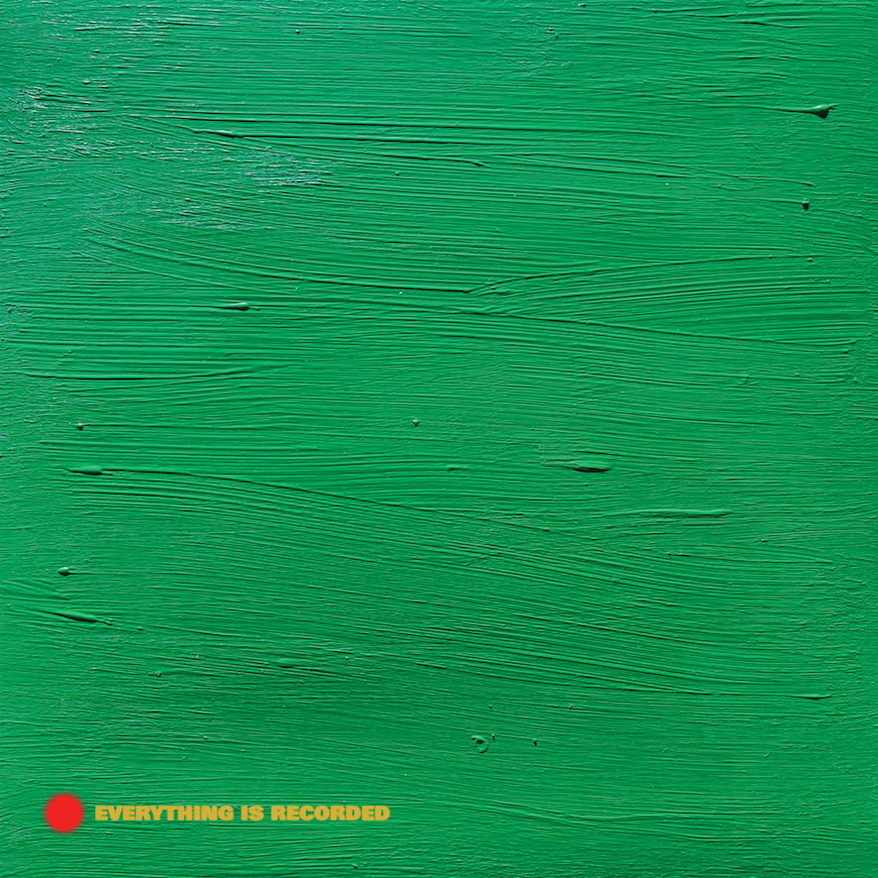

More on Everything Is Recorded:
https://www.instagram.com/everythingisrecorded

