For more information, please contact Marta de Paco
On +34 670 780 664 or email press@comunicahair.com

Important:
These images are only available for editorial content.
Credits must be included.
Notification of their publication is expected.

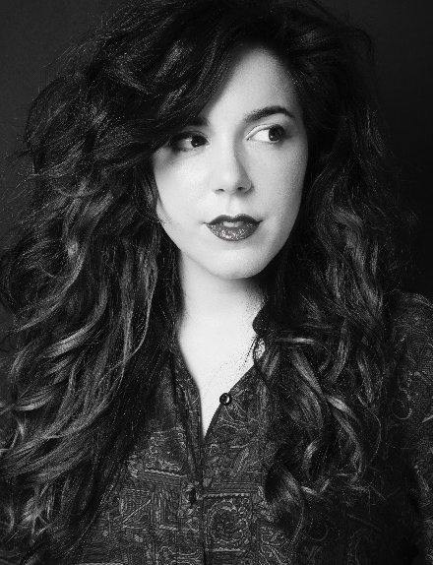
ALAZNE MONTERO
SPECTRUM Collection

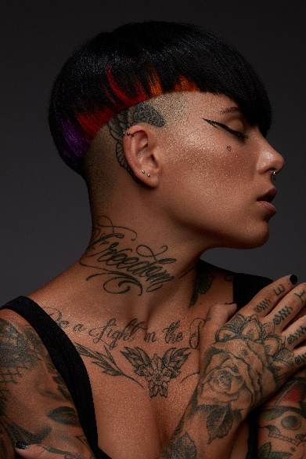
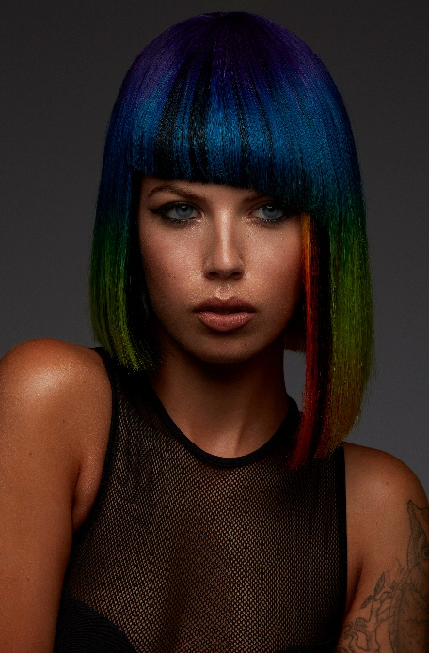
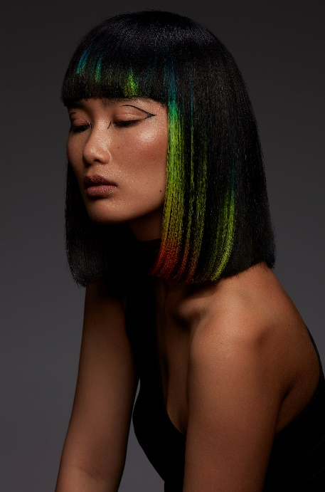
Hair: Alazne Montero | @alaznemontero
Hair Instagram: @furundarenapelukerak
Photography: Joao Ngalia | @joaongalia
Retouche: Joao Ngalia | @joaongalia
MUA: Alba Herrera | @albaherrera.muah
Styling: Alazne Montero | @alaznemontero
Models: Suvdae Batsuuri | @suvdae Bianka
Szamosi | @bian_sz
Haizea Gómez | @haizeaxs
Alba Herrera | @albaherrera.muah
Products: Goldwell | @goldwellpro_es

ALAZNE MONTERO
SPECTRUM Collection

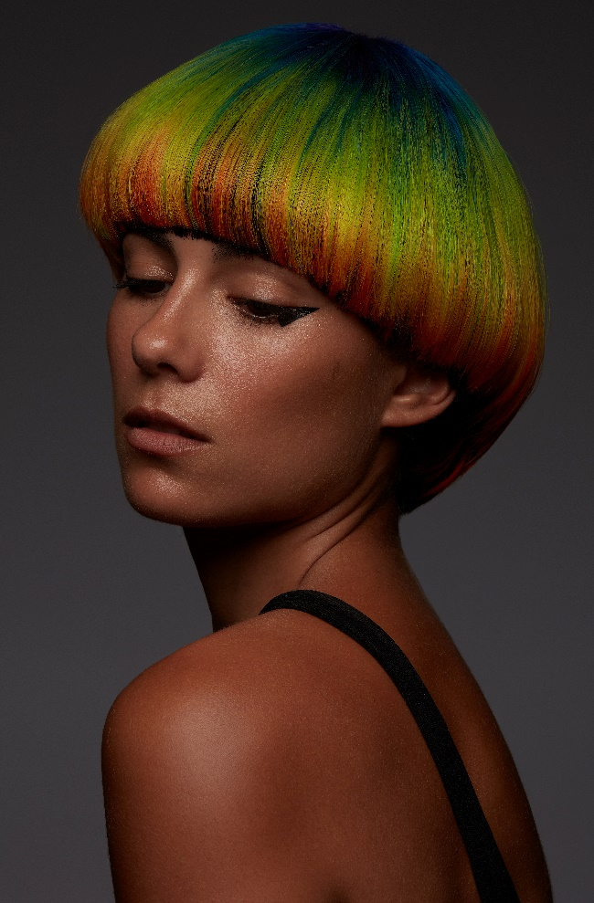

The collection delves into the duality of human beings, in its light and dark. Brightness is represented by the colors of the light spectrum and darkness is represented by the color black. In the looks, the elements, the different color arrangements evoke how sometimes "darkness" covers everything almost completely. Also, how they can coexist and complement each other or how "light" is sometimes so powerful that it can handle everything.
The result of this game of contrasts is an intense and surprising hair that captures the uniqueness of the game of lights and colors, always with a glossy finish.

