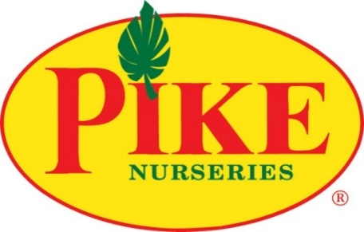

For more information:
Laurel Haislip/Becca Meyer
BRAVE Public Relations
404.233.3993
lhaislip@bravepublicrelations.com/
bmeyer@bravepublicrelations.com

**MEDIA ADVISORY**

Pike Nurseries to host Career Fair for new Lake Norman location, January 24

Job opportunities available at largest independent garden retailer

CHARLOTTE (January 18, 2018) – In preparation for the new location in the Lake Norman area, Pike Nurseries will host a Career Fair on Wednesday, January 24 from 1 p.m. –4 p.m. at the Matthews store, located at 1016 Devore Lane. The nation’s largest independent garden retailer plans to add approximately 20 associates – in all positions, including sales, manager trainee, maintenance and loading – to its new Lake Norman store in the coming weeks. Applicants who love people and playing in the dirt are encouraged to apply.

Pike Nurseries is employee-owned with opportunities for growth and development. Pike Nurseries offers a comprehensive benefits package including medical, dental, 401K and as an employee-owned company, provides employee stock-ownership.

The Lake Norman Pike Nurseries location plans to open its doors in spring 2018. Pike Nurseries is a full-service garden company that offers trees, shrubs, perennials, vegetables and more -- as well as a collection of lifestyle products such as pottery, fountains, patio furniture and birding supplies. Known for their knowledgeable local garden experts at all locations, the garden centers also provide landscape design, installation and planting services to help homeowners as much or as little as they would like in their gardens.

WHAT: Pike Nurseries Career Fair
Local garden center hiring for all positions, including sales, maintenance and loading

WHEN: Wednesday, January 24 from 1-4 p.m.

WHERE: Pike Nurseries Matthews location
1016 Devore Lane
Matthews, N.C. 28105

How: For information on Pike Nurseries careers or to see a full list of positions available, visit pikenursery.com/careers.

###

ABOUT PIKE NURSERIES
Ever committed to its customers’ gardening success, Pike Nurseries, an employee-owned company, takes pride in taking the guesswork out of gardening and helping its customers play in the dirt. Offering superior knowledge, quality and selection in a friendly, caring environment, Pike Nurseries has been an Atlanta icon for over 60 years. Founded in 1958 by Pete Pike, its ability to adapt to market conditions and community needs has made it a respected Southern institution. As Atlanta’s oldest garden chain, Pike Nurseries has 17 retail locations in the Atlanta, Ga., and Charlotte, N.C. areas. Now led by CEO Mike Kunce, Pike Nurseries looks forward to continued growth as it keeps Atlanta and Charlotte beautiful, one landscape at a time.

For more information, please visit Pike Nurseries online at www.pikenursery.com.
Visit Pike Nurseries on Facebook, Twitter, Pinterest and Instagram.

