QUEENS OF THE STONE AGE

“THE WAY YOU USED TO DO” VIDEO NOW VIEWABLE ON YOUTUBE FOR FIRST TIME
WATCH HERE

- JOSH HOMME JOINS ‘A PEACEFUL NOISE’ LINE-UP WITH
EXCLUSIVE ACOUSTIC SET LIVE AT ULU 25TH NOVEMBER 2017
www.apeacefulnoise.com

- QOTSA UK TOUR STARTS AT WEMBLEY ARENA ON SATURDAY 18th NOVEMBER

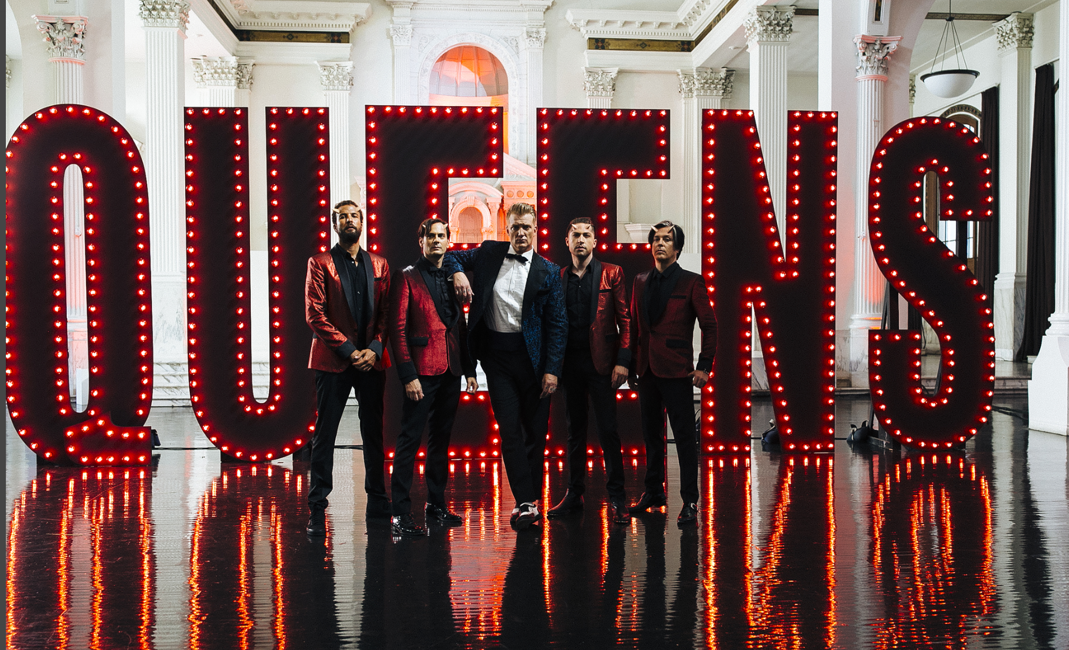

The video for “The Way You Used To Do,” taken from Queens Of The Stone Age’s UK Number One album Villains, is now available to view on Youtube for the first time. The devilish promo has been realized as a fever dream Satanic dance ritual extravaganza—featuring QOTSA founder and frontman Joshua Homme lighter on his feet and darker in his soul than ever before.

Conceived by Joshua Homme, directed by Jonas Akerlund and produced by Serial Pictures, “The Way You Used To Do,” somehow fit its multiple sets, wardrobe changes and intricate dance routines into one day of shooting in Los Angeles. Considering potential reactions to the sinister shuffle of “The Way We Used To Do” being translated into a panoramic soul-selling dance trip, Homme says “It’s our way of paying tribute to Cab Calloway and the film Hellzapoppin’. I fully realize that may be a little more than some are open to, and that’s perfectly fine with me. There’s the door. If some of the more close-minded are gently pruned, that just leaves more room on the dance floor for the open-minded ones to get loose. That’s been the spirit of Queens Of The Stone Age and the space we’ve worked to create from day one.”

Villains was co-produced by Mark Ronson is out now on Matador Records. The album is available now at http://smarturl.it/Villains.

The Nick Alexander Memorial Trust (NAMT) is extremely excited to today announce that Joshua will be performing an acoustic set as part of the second annual A Peaceful Noise show in aid of NAMT and Josh’s Sweet Stuff Foundation at ULU Live on 25th November. A founder member of Eagles of Death Metal, whom Nick was touring with in November 2015 when the attack at the Bataclan took place, Joshua is a valued supporter of the Memorial Trust and we are hugely honoured to have him join us for our flagship fundraiser. With sets from False Heads, Frank Turner and Band of Skulls Joshua’s appearance makes an already legendary night truly unmissable. Full details on below link.

www.apeacefulnoise.com

The colossal Villains tour also hits the UK this Saturday (18th November) with shows at London Wembley Arena and Manchester Arena and will also see Queens play sold out shows at London O2 Arena, Edinburgh Usher Hall and Dublin 3Arena. Tickets for the headline dates are available at http://smarturl.it/QOTSALive.

Queens Of The Stone Age are Joshua Homme, Troy Van Leeuwen, Dean Fertita, Michael Shuman and Jon Theodore.

QUEENS OF THE STONE AGE VILLAINS UK and Ireland Tour details:

Saturday 18th November London Wembley Arena
Sunday 19th November Manchester Arena
Tuesday 21st November London O2 Arena - SOLD OUT
Thursday 23rd November Edinburgh, Usher Hall - SOLD OUT
Friday 24th November Dublin 3Arena - SOLD OUT

Remaining tickets on general sale here

Praise For Villiains

“Villains is brilliant. It's all the things that make QOTSA such a thrilling band condensed into a jolting, compact rock record” / “Desert-dry guitars, motorik rhythms and his own too-cool-for-school-croon…Josh Homme’s winning formula”
✮✮✮✮ Q Magazine

“Heroic stuff.....Homme had already done more than anyone of his generation to pump new heart into rock. Now with an unlikely ally, he's revived the soul too” / “Quintessential QOTSA swagger”
✮✮✮✮ MOJO

“QOTSA at peak party…The sound of living in the moment and it’s glorious”
✮✮✮✮ NME

“Josh Homme and Mark Ronson make dance rock theatre” / “A surprisingly welcome balance between Black Sabbath and disco”
Uncut 8/10

“Deep and danceable delight” / “My, have they come to party”
Classic Rock 9/10

“A great rock ‘n’ roll group” / “Josh Homme's desert vikings beef up their myth” / “sweet and supple melodies galore on this Mark Ronson-produced album”
✮✮✮✮ The Guardian

“One great riff and hook after another”
✮✮✮✮ The Times

“wisecracks about mortality over a driving Led Zeppelin groove”
✮✮✮✮ Financial Times

“Off-hand cool”
✮✮✮✮ i

“Tight as heck and curiously admirable”
✮✮✮✮ Evening Standard

“A reinvention that manages to sound both quintessentially QOTSA and forward-thinking... Villains cuts comfortably shoulder the best of QOTSA's back-catalogue”
✮✮✮✮ Kerrang!

“Their most danceable offering yet - and all the better for it”
✮✮✮✮✮ DIY Mag

