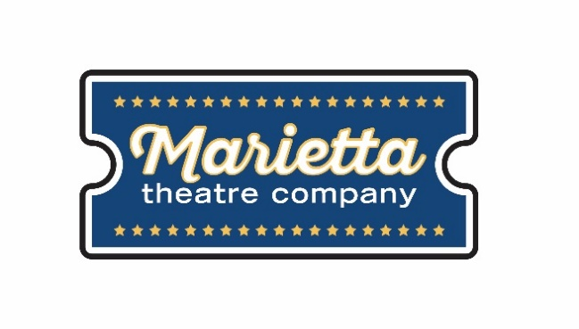

For more information:
Laurel Haislip
BRAVE Public Relations
404.233.3993
lhaislip@emailbrave.com
FOR IMMEDIATE RELEASE

Marietta Theatre Company wraps inaugural season with [title of show], June 8 – 23
Theatergoers invited to downtown Marietta for a musical about making musicals!

Marietta, GA (May 21, 2018) – To conclude a highly successful inaugural season, Marietta Theatre Company is bringing audiences backstage with a musical about writing musicals with [title of show], running June 8 through June 23 at the Lyric Studio on the Square. Written by Hunter Bell with music and lyrics by Jeff Bowen, the Obie Award-winning, internationally acclaimed, one-act musical tributes famous musicals of Broadway’s past and the magic of collaboration and determination.

“The success of our inaugural season would not be possible without the tremendous support of our patrons in the community,” said Blaine Clotfelter, president and co-founder of Marietta Theatre Company. “We’re grateful for the opportunity to bring this award-winning show to our audiences - it’s a story of determination and big dreams that will resonate with anyone who has ever been brave, bold and courageous in their own lives.”

With the submission deadline for an original musical looming, two struggling writers must put their heads together and pens to paper to create a musical that will finally accomplish their dreams of becoming renowned artists. Jeff (Jeff Cooper) and Hunter (Blaine Clotfelter) enlist the help of their friends, Susan (Becky Ittner) and Heidi (Gina Ann Riggs), to make a musical with only four mismatched chairs, three weeks, two writers, one keyboard and a lot of creativity. [title of show] follows the group of friends throughout the writing and performing process, ultimately revealing their true selves as people, friends and artists.

Under the direction and choreography of Zac Phelps with music direction by Shane Simmons, [title of show] is an homage to all the Broadway greats that succeeded in making it to the musical major leagues. Theatergoers of all ages will appreciate this love letter to musical theater and will be able to relate to the sheer determination of the artists who won’t stop until they reach their dream.

[title of show] will premiere at the Lyric Studio on the Square from June 8 – June 23, Thursdays – Saturdays at 8 p.m. and Sundays at 3 p.m. Tickets start at $25 and are on sale now at www.mariettatheatre.tix.com. Individual tickets and VIP tables are available for purchase. After an unprecedented season success, [title of show] is the fifth and final production of Marietta Theatre Company’s 2017-2018 season. The theater also plans to announce their highly-anticipated 2018-2019 season line-up during the show’s opening weekend.

For more information on Marietta Theatre Company and to stay up to date on upcoming season information, please visit mariettatheatre.com or follow along on Facebook and Instagram.

About Marietta Theatre Company:
Marietta Theatre Company (MTC Players, Inc.) is a domestic 501(c)(3) with a mission to provide an atmosphere for the community to experience life together and introduce patrons to outstanding local talent all while supporting local charities. To stay updated on Marietta Theatre Company's latest news and performance schedule, join their email list by visiting www.mariettatheatre.com/join-our-email-list/.

###

