UNDER EMBARGO UNTIL 00:01, THURSDAY 29TH OCTOBER 2026

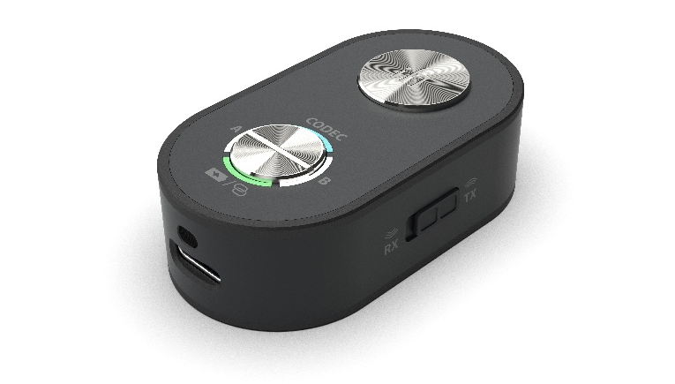
iFi launches UP Travel Max, bringing lossless wireless sound to every journey
“First-Class Sound. Now Lossless.”

Southport, UK – iFi audio, a British pioneer in audio innovation and high-performance sound components, announces the UP Travel Max, a tiny Bluetooth transceiver DAC that brings lossless, CD-quality sound to wherever you’re headed. Flick a switch and it connects your own wireless headphones to a plane’s seat-back screen; flick it back and it gives your car stereo high-quality wireless streaming. It is the first travel adapter that can both send and receive lossless Bluetooth, and the only lossless in-flight adapter built on true Hi-Fi architecture.
Whether your feet are on the ground or your head is in the clouds, the UP Travel Max is designed to come along for the ride. Inspired by a flip-out car key, its 3.5mm connector springs from the body at the press of the power button, ready to plug straight in. No bigger than a USB stick, lighter than an AA battery and with up to 10 hours of battery life, it’s the perfect pocket-sized travel companion.

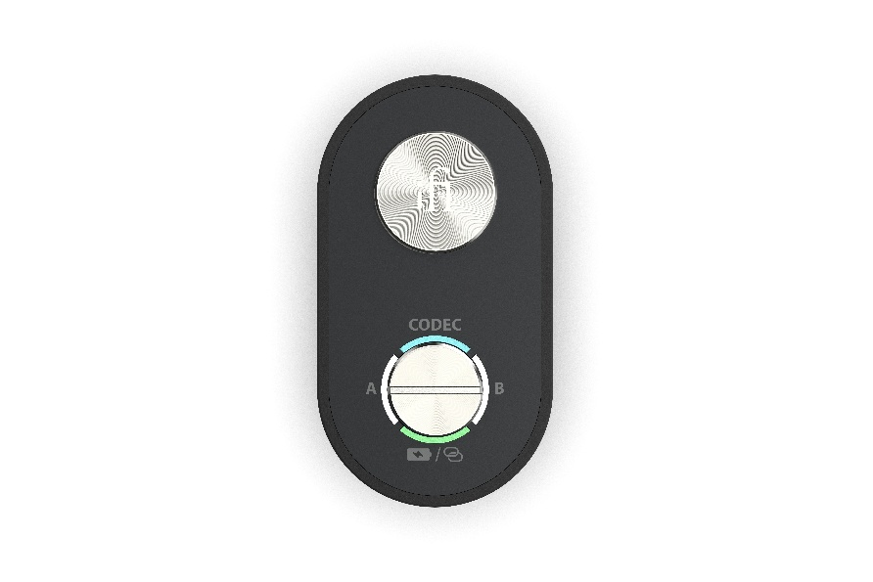

First Class Sound. Now Lossless.
Bluetooth has always been convenient, but that convenience has usually come at the cost of sound quality. Most wireless gadgets rely on a single chip to do everything, from receiving the signal to turning it into sound. UP Travel Max takes a cue from hi-fi systems instead and gives each job to a specialist: a dedicated Qualcomm Bluetooth chip looks after the connection, while a Cirrus Logic MasterHIFI DAC, as found in several of iFi’s award-winning portables, accurately turns that signal into music. The result is cleaner, more detailed sound, wherever you’re listening.
The UP Travel Max also supports the latest high-quality Bluetooth codecs (formats), including aptX Lossless for genuine CD-quality sound, and LDAC, while aptX Adaptive’s low-latency mode keeps sound in sync with the picture when you’re watching a film. A button on the front lets you switch between codecs to suit what you’re doing, and holding it down tells you which one is active.
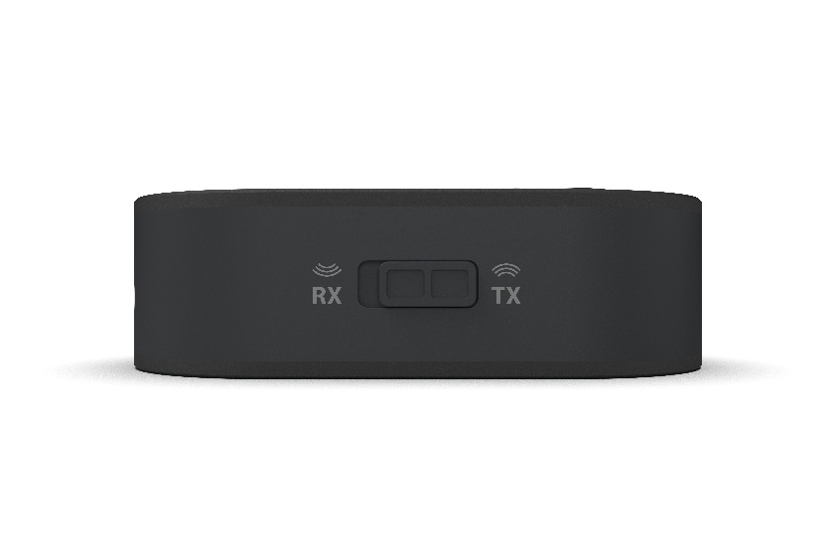

Flight Mode, Drive Mode.
What really separates the UP Travel Max apart is that it works both ways, switching between transmit and receive modes at the flick of a switch.
In transmit mode, plug it into an in-flight entertainment system and enjoy films and music in high-quality through your own wireless headphones, rather than the airline’s complimentary earphones. In receive mode, plug it into your car’s aux input and stream from your phone, giving your car stereo the best Bluetooth performance on the market. A built-in microphone with noise and echo suppression keeps hands-free calls clear, too.

Your iPod. Now Wireless.
With iPods and MP3 players finding a new generation of fans, the UP Travel Max lets your old music collection move with the times. Plug its flip-out 3.5mm connector into the headphone output of a classic iPod or MP3 player, switch to transmit mode, and enjoy your favourite tracks through Bluetooth headphones or a compatible wireless speaker. There’s no need to give up the simplicity of a dedicated music player to enjoy modern wireless freedom, with aptX Lossless available when paired with compatible listening devices.

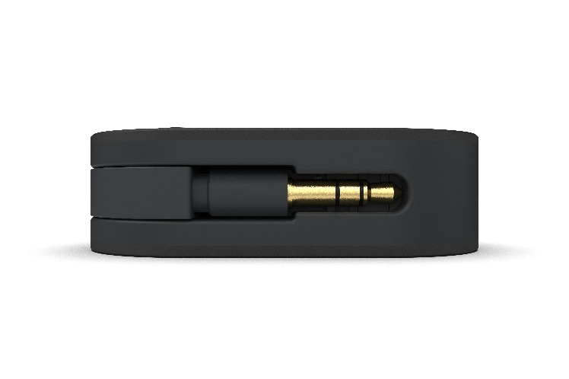
Listen Together.
Sharing music or a film used to mean splitting a pair of earbuds, being tangled up in wires, or trying to sync two screens. The UP Travel Max makes it simple in two ways. Pair two sets of wireless headphones at once, ideal for watching the same in-flight film with the person sat next to you, or use Auracast to share with an unlimited number of listeners. Once Auracast is enabled in the Nexis mobile app, anyone with compatible headphones or speakers can tune in and listen along.
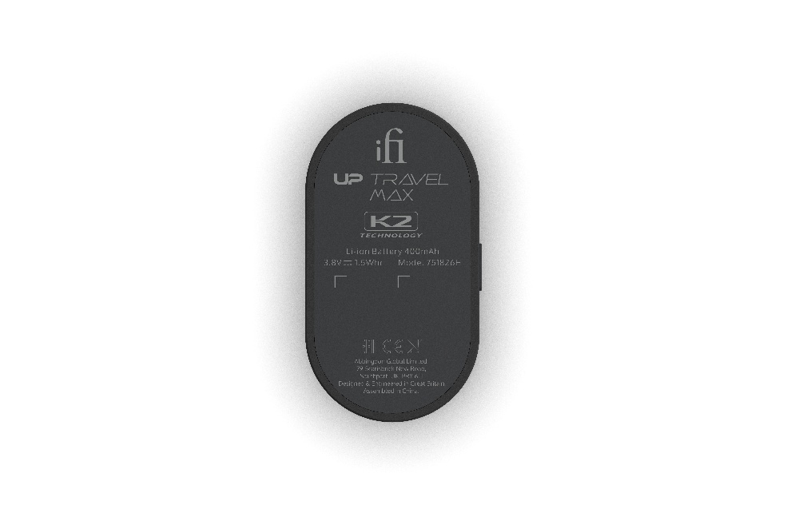
Bringing Back the Warmth.
Much of the music we stream loses some of its richness on the journey from studio to phone, leaving it sounding cold and clinical. The UP Travel Max includes JVCKENWOOD’s K2 Technology, which intelligently restores the natural harmonics and fine high-frequency detail lost along the way, bringing back the warmth and emotion of the original recording.

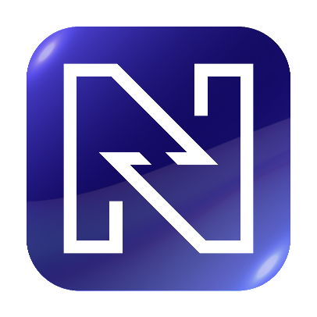
Smarter with Nexis.
The UP Travel Max is the latest product, which is fully integrated with the Nexis app – available on the App Store and Google Play and installs over-the-air updates straight from your phone. The app unlocks additional features, including advanced codec management, Auracast and K2 Technology controls, device customisation and battery optimisation.

Pricing & Availability
The iFi UP Travel Max is available to purchase at ifi-audio.com for [£129 / $129 / €139] from 29th October 2026.

Key features of the UP Travel Max include:

- Transmit and receive modes: use your own wireless headphones with in-flight entertainment, or stream to your car’s aux input
- aptX Lossless for CD-quality Bluetooth audio, plus LDAC for hi-res support and low-latency aptX Adaptive
- Hi-Fi design with a dedicated Qualcomm Bluetooth chip and Cirrus Logic MasterHIFI DAC
- Auracast compatibility for broadcasting to an unlimited number of listeners
- JVCKENWOOD's K2 Technology, activated via the iFi Nexis app
- Native dual Bluetooth headphone pairing
- Built-in mic with Qualcomm noise and echo suppression for hands-free calls
- Up to 10 hours of battery life
- Net Weight – 25.7g
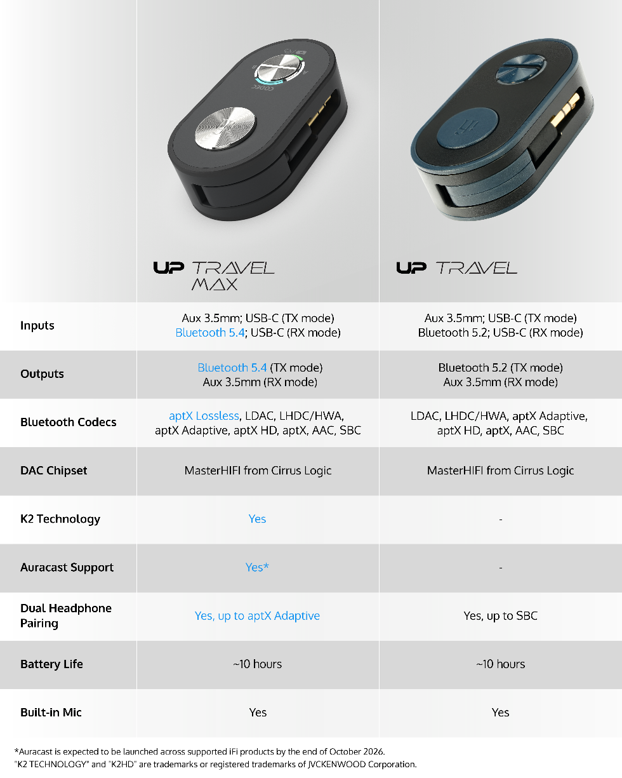

UK Press Contact: ifi@ranieri.agency


Established in 2012 and headquartered in Southport, UK, iFi audio is a globally recognised developer and manufacturer of high-fidelity audio solutions. Its product portfolio encompasses portable, desktop, and lifestyle devices designed to deliver exceptional sound performance through advanced engineering and innov ative design. Guided by a ‘music first’ philosophy, iFi’s products have received numerous international awards and acclaim from professionals and enthusiasts alike, reinforcing its position as one of the leading brands in modern audio. www.ifi-audio.com

