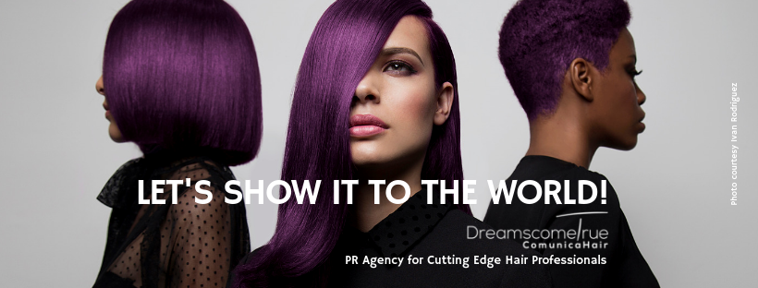
Specialised PR Agency for Cutting Edge Hair Professionals.
Creative Hairdressers are our clients.

For more information, please contact Marta de Paco
On +34670780664 or email press@dreamscometrue.es

Important:
These images are only available for editorial content.
Credits must be included.
Notification of their publication is expected.

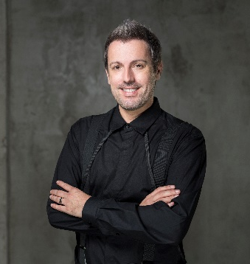
JOSE GARCIA PELUQUEROS
KP Collection

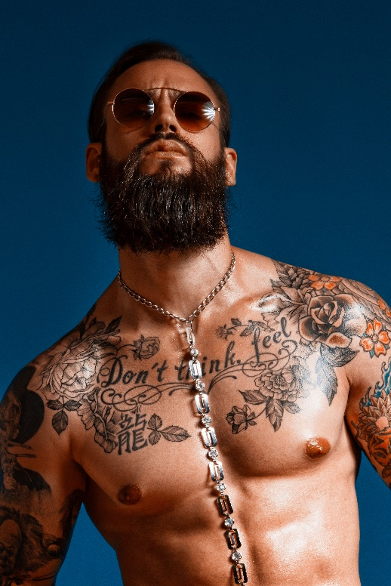
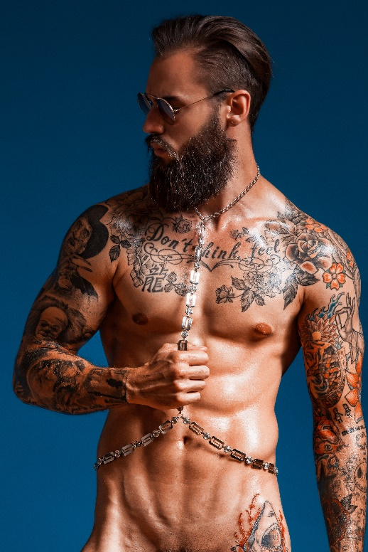
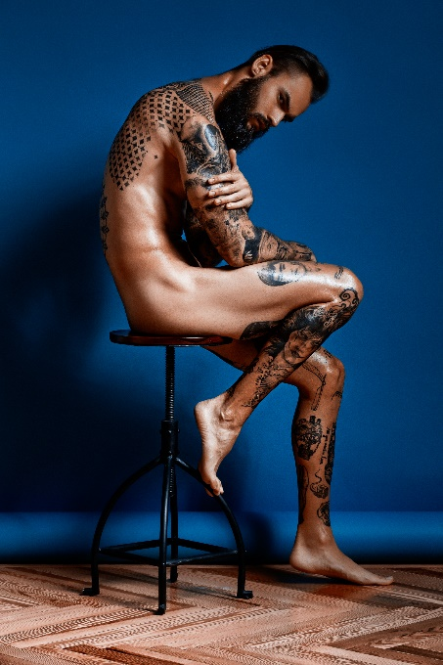

Hair: Jose Garcia @ Jose Garcia Peluqueros
Instagram: @josegarciapeluqueros
Photographer: Joan Crisol
MUA: Jose Garcia Peluqueros
Stylist: Antonio Bordera
Model: Krys Pasiecznik

JOSE GARCIA PELUQUEROS
KP Collection

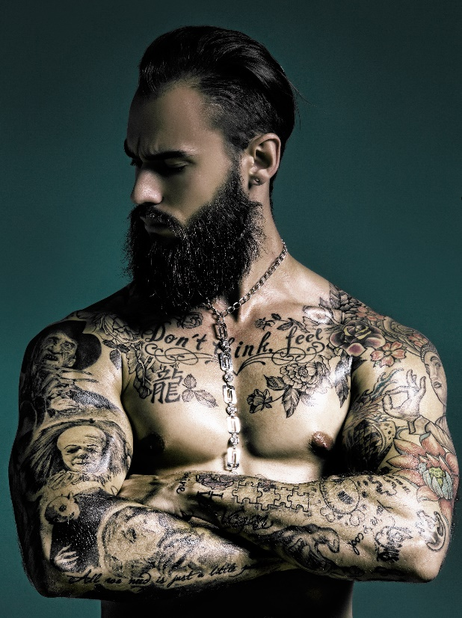

KP – a person, a collection.

A camera is like a window to a world; its ability to capture the pure essence of someone, to expose their true personality. The images it produces allow the viewer an insight into that person, a glimpse of who they are deep down.

This series of images convey the strength and intensity of KP. The indominable spirit that he has shown throughout his life, even when faced with challenges, is evident throughout the collection.

