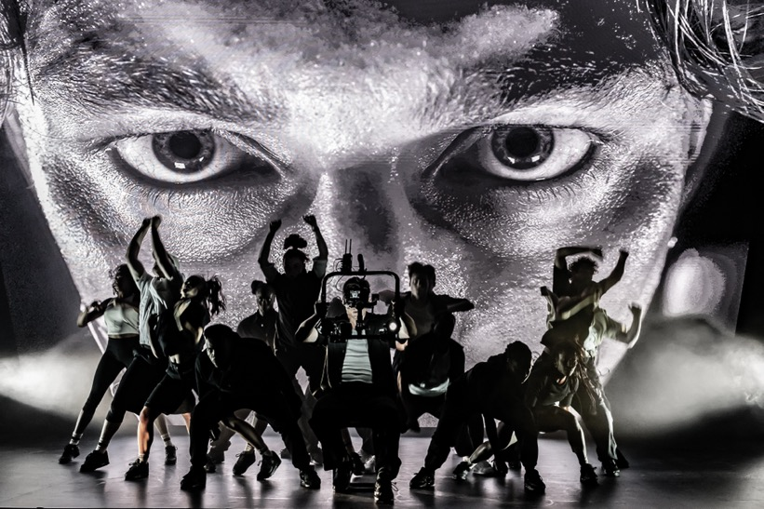
(Picture credit: Marc Brenner)

Multi Olivier Award winning London production of Sunset Boulevard utilises Sennheiser for creative performance solution

A Sennheiser Digital 6000 microphone system teams with the EK 6042 camera receiver to facilitate an unusual request for an imaginative twist to the storyline

Marlow, June 2024 – When Sunset Boulevard’s 16-week run at London’s glittering Savoy Theatre turned from a standard theatre production into a ground-breaking technical challenge, Sound Designer, Adam Fisher, and Production Engineer, James Melling, rose to the task. With the help of Sennheiser’s equipment and expertise, including Fisher’s system of choice, Digital 6000, they devised a robust solution that would work night after night.

With Nicole Scherzinger in the lead role of Norma Desmond, the sell-out run of Andrew Lloyd Webber’s iconic musical was the hottest ticket in town. Heading to Broadway in the autumn of 2024, it is already a multi-award winner, most recently winning seven Olivier awards including Best Sound and Outstanding Musical Contribution. The haul of seven awards means that it ties with classic shows like Hamilton, Matilda and Cabaret for the most Olivier statuettes awarded in a single night.

The technical challenge started when the request came through to film and live stream the actors outside the theatre as part of the performance. Whilst the performance was ground-breaking in many aspects, following cast members out from their dressing room to the street, then to the stage was something new, but the compatibility of Sennheiser’s products made integrating live video and audio streaming into the existing system a complete success.

With Nicole Scherzinger in the lead role of Norma Desmond, the sell-out run of Andrew Lloyd Webber’s iconic musical was the hottest ticket in town (Picture credit: Marc Brenner)

“I’m a big fan of Sennheiser, so it was always going to be a Sennheiser show, the fact there was camera work and video work meant we expected our main challenge to be RF interference from the big screen,” Fisher explains. “Once we were into rehearsals, Show Director, Jamie Lloyd, had the idea to do some remote action. It was a lot of work to figure out the best way to make it happen. Not only from a radio mic point of view, but also from an IEM standpoint.”

“Sennheiser is our go-to solution for all of Adam’s productions,” adds Melling. “On this show we’re using D6000 receivers with SK 6212 mini-bodypack transmitters. With the added challenge of leaving the building, we needed the reliability of long battery life in addition to the strong antenna design and small body-worn packs. The really cool thing was the EK 6042 camera receiver. It works with all the Sennheiser products and uses the same batteries, so we could integrate it with our existing charging solutions.”

Filming the performers as they left the building every night, then travelled back to stage through tight corridors, without losing signal at any point was a technically exciting challenge and Matt Bird, Radio Lead at Autograph Sound, was happy to work on it.

“We needed to utilise multi-zone antennas, a mixture of Sennheiser AD 3700 directional and A 1031-U omni-directional antennas, which is something we don’t often do in theatre,” Bird explains. “This system gave us rock-solid RF reception inside the building and when we left the building, we were able to connect to camera receivers seamlessly, which gave us additional range and flexibility. It’s hugely ambitious and is what sets this solution apart.”

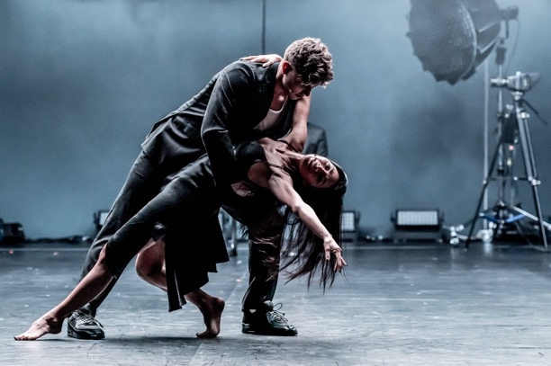 | Adam Fisher’s system of choice, Sennheiser Digital 6000, performed flawlessly night after night for Sunset Boulevard at London’s Savoy Theatre  (Picture credit: Marc Brenner)

Working together, the team settled upon the aforementioned two-channel EK 6042 camera receivers. They are compatible with a wide range of both analogue and digital Sennheiser microphone systems, including Digital 6000, and feature a very wide switching bandwidth of 184 MHz to cover multiple transmitter frequency windows. The EK 6042 has exceptionally low latency, so the performers can stay in time with the music as they perform in a completely different and remote environment.

Backstage: the EM 6000 two-channel receivers | 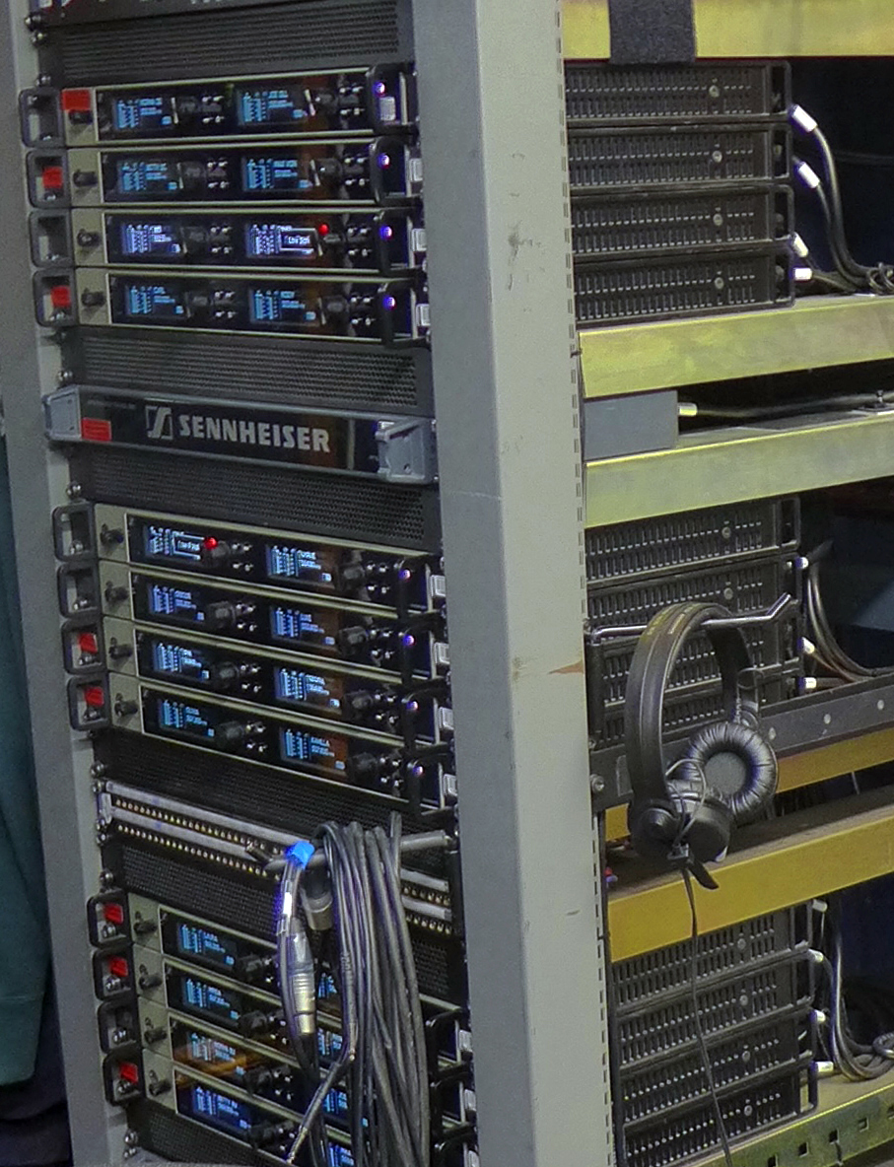

Relationships are also key to solving challenges, and having a great relationship with Sennheiser means the whole team benefits from their expertise. Kevin Gwyther-Brown, Sennheiser’s Business Development Manager, was instrumental in ensuring the team in the theatre and at Autograph Sound had all the information they needed, offering expert advice and insight.

Will McGonagle, Hire Manager for Autograph Sound, expands on the power of strong industry relationships. “Autograph’s relationship with Sennheiser goes back decades, and it’s stronger than ever. Kevin looks after us incredibly well and it means that when last-minute ideas like this come up, we can respond instantly,” he says.

Always keen to keep abreast of the latest developments, Fisher attended Sennheiser’s Sound Experts event in Düsseldorf to find out more about the upcoming Sennheiser and Neumann technologies, such as Wireless Multi-channel Audio Systems (WMAS), to support new developments in theatrical performance.

Sound designer Adam Fisher (right) with Sennheiser’s Kevin Gwyther-Brown | 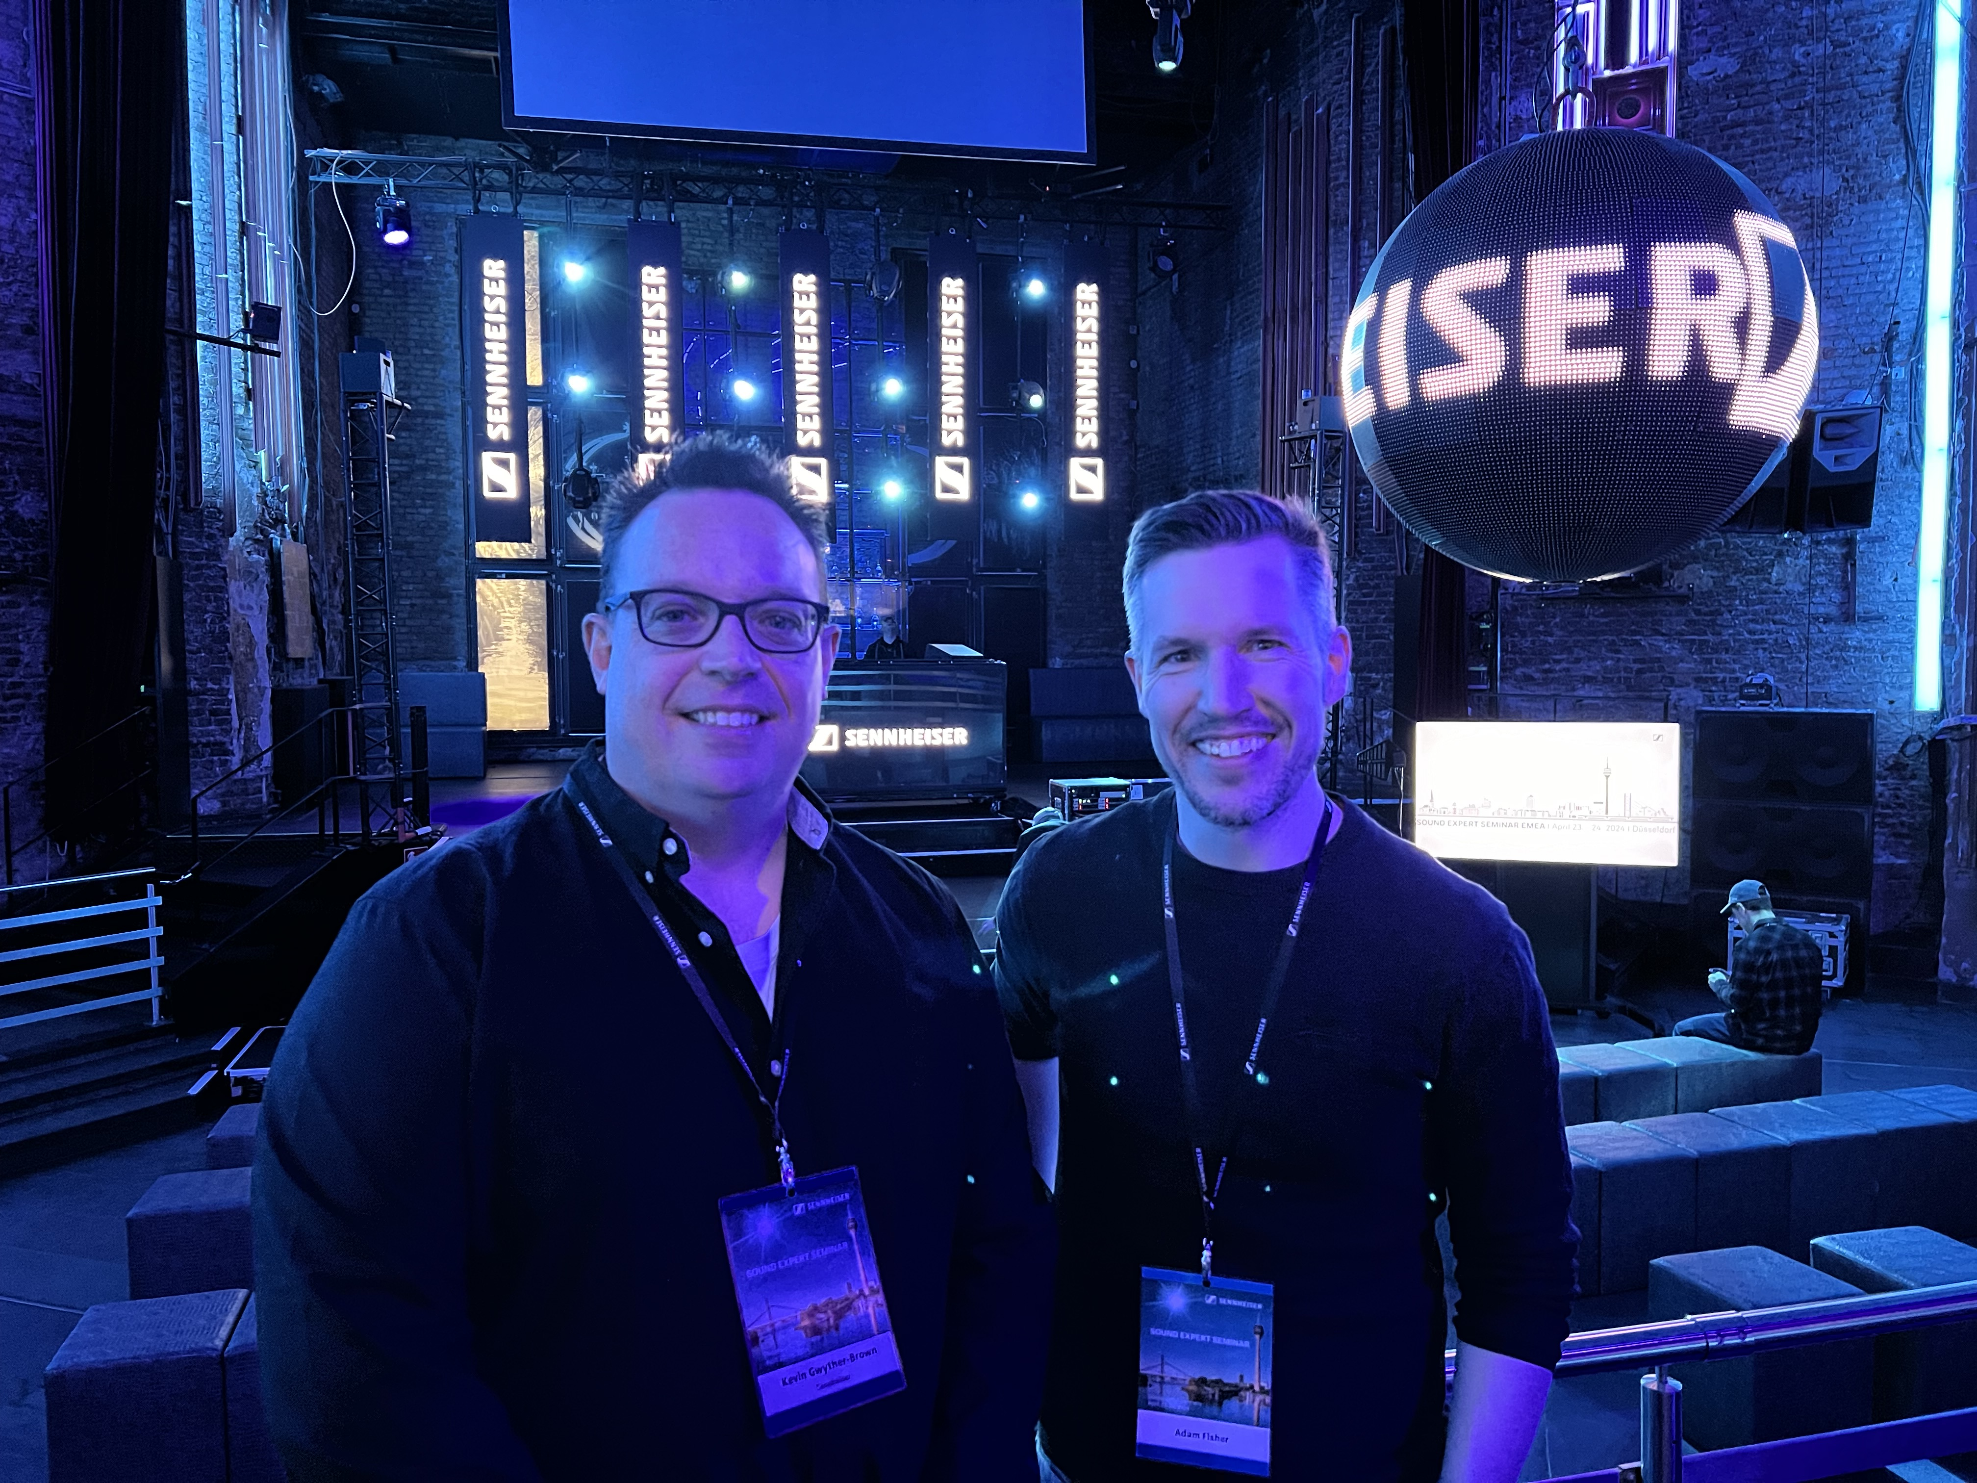

“Using the SK 6212 transmitters for Sunset Boulevard just keeps everyone happy,” Fisher says. “The small size and incredible battery life make them stand out from every other competitor, but the new WMAS technology is even more exciting. It would make situations like escaping outside the theatre more easily achievable and give us some really creative options. WMAS technology will open up many more possibilities, it’s a really exciting design tool.”

“We were delighted to have Adam join us at our recent event in Germany which aligns perfectly with the Sennheiser Group’s strategy of keeping sound designers and industry professionals up-to-date on the latest technologies, as well as offering a glimpse of what’s coming next,” concludes Gwyther-Brown. “This is integral to the trust and openness between us and our industry peers.”

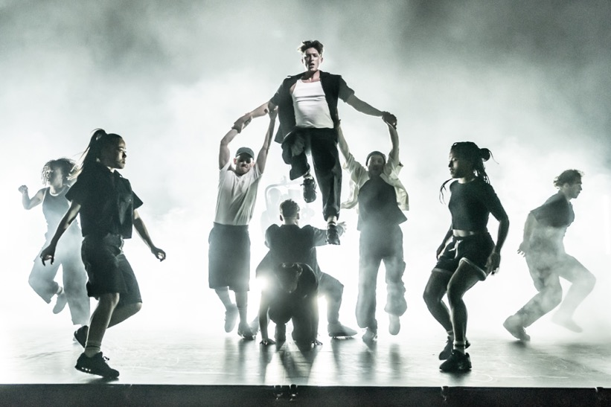
“Using the SK 6212 transmitters for Sunset Boulevard just keeps everyone happy. The small size and incredible battery life make them stand out from every other competitor,” says Adam Fisher, Sound Designer (Picture credit: Marc Brenner)

(Ends)

The high-resolution images accompanying this media release and additional photos can be downloaded here.

About Autograph Sound
Autograph is considered a cornerstone of the industry and the premier theatre sound design and equipment rental company in the world. We provide sound across a majority of West End Shows, we also provide sound and audio-visual solutions globally, for corporate clients, immersive experiences, places of worship, leading educational facilities, festivals, cruise ships and more.

About Adam Fisher
In 2023 alone Adam Fisher designed The Wizard of Oz (UK Tour), Evita (Leicester Curve), Sunset Boulevard (Savoy), The Phantom of the Opera (Middle East Tour), LIZZIE (UK Tour), The Lord of the Rings (The Watermill Theatre), Evita in Concert (Drury Lane), Love Never Dies in Concert (Drury Lane) and The Wizard of Oz (London Palladium).

About the Sennheiser brand
We live and breathe audio. We are driven by the passion to create audio solutions that make a difference. Building the future of audio and bringing remarkable sound experiences to our customers – this is what the Sennheiser brand has represented for more than 75 years. While professional audio solutions such as microphones, meeting solutions, streaming technologies and monitoring systems are part of the business of Sennheiser electronic GmbH & Co. KG, the business with consumer devices such as headphones, soundbars and speech-enhanced hearables is operated by Sonova Holding AG under the license of Sennheiser.

www.sennheiser.com
www.sennheiser-hearing.com

Local Press Contact
Maik Robbe
T +49 5130 600 1028
maik.robbe@sennheiser.com

