The Moog Model 10 Synthesizer Returns + A Look Inside the Moog Factory with New Video: Making a Moog Synthesizer

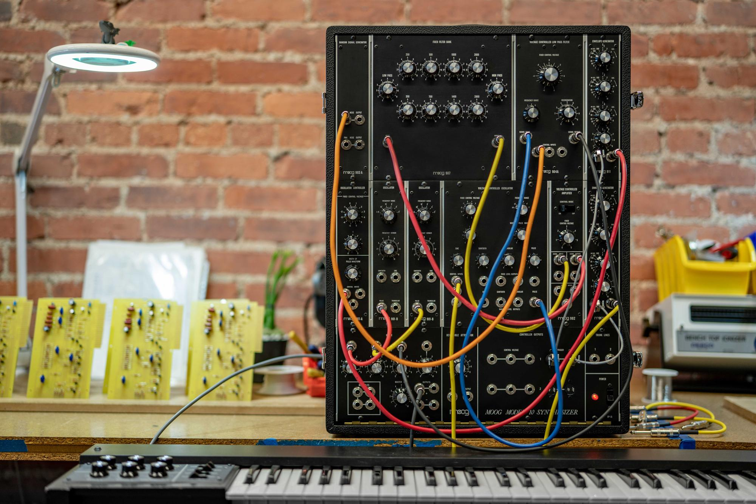

The invention of the Moog Synthesizer in 1964 forever changed the way we hear the world around us. The new machine could break down the fundamental building blocks of sound, gifting the operator the ability to control every aspect of its output – essentially building sound from scratch. Musicians, composers, artists, and explorers would adopt this new device to create unheard-of sounds, develop new musical styles, and explore new frontiers of self-expression – a tradition of electronic experimentation that continues to evolve over 50 years later.

These modular Moog Synthesizers were self-contained electronic music systems, each one hand-built by skilled technicians. Every new synthesizer took weeks of patient, steady crafting to complete, but the payoff would be rich – a tool that would change the landscape of music.
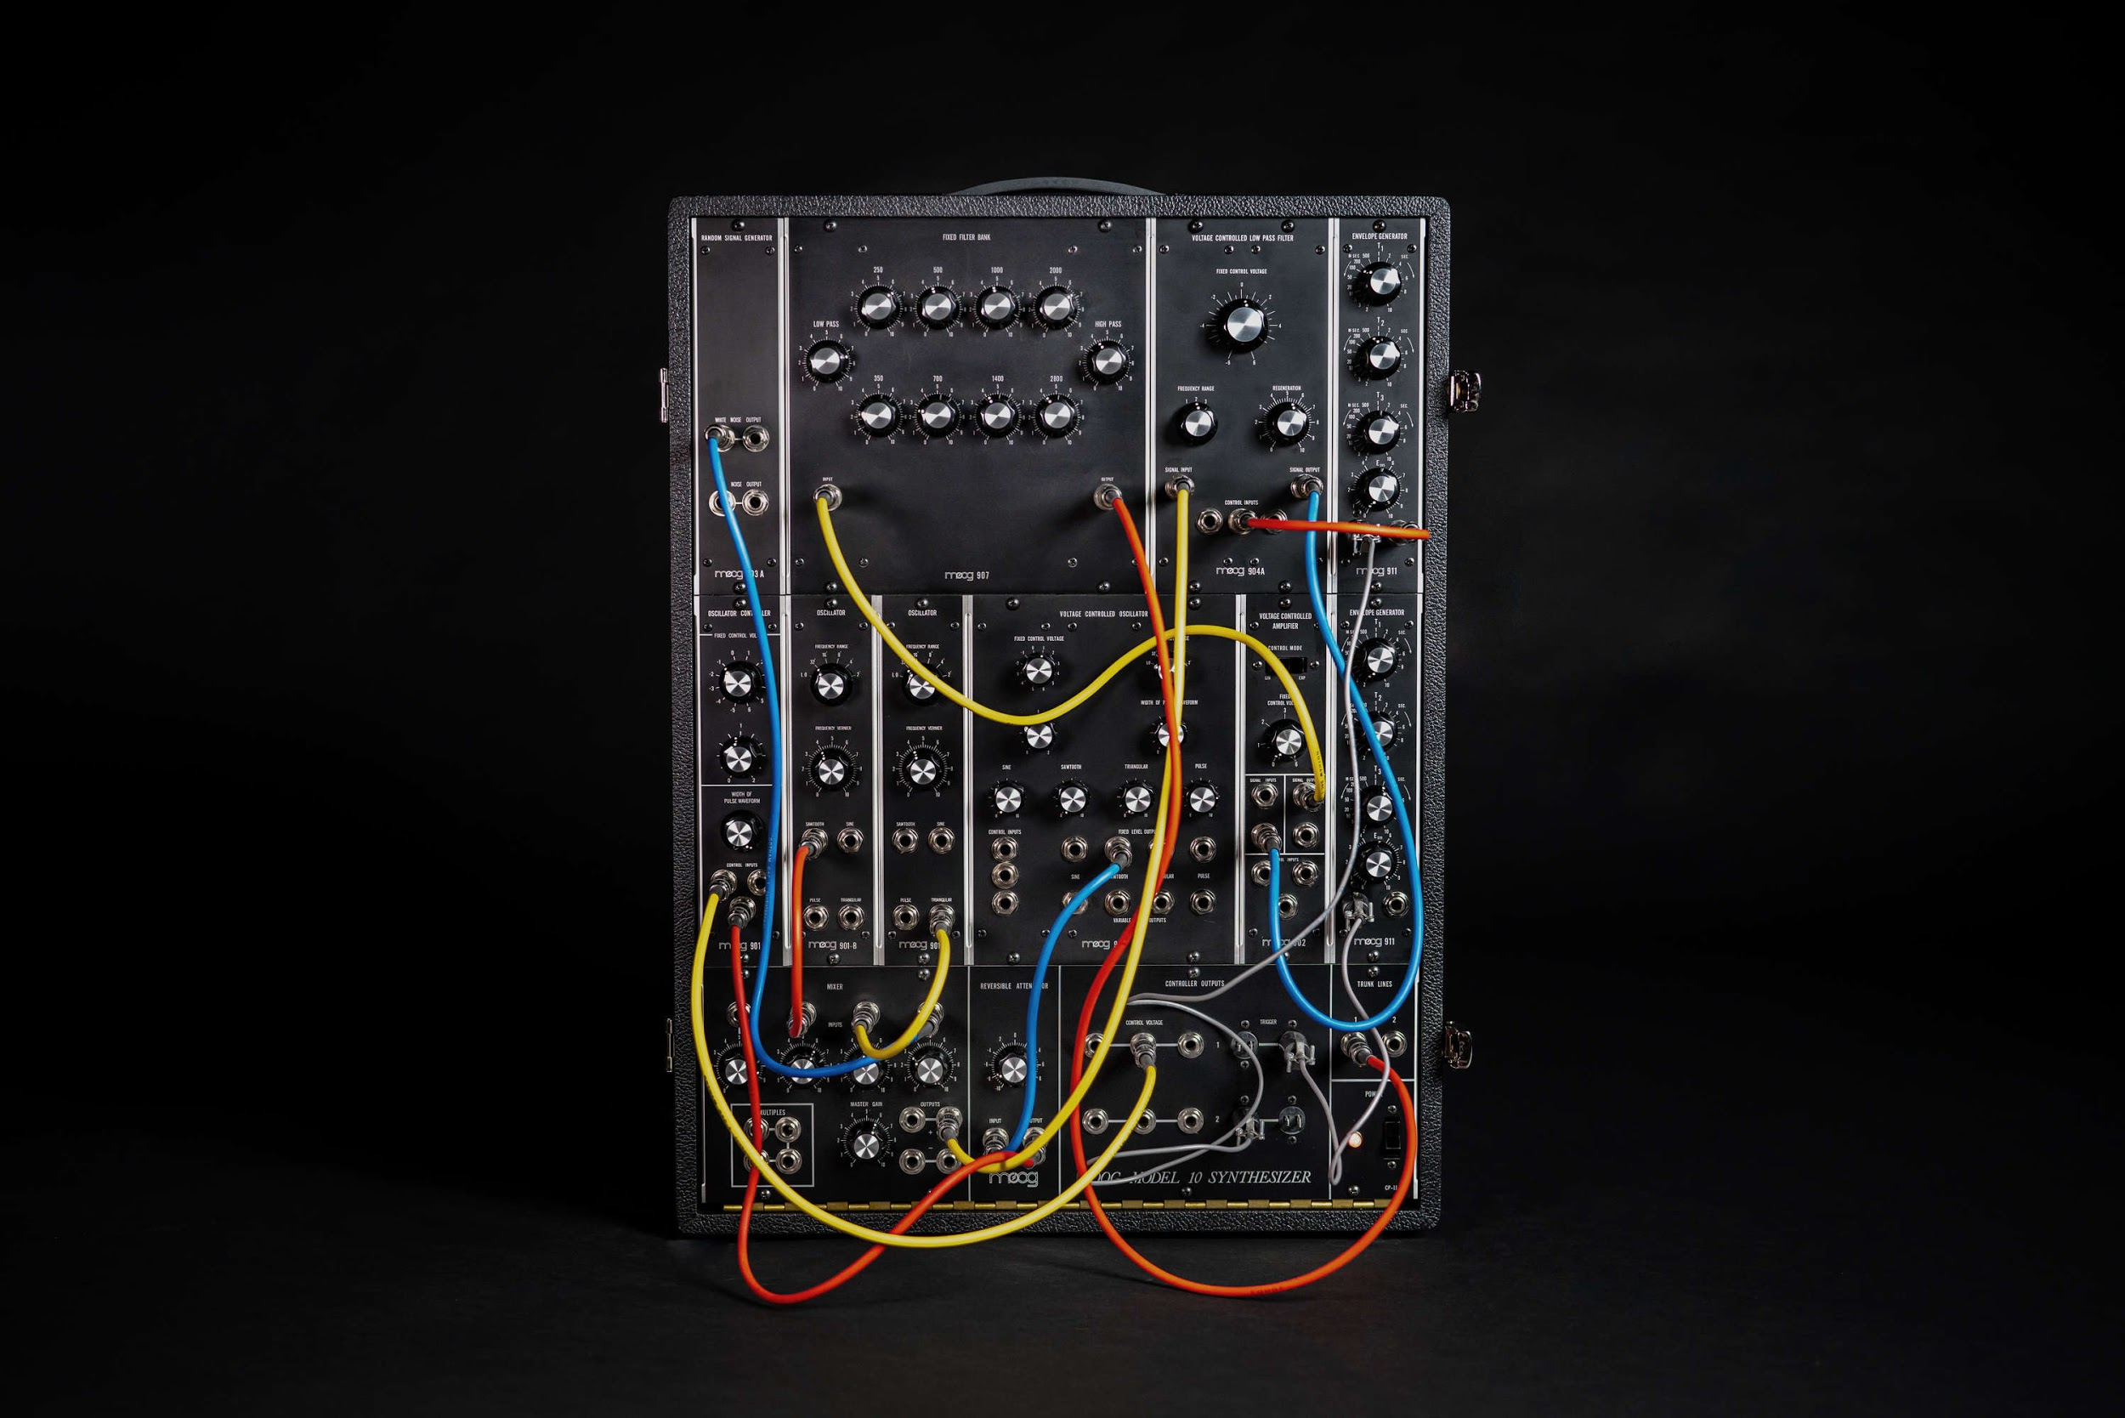

Moog Model 10 Synthesizer
Today the Moog Model 10 Synthesizer returns to production at the Moog Factory in Asheville, NC – making this iconic analog synthesizer once again available to artists after nearly 50 years. The Model 10 is faithful in every way to its 1971 counterpart (the first compact modular synthesizer model created by Dr. Robert Moog) – all the way down to its hand-soldered electronic circuits. The Model 10 is housed in a rugged tolex-wrapped wood cabinet and comprised of 11 discrete analog modules, including the 907 Fixed Filter Bank, revered for its vast sound shaping and timbral possibilities, and three 900-Series oscillators, the foundational sound behind Wendy Carlos’ Switched-On Bach and Isao Tomita’s Snowflakes Are Dancing.
The predecessor to the Model 15, the Model 10 design focuses on the purity of sound, speed, and simplicity while providing the enormous sonic depth and dimension found only in a vintage Moog modular synthesizer.
Each Moog Model 10 is built using all-original documentation, art, and circuit board files, and each hand-crafted module is securely mounted into a solid wood, tolex-wrapped cabinet.

This limited-edition reissue of the Moog Model 10 is built to order and is available in limited quantities for a limited time.

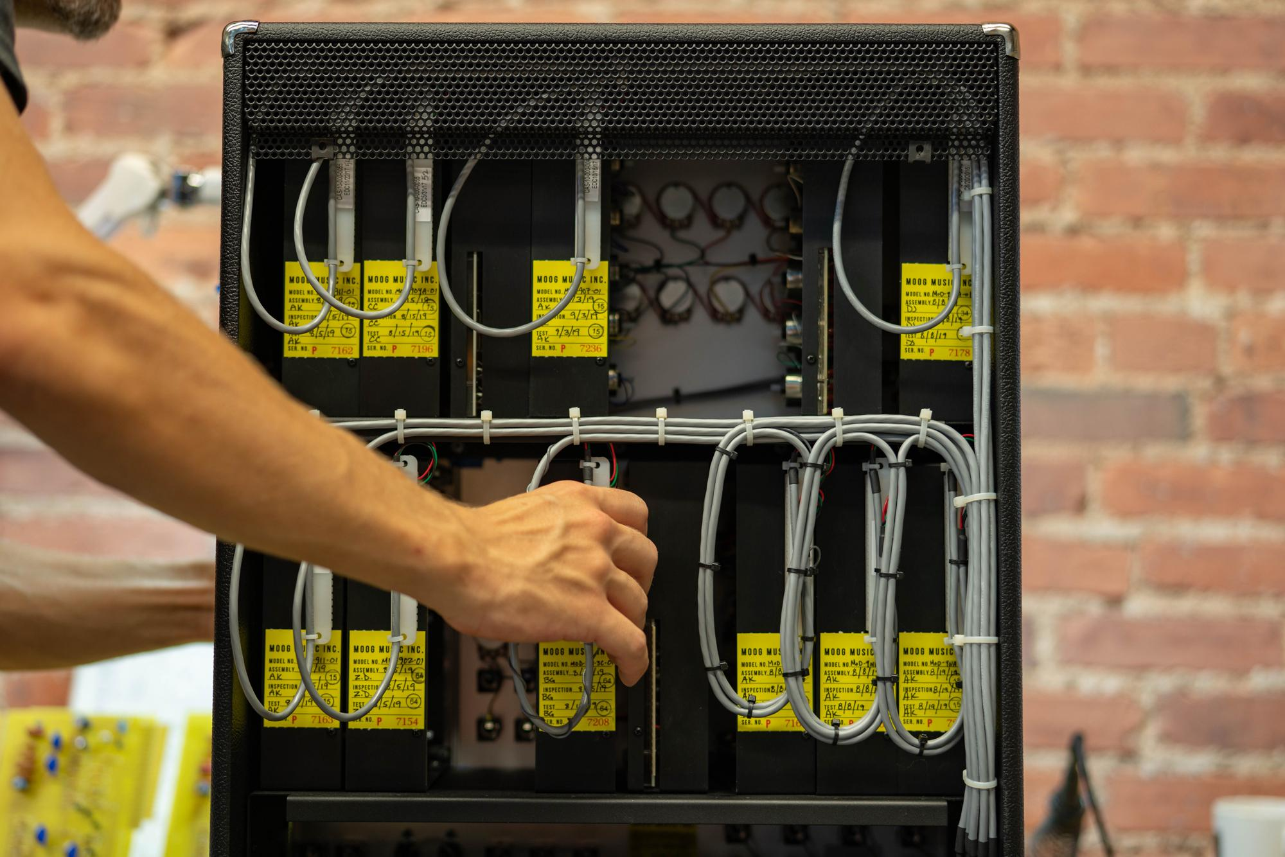

VIDEO: Making A Moog Synthesizer
At the Moog Factory in Asheville, North Carolina, every Model 10 is hand-built to its original 1971 specifications and is a true recreation of the original. Individual modules are brought to life just as they were nearly 50 years ago; by hand-stuffing and hand-soldering components to circuit boards, and using traditional wiring methods. Each module is then hand-tested, finished with an aluminum panel, and placed into a custom cabinet before the synthesizer leaves for its new home. Watch Making a Moog Synthesizer and step inside the Moog Factory to watch how Moog synthesizers are built with love and care by the employee-owners at Moog Music.
Original score created by Bana Haffar and composed on a Moog Model 10 Synthesizer.

Watch Making a Moog Synthesizer

Asset Links (Do not share publicly before September 17)

Making a Moog Synthesizer | Full Video
  - Embeddable YouTube video for use on Model 10 product pages, blog posts, and social media

Model 10 | Moog Factory Build Photos
  - Photoset of Model 10 being hand-built by the employee-owners at the Moog Factory in Asheville, NC

Model 10 | Product Photos
  - Photoset of Model 10 detail and beauty shots

Model 10 | Product Page

Learn more about Moog Music here.

