For immediate distribution

Vintage Analog Within Reach: UK Sound 1173 Mic Pre Compressor Now Shipping
Debut Product from BAE Audio Imprint Enables Users to Access Timeless Circuits at an Affordable Price

North Hollywood, Calif. – December 13, 2017 — UK Sound, purveyor of affordable and sonically concious analog gear, announced that its 1173 mic pre compressor is now shipping worldwide. The new 1U space rack unit — the first to combine the synergies of two timeless circuits, the 1176 compressor and 1073 preamplifier — was previewed earlier this year at Musikmesse in Frankfurt and will be on display at NAMM 2018 in Anaheim next month. The UK Sound 1173 is the first in a line of economically priced sonic equipment from BAE Audio imprint UK Sound. 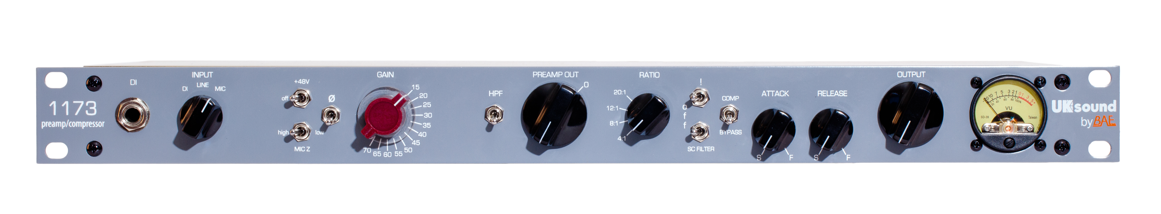
Analog within reach
"UK Sound is addressing an increasingly important market need for emerging engineers and producers," commented Mark Loughman, founder and managing director of UK Sound. "In an industry where software plug-ins have become omnipresent and the defacto status-quo, our mission is to re-introduce analog gear as an affordable and superior alternative to lackluster digital emulations. With our new 1173, we have created the first manifestation of this promise."
The 1173, which is designed to appeal to experienced musicians, producers and engineers looking to diversify their sonic palette while still delivering tried-and-true analog warmth that BAE Audio customers are used to, is the result of a design collaboration among Los Angeles-based producer Warren Huart and gear designer Michael Stucker, produced and manufactured by UK Sound. The new product brings together the combined synergies of two timeless circuits: the 1073 preamp and studio FET compressor — at an affordable price. The marriage of these two classic pieces of analog gear opens up an entirely new sonic palette in the studio, either as a standalone piece in a project studio, or as a unique addition to a heavily fortified rack of outboard gear.

Brave new world
The 1173 owes its unique character to its combined 1073 preamp and FET compressor circuit. It features the recognizable FET compressor controls for input and output gain and the time-honored compression ratio options of 4:1, 8:1, 12:1, and 20:1. Attack and release controls allow users to tailor the compressor’s action to for any given source. While the 1073 preamp helps bring depth and clarity to audio on the front end, the FET compressor is able to manage peaks, adding control and thickness to the signal. Drums, bass, vocals, and synths are among the many sound sources that will benefit from the 1173.
The UK Sound 1173 is priced at $1,200 US and shipping now. For more information, please visit https://uksound.com/1173-mic-pre-compressor/.
About BAE Audio
BAE Audio is a U.S.-based manufacturer of high-end microphone preamp and equalizers, all of which are faithful to vintage designs of the seventies and before. The company is committed to the vintage philosophy of hand wiring and hand soldering all of its components to achieve a high quality and authentically vintage sound. For more information on BAE Audio, please visit our website at www.baeaudio.com.

Media contact
Jeff Touzeau
Public Relations
Hummingbird Media
+1 (914) 602 2913
jeff@hummingbirdmedia.com

