For immediate distribution

Mode Audio Selects Powersoft’s X Series Amplifier Platform
for Dire Straits Legacy Concert at Los Angeles’ The Wiltern
Clarity and musicality make Powersoft’s X Series platform
a perfect pairing with Mode Audio’s FILA 12.2 loudspeakers

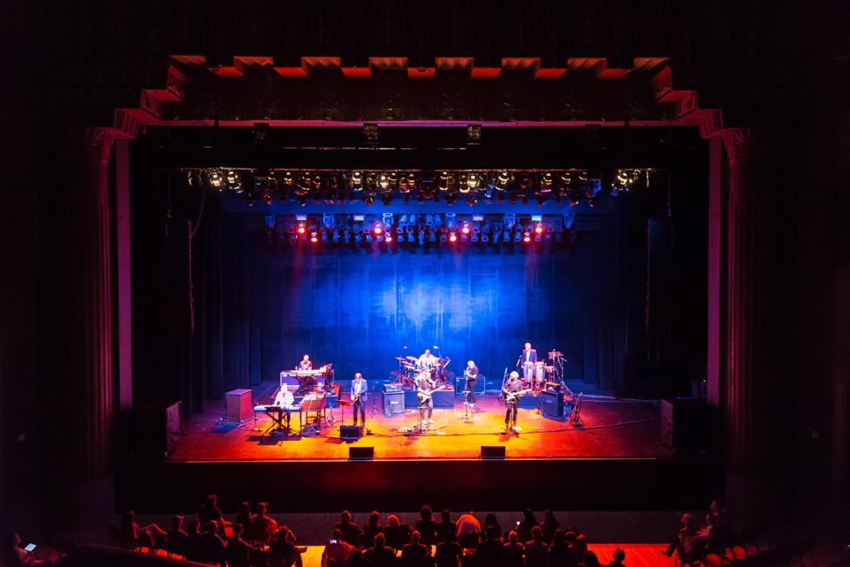
Los Angeles, October xx, 2018 – Loudspeaker systems manufacturer Mode Audio debuted its new FILA Series of line array speakers during the Dire Straits Legacy concert held at Los Angeles’ storied Wiltern theatre on Sept. 26. When seeking an amplifier solution for its high output FILA vertical line array system, Mode Audio looked no further than Powersoft’s X Series amplifier platform, which features fully integrated DSP, unmatched power efficiency and integration flexibility.

In what was a comprehensive search for the perfect amplifier platform, Rodriguez primary requirement was a flexible system that was both efficient and musical. He found the Powersoft X4 to be perfectly suited for this.

“When I first tested the X8 and X4 amplifiers with our new large-scale line array system, I was amazed by the overall power of the X Series,” Rodriguez said. “On top of that, the clarity and musicality of the system — combined with the fact that no sonic colorization was being added from the amplifiers — really solidified the deal for us.”

A Powerful Legacy
For the Dire Straits Legacy concert — which featured nine former members of the popular ’80s band Dire Straits — six Powersoft X4 amplifiers powered 16 FILA 12.2 audio tops, providing nearly 50,000 watts of power to the entire system.
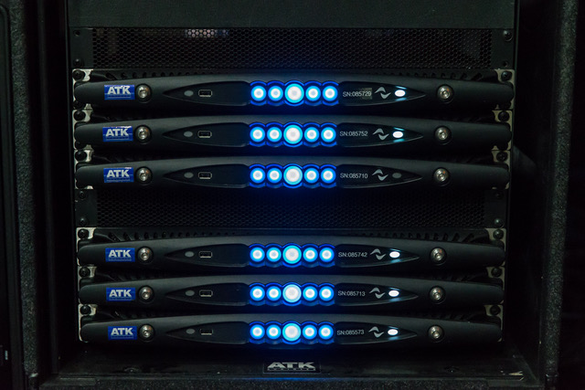
“Our line array system is a 4-way box, and the X Series 4-channel amplifiers basically allow me to configure 4 boxes per component per channel,” Rodriguez explained. “I can use 4 of the complete 12.2. boxes with one X4 which is great because it saves us so much amplifier rack space.”

In addition to powering the FILA 12.2’s, two X4 units were used to power four of Mode Audio’s BPM-218 ultra-low, high-power subwoofers. As a result, Rodriguez also had power front of mind when selecting the X4 units for the system which featured 10-15 dB headroom. “The headroom we had was just amazing,” he said. “The X Series amps never sounded like they were choking or stressing for power so that also made them a good fit for the system.”

For ease of use and peace of mind, X4 amplifiers come equipped with Powersoft’s ArmoníaPlus System Manager software which allows for remote control and monitoring of Powersoft’s full range of products.

“Using the Armonía software helped make everything run even smoother,” Rodriguez said. “Because this was the first event where we were showcasing the new line array system, it was great to have this support from Powersoft to insure everything ran even smoother.”
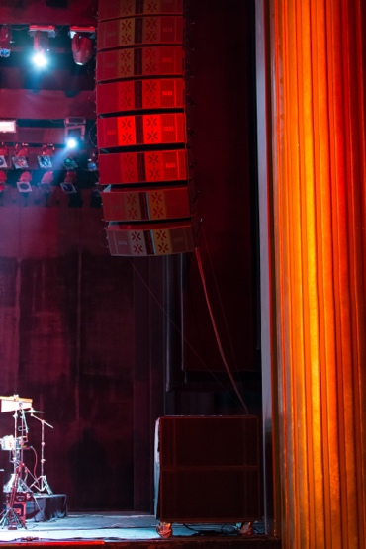
A Debut for the Ages
With the debut of the FILA system and the first pairing of Mode Audio and Powersoft now in the books, Rodriguez said he couldn’t have been happier with the results.
“The whole night went great,” he said. “It was a great show, and the sound quality from the X Series was amazing — so much so that even the band’s sound engineer was extremely satisfied with the sound, and that of course gives me great satisfaction.”

###

For further information, contact:

Jeff Touzeau (media contact)  Hummingbird Media  Tel : +1 (914) 602 2913  Email: jeff@hummingbirdmedia.com | Francesco Fanicchi  Powersoft (Florence, Italy)  Tel: +39 339 6381206  Email: francesco.fanicchi@powersoft.it

Or visit www.powersoft-audio.com
About Powersoft:
Powersoft is the world leader in lightweight, high power, single rack space, energy efficient amplifiers for the professional audio market. Founded in Italy in 1995, headquartered in Florence, Italy, with offices in New Jersey, , Powersoft couples the experience and precision of its production department with exceptional components to deliver products with perfect audio response and high-performance reliability. Its state-of-the-art amplifiers can be found in an array of markets, ranging from stadiums, sporting arenas, theme parks, performance venues and airports to convention centers, churches, and clubs, and are used by the world's leading tour sound companies. For more information, visit the Powersoft website at www.powersoft-audio.com.

