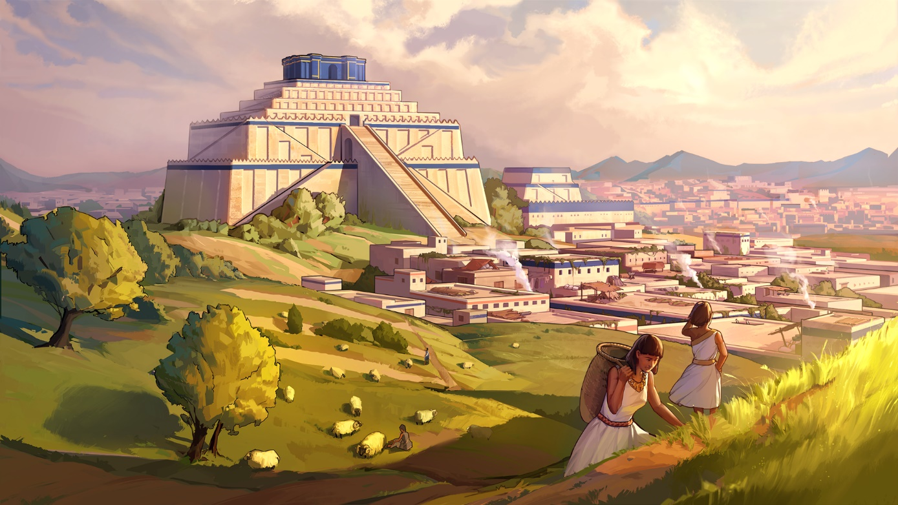

HUMANKIND OPENDEV SCENARIO 1 “TOWERS OF BABYLON”

AVAILABLE TO PLAY THIS WEEKEND

A first wave of players will gain access to the “Towers of Babylon” OpenDev scenario.

Paris, July 30th – Standing at the center of civilization, Babylon is, was, and always will be one of the greatest cities the world has ever seen. It’s your turn to write a chapter in its glorious history. How will you be remembered?
Ourselves, we hope to be remembered for our wonderful strategy games, always crafted with the community’s input. Today we start that process for Humankind by giving access to a first 45-minute OpenDev scenario focused on exploration. Two more scenarios will follow in the coming month.
A few key things to remember:
- Scenarios are time limited – each will be available from Thursday at 15:00 BST / 16:00 CEST / 07:00 PDT through Monday at the same time
- We will grant access to additional applicants with each new scenario – so players should keep checking their email in the coming weeks
- Getting access later grants access to all previous scenarios – In fact, we would prefer that newcomers play the scenarios in order as they have a bit of an onboarding logic to them
- Applications will remain open during the entire process – Even if you weren’t selected for this first round, you can apply now for a chance to be included in the 2nd or 3rd wave of players

Last but certainly not least, a reminder about why we’re doing OpenDev: to get your feedback. The game is still in an early state, and these scenarios are targeted to test out small slices and specific features.
Community input is extremely important to us and we want to work together to make Humankind an amazing game!
We hope you enjoy & can’t wait to hear what you think!

- The Ampliteam
--
For more information about Humankind visit https://humankind.game, or follow us on Facebook, Twitter, & Instagram. Learn more about SEGA at https://sega.co.uk.

